

[School/District] puts students in the driver’s seat of their education with online courses that give students the flexibility they need to meet athletic, work, or family obligations. And with a wide selection of electives to choose from, students can explore areas of interest and courses that align to their goals for college or career.

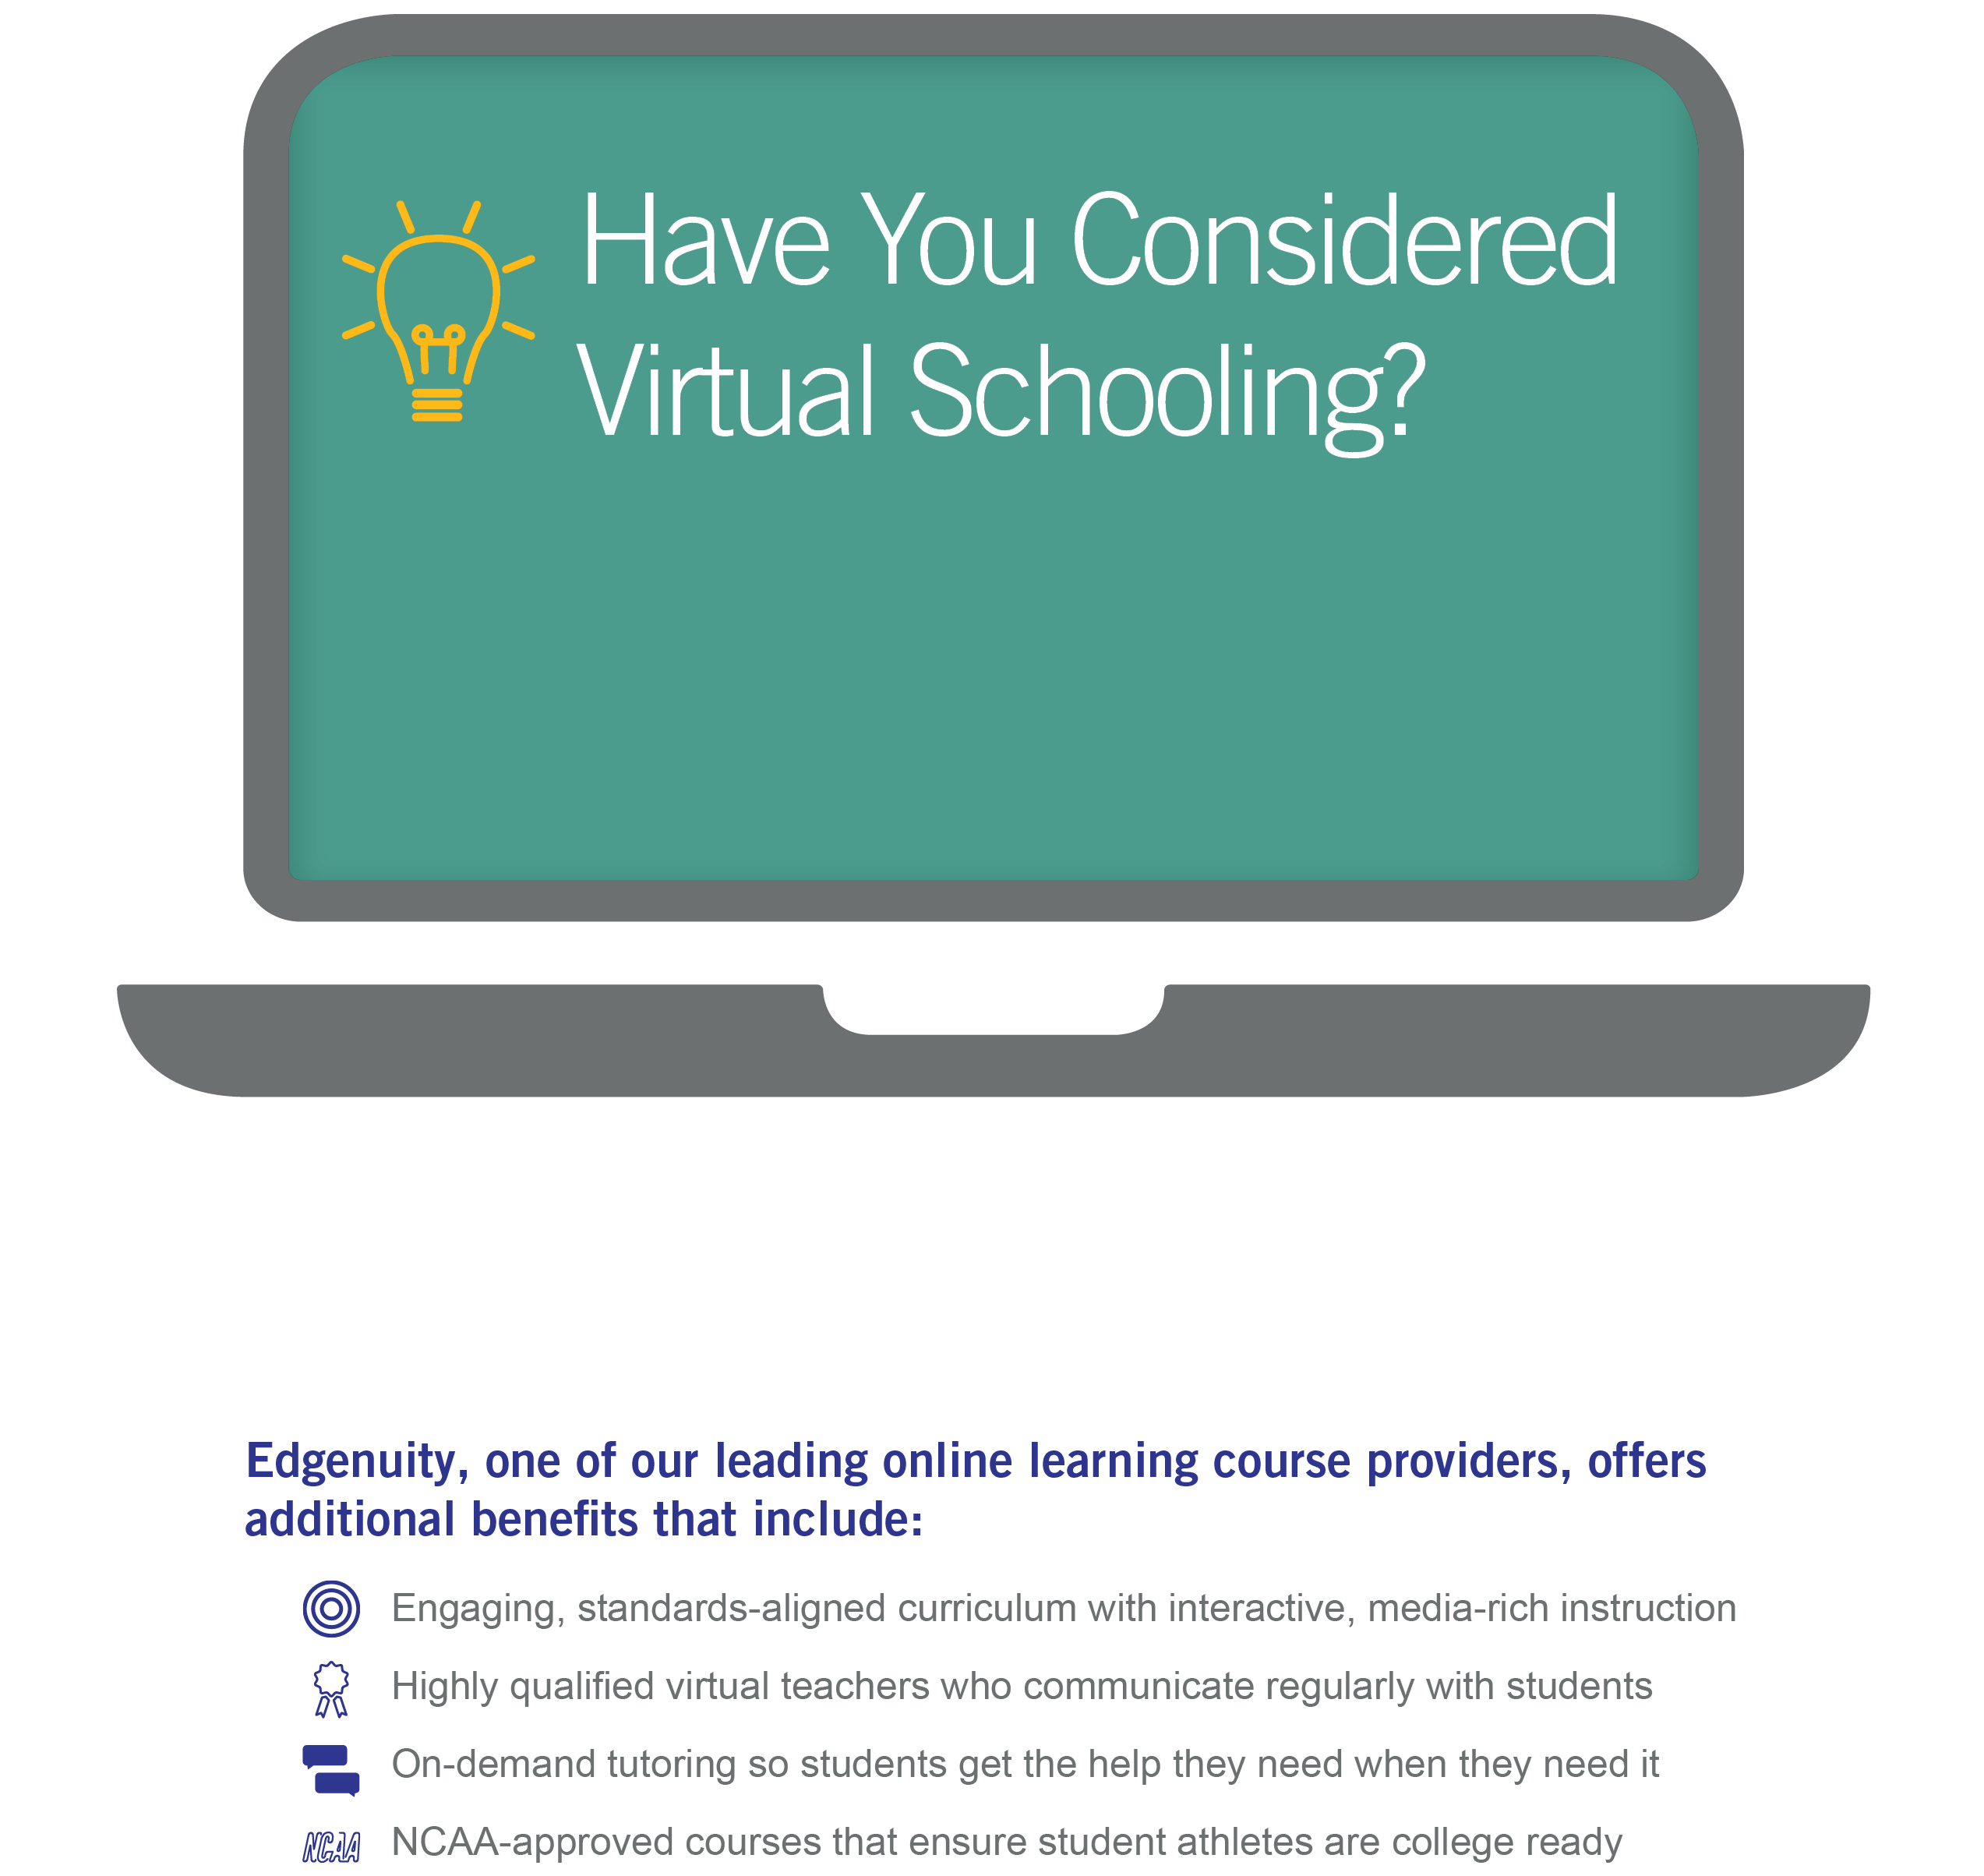

[School/District] gives students

an alternative to the traditional classroom.

**Visit our enrollments page at [Website]**

**or speak with one of our counselors today to learn more.**

**[School/District]**

[Address]

[Website]

[Phone] | [E-mail]

**School/ District Logo**