Pre-Lab Information
Purpose Use a microscope to investigate differences between a variety of cells.
Time Approximately 60 minutes
Question What are the characteristics of different cells?
Summary All living organisms are composed of cells. Your own body is composed of trillions of cells. Cells are the smallest units of life that can satisfy all of the characteristics that define something as “living”: they respond to stimuli, grow and develop, reproduce, and need energy.

Using a microscope, you will investigate and describe similarities and differences between cells. First, you will compare and contrast prokaryotic and eukaryotic cells. Next, you will examine unicellular and multicellular organisms. Finally, you will explore the differences and similarities between animal and plant cells.

Every plant and animal cell has a nucleus, a cell membrane, and cytoplasm. They differ in that a plant cell has chloroplasts and a rigid cell wall, which gives the cell a more defined shape and contains the cell as it swells with water. Animal cells do not have these features.

Safety
- Microscopes are delicate instruments that require careful handling. Make sure power cords are secured properly.
- Glass slides may have sharp edges and can break easily. Please handle them with care.
- Be careful when focusing the microscope; do not allow the objective lenses to come in contact with the slides.
- Behavior in the lab needs to be purposeful.
- Report all accidents—no matter how big or small—to your teacher.

Lab Procedure
- Gather materials.
- Microscope  - Newsprint slide  - Prokaryote slides: Bacillus subtilis and Streptococcus pyogenes  - Eukaryote slides: Euglena gracilis and Amoeba proteus | - Plant slides: Elodea canadensis and Allium sp.  - Animal slides: Homo sapiens (skeletal muscle cells) and Homo sapiens (cheek cells)  - Unknown slide set (four slides)  - Tissues (for cleaning slides)

- Review how a microscope works and examine a practice slide.
  - Remove the dust cover and store it until the end of the lab. Plug in the microscope.
  - Locate the following parts of the scope, using the diagram for reference: eyepiece, objective lenses, stage, stage controls, coarse and fine focus knobs, light source, and iris diaphragm. Locate the on/off switch and turn the scope on. Scopes may vary. Your teacher will provide specific guidance on using your microscope.

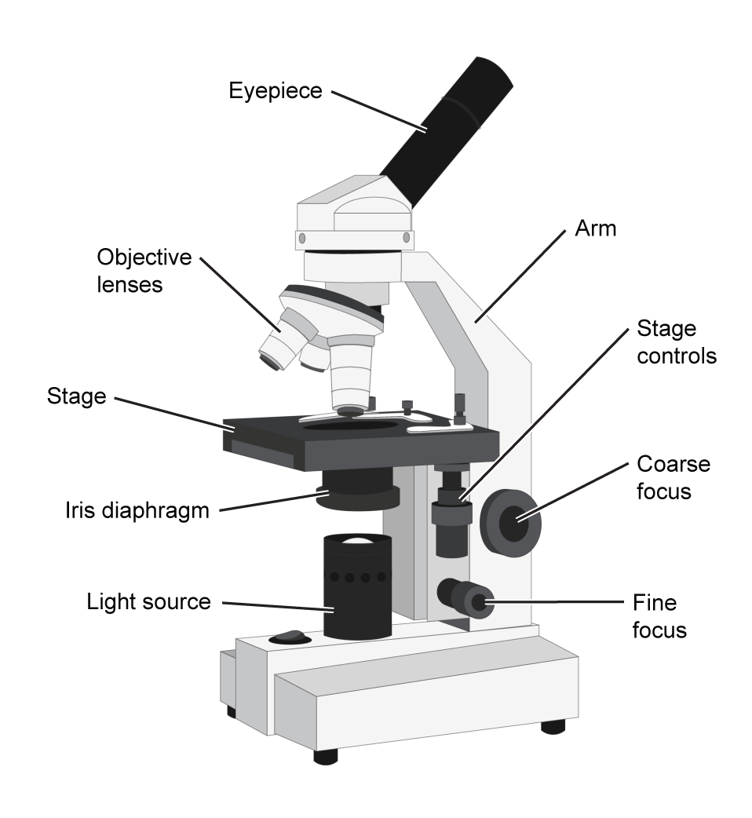

  - Be sure the stage is at the lowest setting.
  - Make sure the lowest-power objective (10X) is rotated into place.
  - Center the newsprint slide on the microscope stage.
  - Look through the eyepiece and use the coarse focus to bring the print into view.
  - Now, use the fine focus to sharpen the image.
  - Switch to the high-power objective (40X) and use the coarse and fine focus knobs to bring the image into view.
  - Check with your teacher to make sure your image is good. Once your teacher has approved your image and you are comfortable using the scope, move on to the next step.

- Examine slides of prokaryotes and eukaryotes.
  - Locate the prokaryote slides Bacillus subtilis and Streptococcus pyogenes. Write the name of each organism in Table A.
  - Return the microscope to the lowest-power objective.
  - Place one prokaryote slide on the microscope stage. Bring the organism into clear view using the coarse and fine focus knobs.
  - Leave the slide in place and rotate to the highest objective. Bring the organism into clear view using the coarse and fine focus knobs.
  - In Table A, sketch and label what you see in the microscope. Label these parts in each cell sketch: the cell membrane, the cytoplasm, and the nucleus (if there is one).
  - Repeat Steps 3b–3e for the other prokaryote slide.
  - Locate the eukaryote slides. Write the name of each organism in Table A.
  - Repeat Steps 3b–3e for each of the two eukaryote slides, Euglena gracilis and Amoeba proteus.

- Compare and contrast the structures of plant and animal cells.
  - Locate the plant cell slides Elodea canadensis and Allium sp. Write the name of each organism in Table B.
  - Return the microscope to the lowest-power objective.
  - Place one plant cell slide on the microscope stage. Bring the organism into clear view using the coarse and fine focus knobs.
  - Leave the slide in place and rotate to the highest objective. Bring the organism into clear view using the coarse and fine focus knobs.
  - In Table B, sketch and label what you see in the microscope. Label these parts in each cell sketch: the cell membrane, the cytoplasm, and the nucleus.
  - Repeat Steps 3b–3e for the other plant cell slide.
  - Locate the animal cell slides, Homo sapiens (skeletal muscle cells) and Homo sapiens (cheek cells). Write the name of each organism in Table B.
  - Repeat Steps 3b–3e for each of the two animal cell slides.

- Characterize each of the organisms you have looked at.
  - Find the names of the organisms in Table C.
  - For each organism, complete the chart by answering these questions.
      - Is the organism unicellular or multicellular?
      - Is the organism prokaryotic or eukaryotic?
      - Is the organism a plant, an animal, or neither?

- Examine slides of unknown organisms.
  - Locate the first unknown slide.
  - Return the microscope to the lowest-power objective.
  - Place the slide on the microscope stage. Bring the organism into clear view using the coarse and fine focus knobs.
  - Leave the slide in place and rotate to the highest objective. Bring the organism into clear view using the coarse and fine focus knobs.
  - In Table D, sketch and label what you see in the microscope. Label these parts in each cell sketch: the cell membrane, the cytoplasm, and the nucleus (if there is one).
  - For this organism, complete the chart by answering these questions.
      - Is the organism unicellular or multicellular?
      - Is the organism prokaryotic or eukaryotic?
      - Is the organism a plant, an animal, or neither?
  - Repeat Steps 6b–6f for the remaining unknown slides.
  - Once you have sketched all of the unknown organisms, show your sketches to your teacher. Your teacher will provide you with the names of the organisms, which you should add to Table D.

- Clean up the lab.
  - Remove the slides from the microscope and clean and store them properly.
  - Clean up your microscope and store it properly according to your teacher’s instructions.

Data
Record your data either in your lab notebook or in the tables below.
Table A
Prokaryotes
Name: | Name:
Eukaryotes
Name: | Name:

Table B
Plant Cells
Name: | Name:
Animal Cells
Name: | Name:

Table C
Name of Organism | Unicellular  or  Multicellular | Prokaryote or Eukaryote | Plant, Animal, or Neither
Bacillus subtilis
Streptococcus pyogenes
Euglena gracilis
Amoeba proteus
Elodea canadensis
Allium sp.
Homo sapiens
(skeletal muscle cells)
Homo sapiens
(cheek cells)

Table D
Sketch | Unicellular  or  Multicellular | Prokaryote or Eukaryote | Plant, Animal, or Neither | Name of Organism
1
2
3
4

Follow-Up Questions
Answer the following questions.
- How are plant and animal cells similar?

- How do plant and animal cells differ?

