Pre-Lab Information
Purpose To use weather data to interpret atmospheric conditions and forecast weather
Time Approximately 60 minutes
Question How do atmospheric conditions influence weather patterns?
Summary In this lab activity, you will create isobars, isotherms, and isodrosotherms on a weather map. You will then use weather station data to analyze current atmospheric conditions, identify fronts and weather patterns, and forecast future weather patterns.

Safety
- Behavior in the lab needs to be purposeful.
- Report all accidents—no matter how big or small—to your teacher.

Lab Procedure
- Gather materials.
- Colored pencils
- Create isobars.
  - Use Map A located in the Data section.
  - Start by connecting the points of highest air pressure. Draw a line to all the points with the same air pressure. Remember, isobars are smooth, rounded lines—not straight, jagged lines.
  - Repeat Step b for each air pressure measurement.
  - Label each isobar with the air pressure measurement.
  - Label the high pressure area on the map in red.
  - Label the low pressure area on the map in blue.
  - Recall the information you learned in the lesson about high and low pressure and weather patterns. Color areas where you expect to see rain or snow purple.
  - Color areas where you expect to see clear skies red.
- Create isotherms.
  - Use Map B in the Data section.
  - Draw a line to connect points of equal temperature. Remember, isotherms are smooth, rounded lines—not straight, jagged lines.
  - Color the areas of lowest temperature blue.
  - Color the areas of highest temperature red.
  - Use a variety of colors to fill in other bands of equal temperature.
- Create isodrosotherms.
  - Use Map C in the Data section.
  - With a purple colored pencil, connect points on the map of equal dew point. Remember, isodrosotherms are smooth, rounded lines—not straight, jagged lines.
  - Recall from the lesson that dew points above 70 degrees often indicate severe weather. With the purple colored pencil, color any areas with a dew point of 70 degrees or higher.
- Locate fronts and forecast weather patterns.
  - Use Map D in the Data section.
  - Label the high pressure area with an H.
  - Label the low pressure area with an L.
  - Recall that fronts occur where there are large changes in temperature, air pressure, and wind speed. Remember that the more fletches, or lines, on a weather symbol indicate higher wind speeds. Using a blue colored pencil, draw and label the cold front on the map.
  - Using a red colored pencil, draw and label the warm front on the map.
  - Use the map to answer the follow-up questions.
- Clean up your area.
  - Return unused materials and dispose of any trash according to your teacher’s directions.

Data
Record your data either in your lab notebook or in the space below.

Map A: Air Pressure
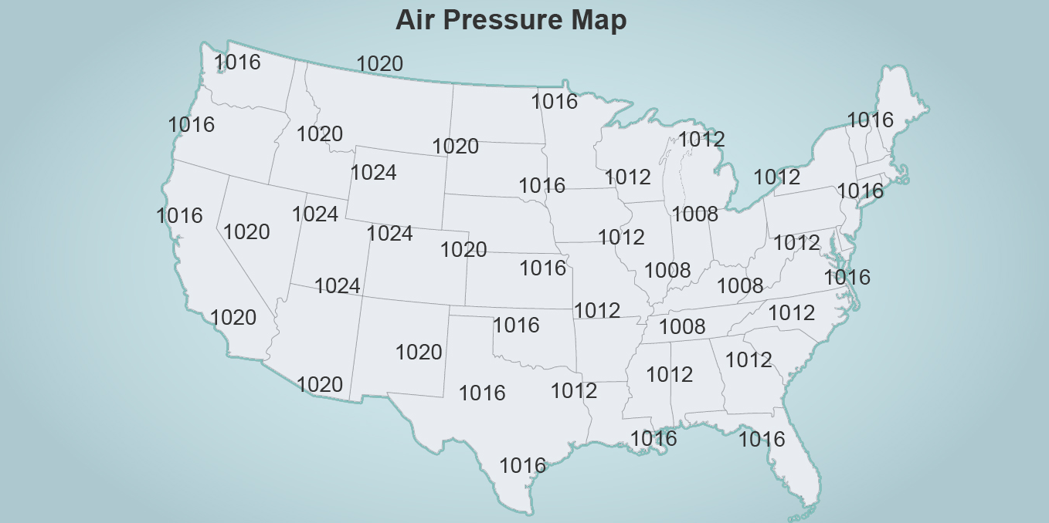

Map B: Air Temperature
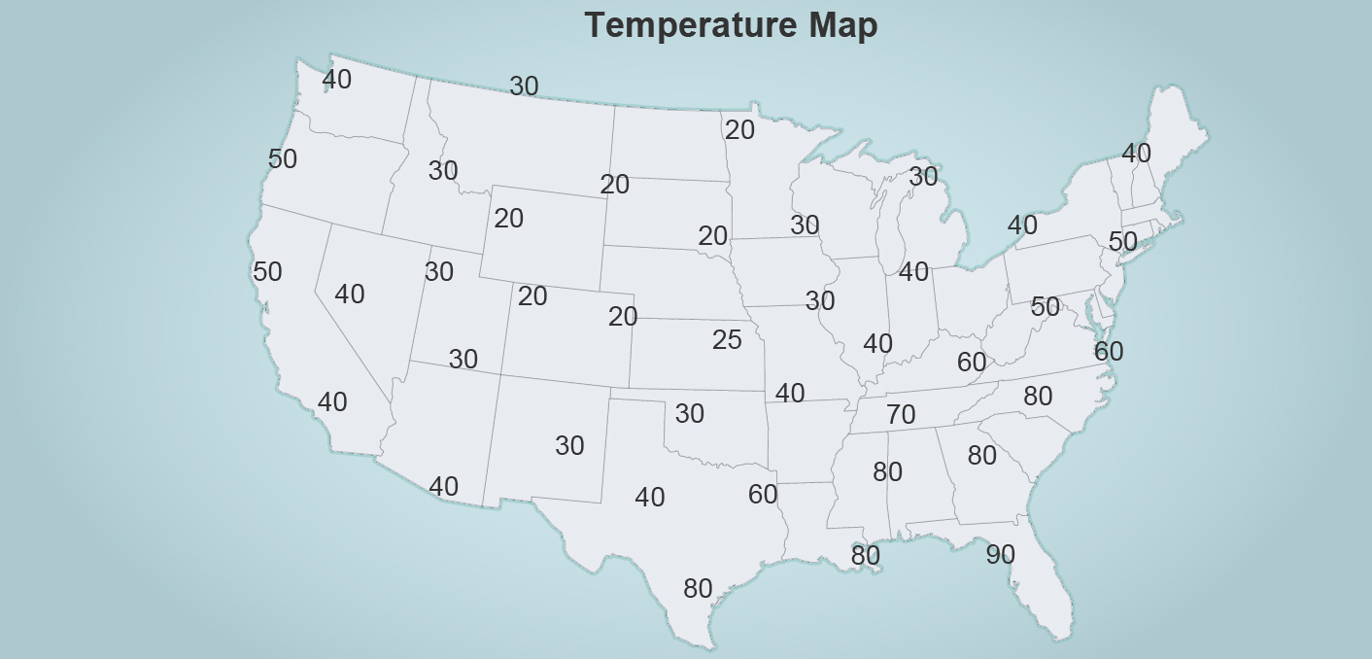

Map C: Dew Point
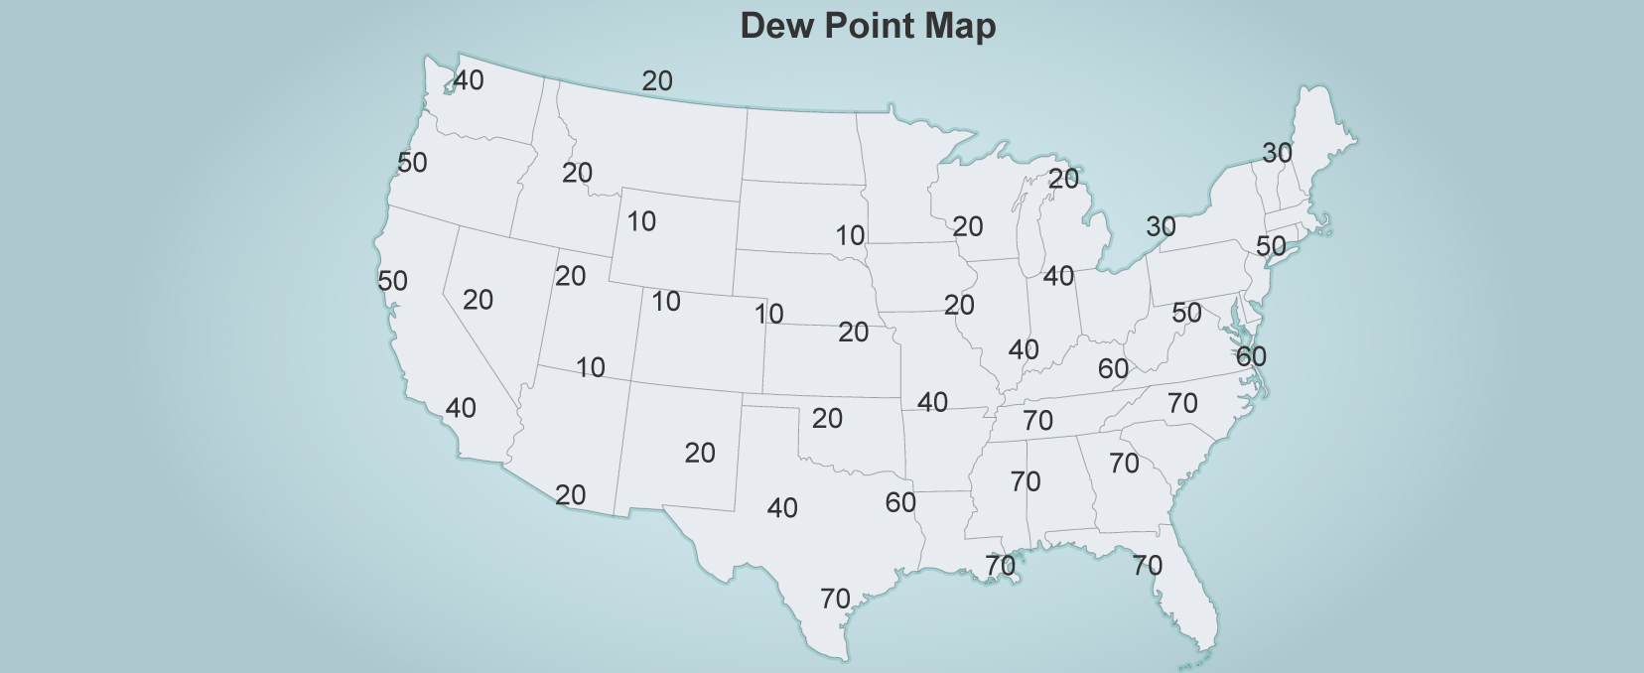

Map D: Weather Station Data
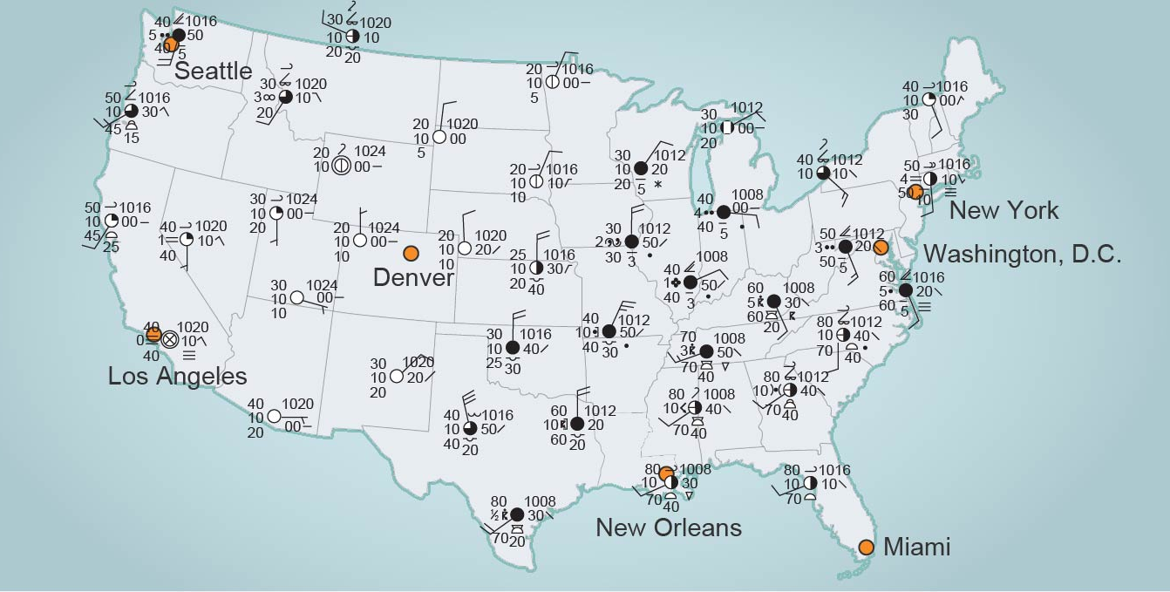

Follow-Up Questions
Answer the following questions.
- What happens to weather patterns when a cold front approaches? What happens to weather patterns when a warm front approaches?

- Explain the connections among air pressure, temperature, humidity, and fronts.

- Review Map D. Predict future weather for New Orleans, LA. What weather might occur there? What is the cause of this weather? Predict the future weather for Washington, DC. What is the cause of this weather?

