# Pre-Lab Information

Purpose Explore the process of thermal energy transfer using a laboratory procedure.

Time Approximately 45 minutes

Question How do mass and type of material affect thermal energy transfer?

Hypothesis #1 Different masses will change temperature at different rates when exposed to the same amount of thermal energy. This is because the amount of mass affects an object’s ability to absorb thermal energy.

Variables *Independent Variable:* mass of the substance

*Dependent Variable:* amount of heat absorbed

*Controlled Factors:* type of substance, initial temperature

Hypothesis #2 Different materials will change temperature at different rates when exposed to the same amount of thermal energy. This is because each substance has its own specific heat.

Variables *Independent Variable:* type of substance

*Dependent Variable:* amount of heat absorbed

*Controlled Factors:* mass, initial temperature

Summary In Part I of the experiment, students will determine how changing the mass of a given material affects thermal energy transfer by observing the amount of heat absorbed, as indicated by a temperature change. Students will also compare how different materials transfer and absorb thermal energy, and provide qualitative observations on their experimental results.

In Part II, students will explore how different materials of the same mass, such as aluminum, steel, and lead, transfer different amounts of thermal energy. Then, the specific heat capacities of these three substances will be calculated and compared, using the equation below.

**

# Safety

* Always wear a lab coat, gloves, and safety goggles when performing an experiment. Wearing gloves is very important when handling metal samples, especially lead if used.
* Behavior in the lab needs to be purposeful. Use caution when heating and cooling substances.
* Use the right gear, such as tongs and thermal mitts, to handle hot objects.
* Check glassware, such as beakers and flasks, for cracks and chips prior to use.
* Report all accidents—no matter how big or small—to your teacher.

# Lab Procedure

|  |  |
| --- | --- |
| * 300 g of dry sand * 300 g of wet sand, drained * Tap water (room temperature) * Utility knife * 9 foam coffee cups (16 oz.) * Mass balance * 3 thermometers * 1 or 2 120W heat lamps * Timer (or clock) * Hot plate | * Pencils * Stir sticks * 500 mL beaker * 1 L beaker * 50 g of aluminum wire * 50 g of steel wire * 50 g of lead pellets * Wire cutters * Tongs * Long-handled strainer or spoon |

1. **Gather materials.**

PART I: Examining the Effect of Material and Mass on Thermal Energy Transfer

1. **Set up samples to examine thermal energy transfer with varying material and mass.**
   1. Trim off the bottom half of three foam cups. Place an empty trimmed cup on the mass balance and tare for zero. Add water to the cup until the total mass reads 200 g. Repeat for the other two cups, filling one with 200 g of wet sand and one with 200 g of dry sand.
   2. Trim three more foam cups to half size. Place an empty trimmed cup on the mass balance and tare for zero. Add water to the cup until the total mass reads 100 g. Repeat for the other two cups, filling one with 100 g of wet sand and one with 100 g of dry sand.
   3. The three material types should be room temperature, but place a thermometer in each cup, allow the reading to stabilize. Record an initial temperature for each type of material in Table A.
   4. Place the cups under the heat lamp(s). If using one heat lamp, put the six cups in a tight circle, each equidistant from the lamp. The lamp bulb should be positioned over the cups at a height of 10 cm from the materials. If using two lamps, place three cups under each.
   5. Turn on your heat lamp(s). Start a timer or note the time on a clock. From this point, let the samples set for approximately 25 minutes. Time can vary slightly as needed to complete other steps of the lab.
   6. Make a hypothesis about which set of sample mass, the 200 g or 100 g, will heat up the fastest. Also make a hypothesis about which type of material will heat up the fastest. Record these guesses in Table A. You may continue with Part II until it is time to check these samples.
2. **Measure the change in temperature for different materials and mass.**
   1. After the time has elapsed, record the actual elapsed time in the Tfinal column in Table A. Remove the three cups that have samples of 100 g. Stir each sample gently to mix them, then place a thermometer in each cup and observe the readings until they do not climb any higher. Record the final temperature value for each cup in Table A.
   2. Repeat Step 3a for the 200 g samples. Record all data in Table A, and calculate the temperature change, ΔT, for each sample. In your observations, include qualitative descriptions of the heat gained by water, wet sand, and dry sand that you have made by touching the materials to assess their thermal energy.

PART II: Examining the Effect of Material Type on Thermal Energy Transfer and Specific Heat

**Be sure to wear protective gloves when handling all metal samples!**

1. **Establish an initial temperature of the metal samples.**
   1. Measure out 500 mL of tap water in the 1 L beaker and bring it to a boil using a hot plate or other heating source.
   2. Measure out approximately 50 g of aluminum wire using a mass balance. Coil the wire slightly to facilitate measurement, if needed, and carefully trim the sample down to 50 g. Record the exact mass in Table B.
   3. Coil the wire around a pencil or other object, or fold the wire tightly to create a more compact mass. Use tongs to carefully place the sample in the hot water bath.
   4. Repeat Steps 4b–c for 50 g of the steel wire.
   5. Measure out approximately 50 g of lead pellets, record the exact mass in Table B, and place the pellets in the strainer. Place the strainer and lead in the hot water bath.
   6. Allow the metal samples to reach thermal equilibrium with the boiling water over the next 5 minutes, while you prepare the calorimeter in the next steps.
2. **Assemble a “coffee cup” calorimeter.**
   1. Place one foam coffee cup inside the other.
   2. With a third cup, trim off the upper ¼ of the cup and discard it. Invert the trimmed cup to make a lid, and check for a snug fit within the other two cups. Punch a small hole in the center of the lid to hold the thermometer. Place the thermometer in the hole, and then remove the lid with the thermometer.

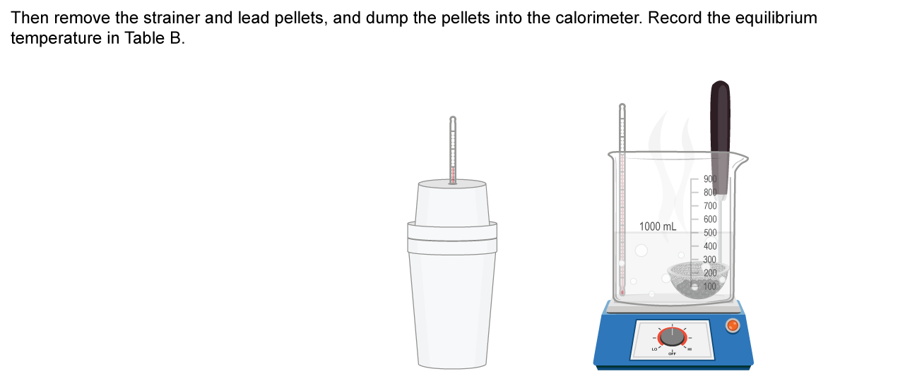

Thermometer

2 stacked foam cups (base)

Partial foam cup, inverted (lid)

Basic coffee cup calorimeter setup

1. **Measure the mass of the water in the calorimeter.**
   1. Place the calorimeter (no lid) on the balance and tare the balance. Using a 500 mL beaker with 300 mL of room temperature, add water to the calorimeter until you read 300 g of mass. Record the exact mass in Table B in the row for aluminum, as this will be the first sample.

1. **Reassemble the calorimeter and position the thermometer.**
   1. Place the lid on the calorimeter, and insert the thermometer. If needed, place the calorimeter into a beaker or other secondary container to prevent wobbling.
   2. Swirl the thermometer slightly, and confirm that the thermometer is well within the water. Allow the temperature to stabilize, and record this initial temperature to the nearest 0.1°C in Table B.
2. **Transfer metal samples to the calorimeter and measure the temperature change.**
   1. Use a thermometer to check the hot water bath temperature, which should be near 100°C if the water bath is boiling. The temperature of the metals should have reached the same temperature. Record this initial temperature for the three metal samples in Table B.
   2. Raise the thermometer and lid off the calorimeter, and carefully transfer the bundle of heated aluminum wire from the hot water to the calorimeter using the tongs. Try to let any excess water drip off the wire sample, but make the transfer quickly so the metal does not begin to cool. Close the lid snugly and make sure the thermometer is immersed in the water.
   3. Observe the increase in temperature every 20 seconds for 3 minutes, or until the bundle of wire and water reach an equilibrium temperature (the water temperature stops increasing). Record the equilibrium temperature in Table B.
   4. Remove the aluminum wire sample and empty the calorimeter. Repeat Steps 6–8d for the bundle of steel wire.
   5. Remove the steel wire sample and empty the calorimeter. Repeat Steps 6–8d for the lead pellets, and briefly allow the excess water to drain from the pellets and strainer before dumping the sample into the calorimeter.
3. **Compute the** s**pecific heat of each type of metal.**
   1. Using your data in Table B, calculate ***∆Twater*** and ***∆Tmetal***, using ***Teq*** and ***Ti*** for each metal and the calorimeter water.
   2. Use your data, the equation below, and the specific heat of water (4.184 J/g°C) to compute the specific heat values of each type of metal sample. Use a calculator, and round to the nearest hundredth place.

**

When solving for the specific heat of each metal ($c_{metal}$), $c_{water}$ is the specific heat of water, $m_{water}$ is the mass of the water in the cup, and $∆T_{water}$ is the increase in temperature of the water; whereas $m_{metal}$ refers to the mass of the metal and $∆T_{metal}$ is the decrease in temperature of the metal.

* 1. Table C lists some known reference values for the specific heat of various materials. How do your determined values compare? What factors could cause them to differ? Keep these questions in mind when you start to write your lab report.

1. **Check for errors.**
   1. Now that you have calculated specific heat values for the metals, see how far off the values are from known values. Use data from Tables B and C to calculate the error, as a percent, for each metal sample. Use the formula:

% Error $=100\% \frac{(calculated - known )}{known }$

where $calculated$ is your value from Table B, and $known$ is the value from Table C. Report the error for each metal as a percent, next to the known value in Table C.

1. **Dispose of all materials according to your teacher’s directions.**

# Data

Record your data either in your lab notebook or in the space below.

**Table A: The Effect of Mass or Material Type on Thermal Energy Transfer**

|  |  |  |  |  |
| --- | --- | --- | --- | --- |
| **Material** | **Mass**  **(g)** | **Tinitial**  **0 min** | **Tfinal**  **_____ min** | **∆T** |
| Water | 200 |  |  |  |
| Water | 100 |  |  |  |
| Wet sand | 200 |  |  |  |
| Wet sand | 100 |  |  |  |
| Dry sand | 200 |  |  |  |
| Dry sand | 100 |  |  |  |
| Which samples will heat up faster? circle one  100 g (least massive) 200 g (most massive) No Difference  Explain your reasoning: | | | | | |
| Which samples will heat up faster? circle one  Water Wet Sand Dry Sand No Difference  Explain your reasoning: | | | | | |

**Table B: Calculation of Specific Heat**

|  |  |  |  |  |  |  |  |  |  |
| --- | --- | --- | --- | --- | --- | --- | --- | --- | --- |
| **Material** | **Mass of Metal**  **(g)** | **Mass of Water**  **(g)** | **Ti(Metal)**  **(oC)** | **Ti(Water)**  **(oC)** | **Teq**  **(oC)** | **∆Twater**  **(Teq–Ti(water))**  **(oC)** | **∆Tmetal**  **(Teq–Ti(metal))**  **(oC)** | **Cwater**  **J/g°C** | **Cmetal**  **J/g°C** |
| Aluminum wire |  |  |  |  |  |  |  | 4.18 |  |
| Steel wire |  |  |  |  |  |  |  | 4.18 |  |
| Lead pellets |  |  |  |  |  |  |  | 4.18 |  |

**

**Table C: Known Specific Heat Values for Common Materials**

|  |  |  |
| --- | --- | --- |
| **Material** | **Specific Heat**  **(J/g*C)** | **% Error**  **(deviation from known)** |
| Water | 4.18 |  |
| Concrete | 0.88 |  |
| Wood | 1.80 |  |
| Aluminum | 0.90 |  |
| Glass | 0.84 |  |
| Sand | 0.83 |  |
| Steel | 0.49 |  |
| Iron | 0.44 |  |
| Copper | 0.38 |  |
| Lead | 0.16 |  |
| Gold | 0.13 |  |