Pre-Lab Information
Purpose To understand how relative dating and absolute dating are used to determine the age of rock layers
Time Approximately 60 minutes
Question How are relative and absolute dating methods used to determine the age of rocks and fossils?
Summary In this lab, you will examine examples of rock outcrops and determine the relative age of each layer, including the use of cross-cutting intrusions and index fossils. Then, you will model radioactive decay by using pennies. Finally, you will graph your results.

Safety
- Behavior in the lab needs to be purposeful.
- Report all accidents—no matter how big or small—to your teacher.

Lab Procedure
- Gather materials.
- Colored pencils
- 100 pennies
- Box or container with lid
- Construct a geologic history of a region by determining the relative age of rock layers in different locations.
  - Examine the sample rock outcrops that follow and the key that accompanies the sample.
  - Remember that similar rock layers in different locations would be the same age.
  - Use the law of superposition to reconstruct the sequence of rock layers with the oldest layer at the bottom and the youngest at the top. Use colored pencils to draw in the appropriate layers in Table A in the Data section.
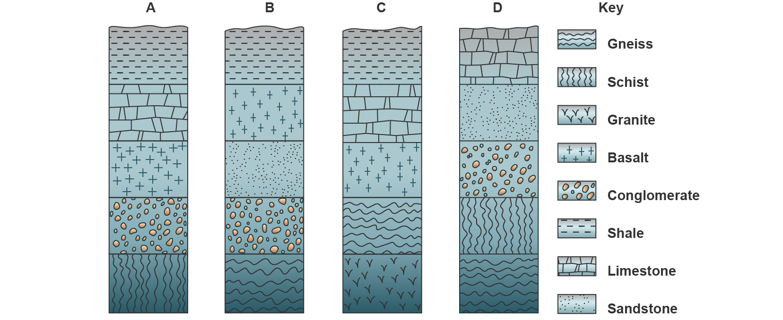

- Construct a geologic history of a region using index fossils.
  - Examine the sample rock outcrops with index fossils that follow and the key that accompanies the sample.
  - Use the index fossils to determine the proper relative age of the three rock columns.
  - Reconstruct the sequence of rock layers with the oldest layer at the bottom and the youngest layer at the top. Use colored pencils to draw the appropriate layers in Table B in the Data section. Include the index fossils in your drawings.
  - Use the index fossils to identify the geologic age during which certain layers formed.
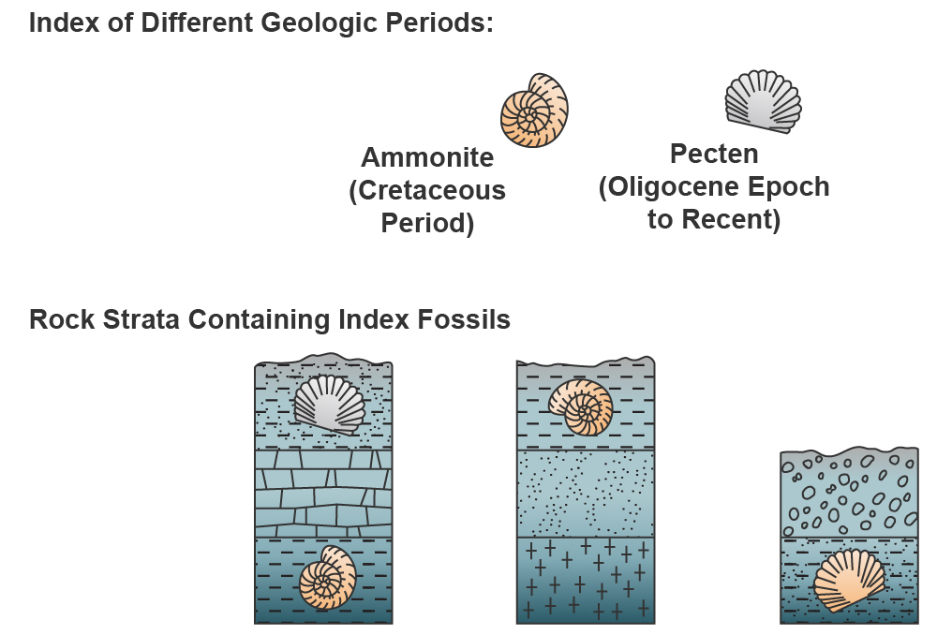
- Determine the relative age of each layer of a sample outcrop.
  - Examine the sample outcrop below.
  - Recall the definitions of cross-cutting and rock intrusion.
  - Record the rock layers from oldest to youngest in Table C in the Data section by writing the letter of each rock layer.

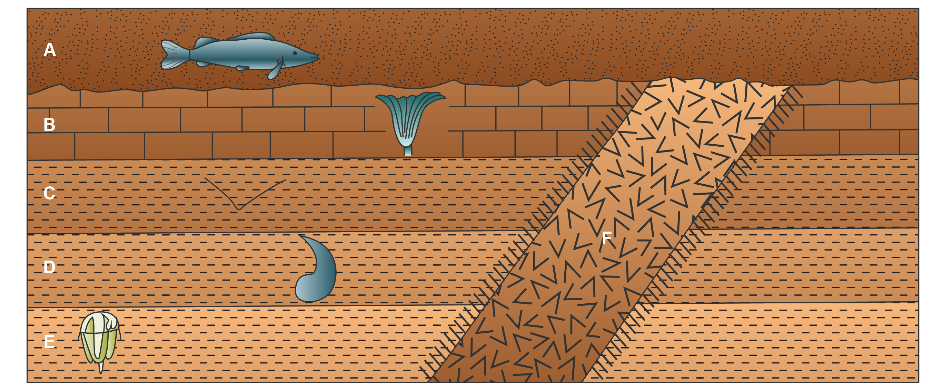

- Model Radioactive Decay
  - Place 100 pennies in a box.
  - Gently shake the box.
  - Remove the lid and dump the pennies on your desk. Be careful that no pennies fall on the floor.
  - Remove all the pennies that have the “heads” side facing up.
  - Record the number of pennies remaining after each shake in Table D in the Data section.
  - Repeat steps b, c, d, and e for 10 shakes or until no more pennies remain.
- Graph and Analyze the Data
  - Use Table E in the Data section to graph the results recorded in Table D.
- Clean up your area.
  - Return unused materials and dispose of any trash according to your teacher’s directions.

Data
Record your observations and data either in your lab notebook or in the space below.
Table A: Rock Layer Relative Age
Rock Layer Drawing (oldest at the bottom)

Table B: Rock Layer Relative Age with Index Fossils
Rock Layer Drawing | Geologic Age

Table C: Relative Dating with Intrusions
Rock Layer Label (oldest at the top)

Table D: Radioactive Decay Model
Shake | Number of Pennies Remaining
0 | 100
1
2
3
4
5
6
7
8
9
10

Table E: Graph of Radioactive Decay Model
Directions: Graph the results recorded in Table D in the following graph.

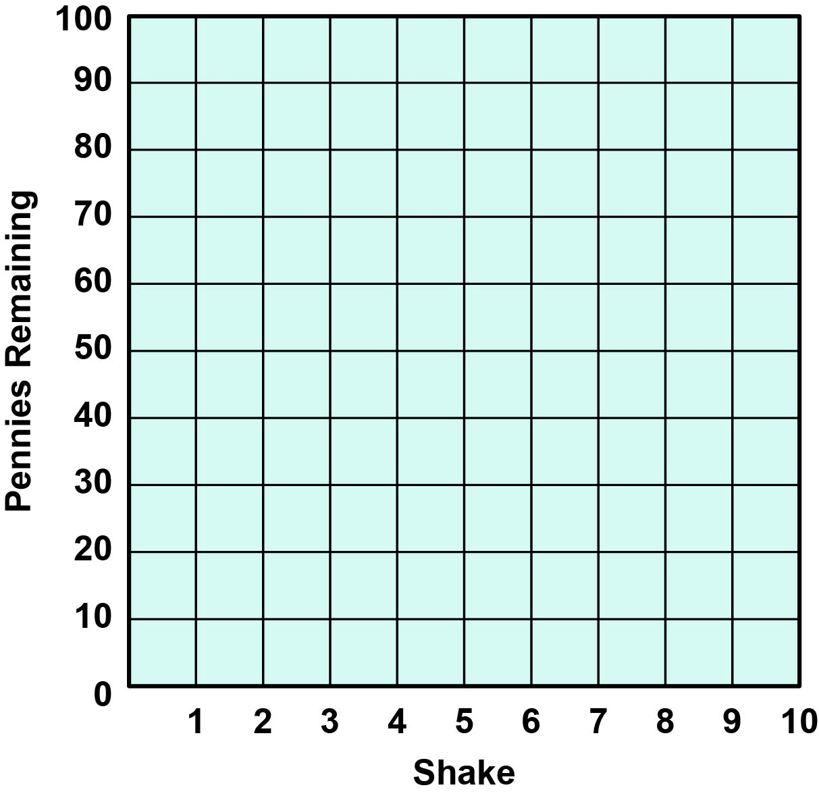

Follow-Up Questions
Answer the following questions:
- Review your drawings of different rock layers. How were you able to determine the proper relative ages of rock layers? How did using index fossils help determine relative age?

- Compare the penny activity to radioactive decay. In your model, what do the pennies represent? What does each shake of the box represent?

- Compare and contrast relative and absolute dating. How are they similar? How are they different? How is each useful in determining the age of rock layers?

