Pre-Lab Information
Purpose Experimentally observe how magnet polarity affects induced current in a wire loop.
Time Approximately 35 minutes
Question How does magnet polarity affect the current flowing in a loop of wire?
Hypothesis If the polarity of a moving magnet is reversed, then the current induced in a loop of wire will reverse in direction, because magnet polarity determines the direction of the electromagnetic force.
Variables: Independent Variable: magnet polarity
Dependent Variable: induced current
Constants: number of coil turns, magnet strength
Summary Faraday’s experiments in the early 1800s provided fundamental insights into the nature of electromagnetism. By moving a magnet near or through a coil of wire, he was able to demonstrate that a moving magnetic field produced a current in the wire. The process that produces a current by using a moving magnet is known as electromagnetic induction.

In this experiment, you will study electromagnetic induction in a wire coil by manipulating magnet polarity and observing changes in the current produced. This is very similar to the types of experiments that Faraday carried out more than two hundred years ago. The current produced will be assessed by using a galvanometer. Besides recording quantitative data in terms of the current produced, you will also record qualitative data in the form of observations regarding current changes.

Safety
- Always wear safety goggles when performing an experiment, especially with objects in motion.
- Make sure you understand the proper use and assembly (if necessary) of the electromagnetic induction components.
- Use caution when assembling and adjusting the components. Wire connectors may have sharp edges, and magnets should not be placed near computers or other electronic devices where magnetic interference can cause problems.
- A galvanometer is a delicate instrument; avoid dropping or jarring the instrument to ensure that it functions properly.
- Behavior in the lab needs to be purposeful.
- Report all accidents—no matter how big or small—to your teacher.

Lab Procedure
- Gather materials.
- Faraday’s Magnetic Field Induction Experiment Kit

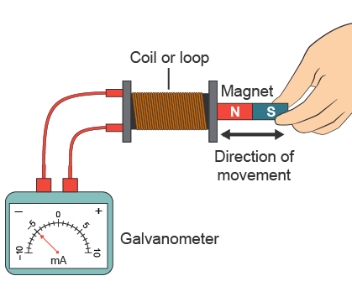
- Set up the electromagnetic induction apparatus.
  - Place the electromagnetic induction apparatus on the tabletop. The basic components should include a galvanometer, wire connectors, an induction coil, and a magnet with the north and south poles marked.
  - Connect the coil to the galvanometer using the wire connectors. Refer to your specific kit instructions or teacher guidance for proper connection.
  - Set the bar magnet to the side of the apparatus. You may have a wand-like device that attaches to the magnet as part of your kit. This provides an extension that makes inserting the magnet into the coil easier.
  - Make sure all wires are clear of the induction coil so that it is easily accessible for the magnet.
- Measure current induction using normal magnet polarity.
  - Position the magnet above the coil, and slowly move the magnet toward and into the coil, north end first, until the magnet is fully inserted in the coil. If the current did not register on the galvanometer, withdraw the magnet and repeat the forward movement, increasing the speed slightly, until you can see the galvanometer needle move enough to register a current.
  - Using the same forward magnet speed, repeat the movement, consistently using the same speed each time. Determine the maximum current value on the galvanometer. Record this value in Table A, in milliamps (mA).
  - What direction is the current that is induced in the coil with forward magnet movement? If the galvanometer needle moves left, record a negative (–) for current direction in Table A. If the needle moves to the right, record a positive (+) for direction.
  - Now repeat the steps above, but start with the magnet inside the coil. Withdraw the magnet at the same speed you used for the forward direction. Repeat this several times until you get a consistent reading on your galvanometer.
  - What is the maximum current produced under reverse magnet movement? Which direction of induced current is indicated by the galvanometer needle, positive or negative? Record your observations in Table A.
- Measure current induction using reversed magnet polarity.
  - Reverse the magnet polarity. Turn the magnet to position the opposite, south end (S), for interaction with the coil. If you are using an extension for the magnet, make sure the S end is pointing away from the wand.
  - Now you will repeat Step 4, using the reversed polarity magnet. Be sure to record all data in Table A.
  - Compare the data you have collected using normal and reversed magnet polarity. What differences can you see in maximum current and current direction between the normal and reversed magnet trials? Can you spot any trends? Record your observations in Table B.
- Clean up the lab.
  - Put away the Faraday electromagnetic induction apparatus and the magnet, as directed by your teacher.

Data
Record data either in your lab notebook or in the tables below.
Table A

 | Magnet Polarity Normal (N) |  | Magnet Polarity Reversed (S)
Direction of Movement | Maximum Current  (mA) | Current Direction  (+ or –) | Maximum Current  (mA) | Current Direction  (+ or –)
Forward
Reverse

Table B
Comparing the Data between Normal and Reversed Magnet Polarity

