Pre-Lab Information
Purpose To understand the methods of classification of rocks and minerals, as well as how rock formation affects classification
Time Approximately 45 minutes
Question How are minerals and rocks classified?
Summary You will utilize a hand lens and streak plate to examine unknown minerals and rocks. Next, you will compare their recorded observations to an identification chart to identify each mineral. Finally, you will use the flowchart provided to identify the unknown rocks.

Safety
- Behavior in the lab needs to be purposeful.
- Use caution when scratching minerals. Always scratch the mineral with the object moving away from your body.
- Report all accidents—no matter how big or small—to your teacher.

Lab Procedure
Step 1: Gather materials.
Mineral Identification  - Hand lens  - Streak plate  - 10 mineral samples | Rock Identification  - Hand lens  - Igneous, metamorphic, and sedimentary rock samples
Step 2: Prepare for the project.
- Read through this guide before you begin so you know the expectations for this project.
- If there is anything that is not clear to you, be sure to ask your teacher.

Step 3: Classify minerals based on their observable properties. Record your data in Table A.
- Determine the streak of each mineral by gently dragging it across the streak plate. Observe the color of the streak left on the plate.
  - If a mineral is harder than the streak plate, it will not produce a streak.
- Record the color of each mineral.
- Determine whether each mineral has cleavage or shows fracture.
- Determine the luster (shiny or dull) of each mineral.
- Determine the relative hardness of each mineral.
  - Find the relative hardness by scratching each mineral with other minerals. If one mineral scratches another, the first mineral is harder.
- Compare your observations in Table A to the Mineral Identification Chart to determine the name of each mineral.
Step 4: Complete the Rock Identification Flow Chart to classify rocks.
- Read question number 1. Answer Yes or No based on your observations.
- After the words Yes and No, you will find directions to proceed to the next question.
- Continue working through the questions in this way until you come to a statement that allows you to classify your rock sample.
- Follow steps a through c for all of the rock samples.
Step 5: Clean up your area.
  - Return unused materials and dispose of any trash according to your teacher’s directions.

Data
Record your data either in your lab notebook or in the space below.

Table A
Mineral # | Streak | Color | Relative Hardness  (1–10) | Cleavage or Fracture | Luster  (shiny or dull) | Mineral Name
1
2
3
4
5
6
7
8
9
10

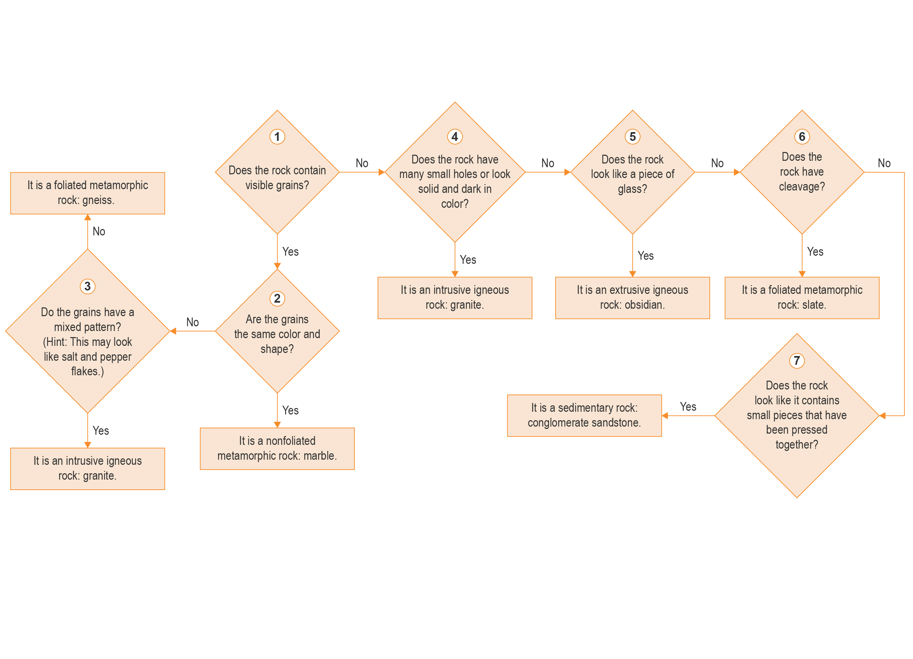
Rock Identification Flowchart

Mineral Identification Chart

Cleavage or fracture | Streak | Color | Relative hardness (1–10) | Luster  (shiny or dull) | Name of mineral
Cleavage | Yellow or brown | Yellow, brown, or black | 5 | Shiny or dull | Goethite
Cleavage | White, yellow, or brown | White, red, yellow, brown, green, or black | 4 | Dull | Sphalerite
Cleavage | White or gray | Dark green, dark brown, or black | 3 | Dull | Biotite
Cleavage | Black | Black, silver, or gray | 1 | Shiny, sometimes dull | Graphite
Fracture | Brown to black | Brassy yellow | 6 | Shiny | Pyrite
Fracture | Reddish brown | Red-brown, black, or silver | 6 | Shiny or dull | Hematite
Fracture | Black | Black or silver | 6 | Shiny or dull | Magnetite
Fracture | Black or dark gray | Brownish, reddish, bronze, or yellow | 4 | Shiny | Pyrrhotite
Fracture | Greenish black | Brassy yellow | 4 | Shiny | Chalcopyrite
Fracture | Dark gray or black | Black with iridescent colors | 3 | Shiny | Bornite

Follow-Up Questions
Answer the following questions:
- How are graphite and pyrite similar? How do they differ? Explain.

- If you were trying to classify a rock sample that has distinct bands, what type of rock might this be? What if you were classifying a sample that contains pebbles? What type of rock might this be? Explain why.

- When classifying igneous rocks, how do you determine between the two types? Explain why these are different.

