Pre-Lab Information
Purpose Conduct an investigation to explore how owl pellets are used to study ecology.
Time Approximately 45 minutes
Question How are owl pellets used to study ecology?
Summary You will examine an owl pellet to identify the owl’s prey. First, you will use tools to carefully pick bones out of the owl pellet. Then you will use a bone chart to identify the animals the bones came from.

Safety
- Behavior in the lab needs to be purposeful.
- Use caution when handling dissecting needles and forceps.
- Wear gloves and goggles throughout this dissection.
- Treat all animal material with respect.
- Wash hands after completing the lab.
- Report all accidents—no matter how big or small—to your teacher.

Lab Procedure
- Gather Materials
- Owl pellet  - Gloves  - Dissecting tray  - Goggles | - Hand lens  - Metric ruler  - Scale | - Forceps  - Dissecting needle  - Bone chart
- Unwrap the owl pellet.
  - Carefully unwrap the foil around the owl pellet.
  - Place the owl pellet on a dissecting tray.
- Observe and measure the owl pellet.
  - Measure the length of the owl pellet in centimeters and record it in Table A.
  - Measure the width of the owl pellet in centimeters and record it in Table A.
  - Obtain the mass of the owl pellet in grams and record it in Table A.
  - Record any other observations, such as color or the presence of feathers or fur, in Table A.
- Pick bones out of the owl pellet.
  - Use a dissecting needle to loosen the bones from the fur and/or feathers.
  - Use forceps to pull bones from the pellet.
  - Use forceps and a dissecting needle to clean material from the bones.
  - Rub small clumps of the pellet between your fingers to be certain all bones are removed.
- Identify bones.
  - Separate the bones by type.
  - Use Figure A to identify the types of prey (rodent, shrew, etc.) in the owl pellet.
  - Record the number of each type of bone in Table B.
  - Record the name and the number of each type of prey in Table C.
- Clean up your area.
  - Dispose of all materials according to your teacher’s directions.

Figure A
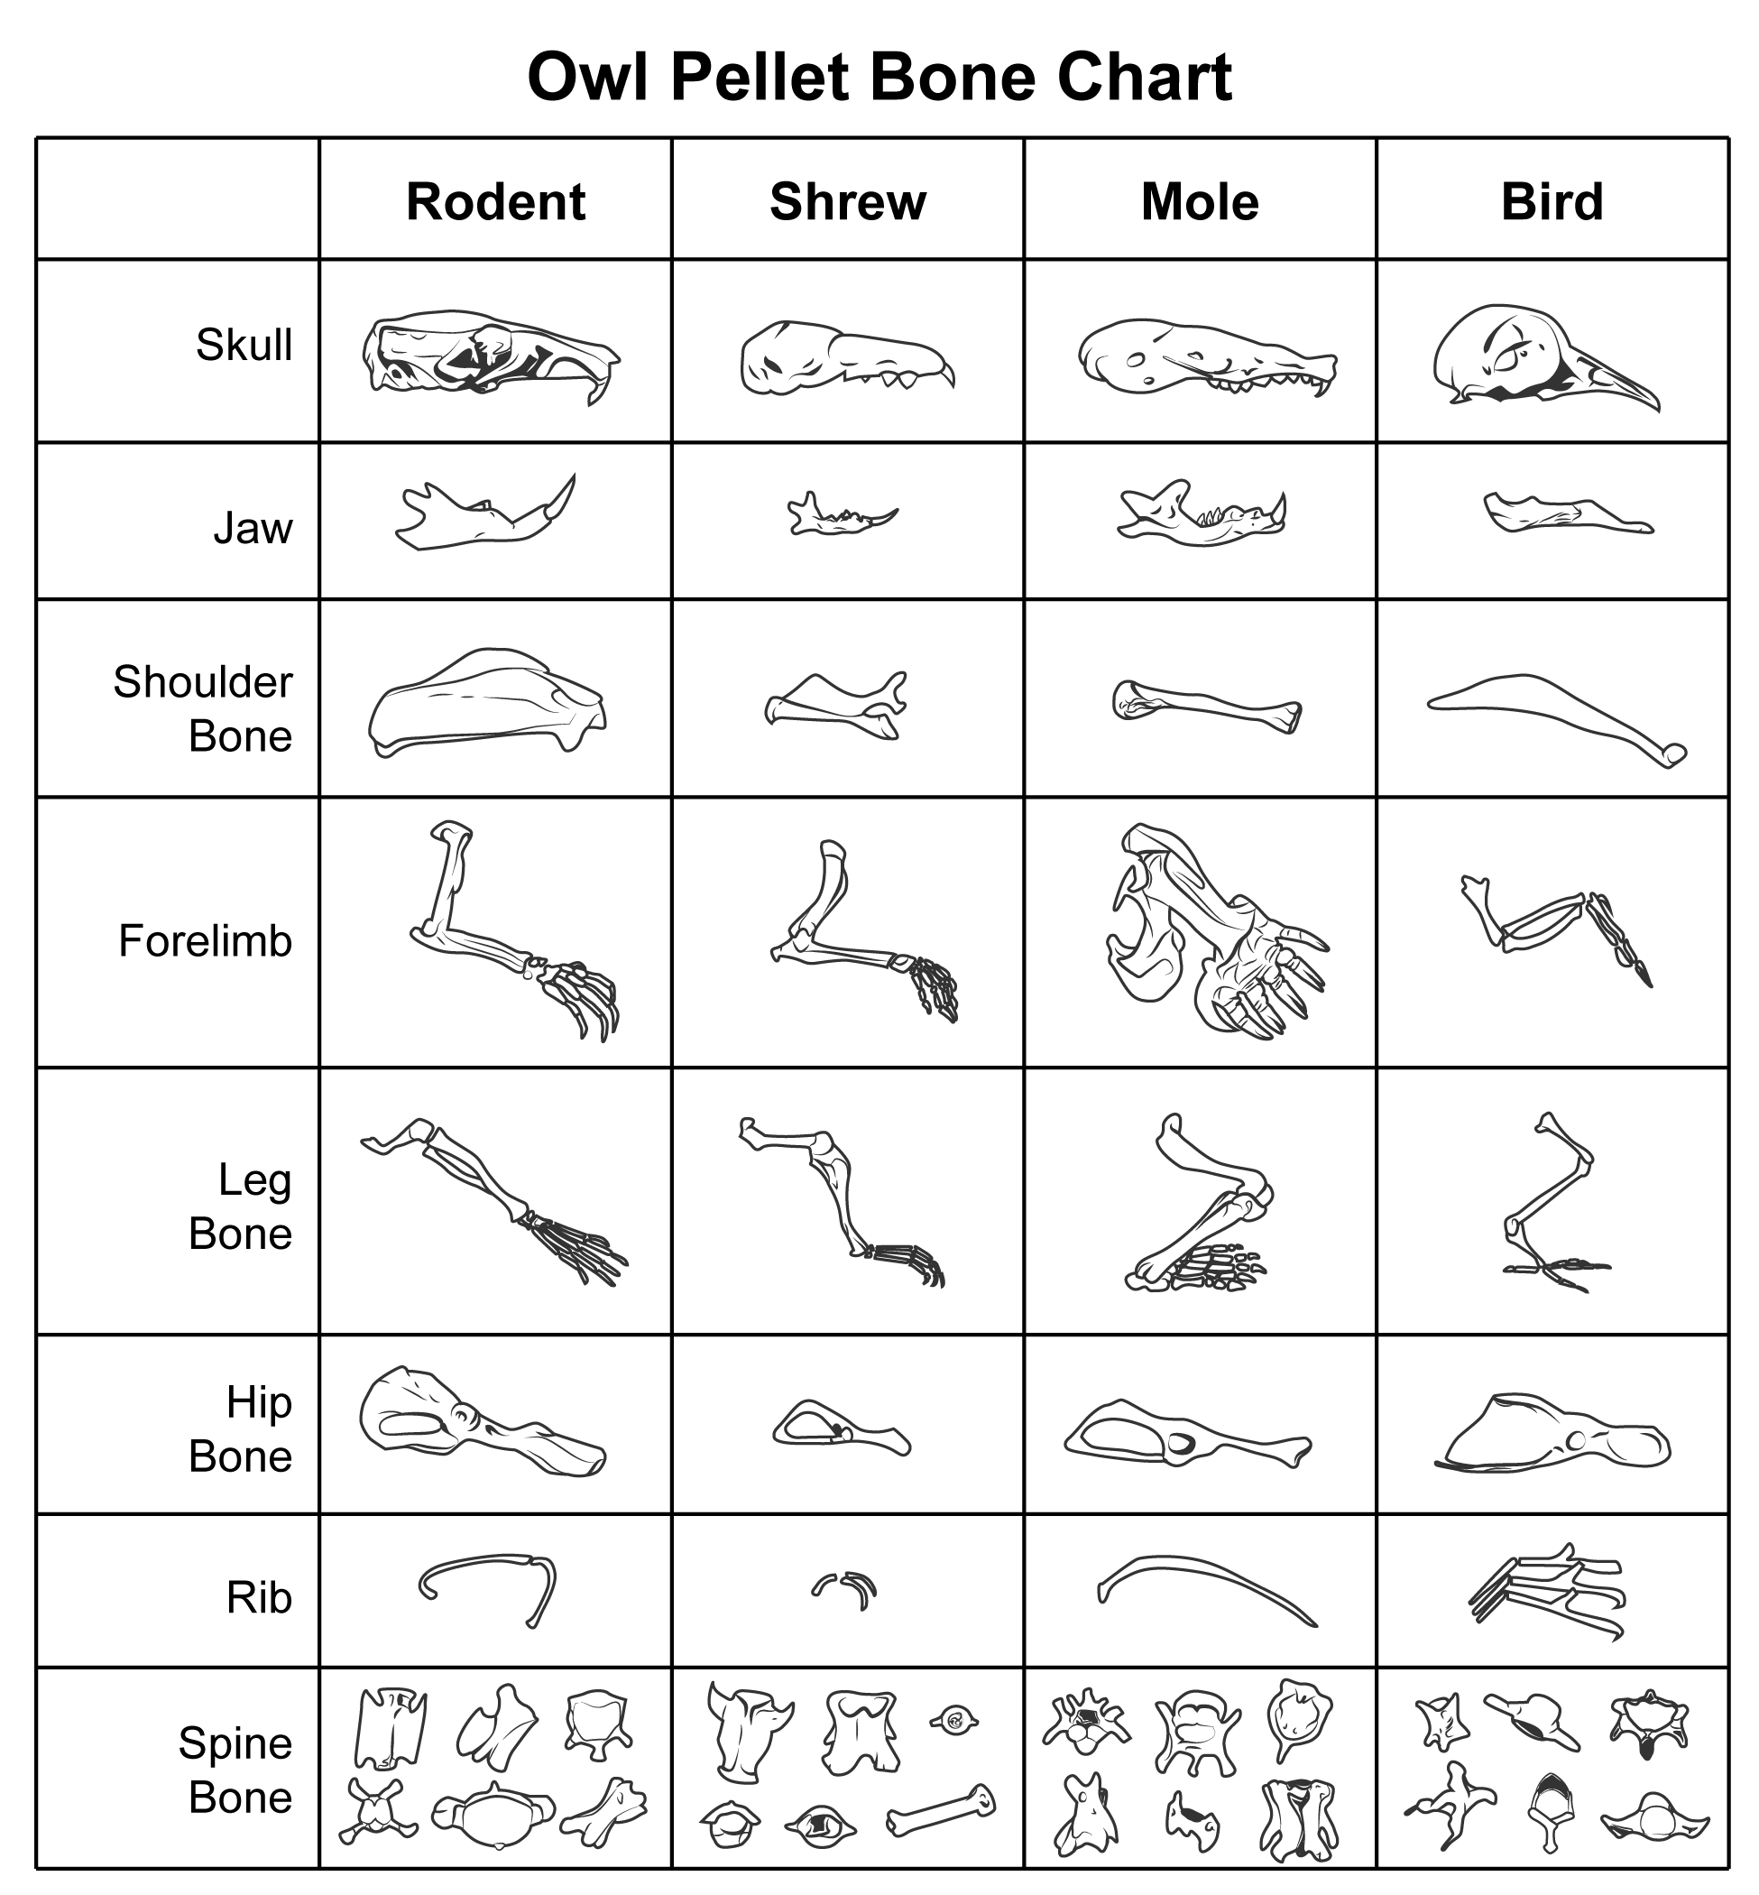

Data
Record your data either in your lab notebook or in the space below.
Table A
Length (cm) | Width (cm) | Mass  (g) | Observations

Table B
Skulls | Jaws | Shoulder Bones | Forelimbs | Leg Bones | Hip Bones | Ribs | Spine Bones

Table C
Type of Prey | Number of Individuals

Follow-Up Questions
Answer the following questions:
- If an owl produces two pellets every 24 hours and each pellet contains the remains of 3 prey, how much does it eat in a week? A month?

- Convert the mass of the pellet from grams to milligrams.

- Convert the length of the pellet from centimeters to millimeters.

