Pre-Lab Information
Purpose Experimentally determine how the variables in an electric circuit are related by Ohm’s law using a laboratory procedure.
Time Approximately 45 minutes
Question How do changes in voltage or resistance affect current in an electric circuit?
Hypothesis #1: If voltage in a circuit is increased under constant resistance, then current must increase because voltage and current are directly proportional.
Variables: Independent Variable: voltage
Dependent Variable: current
Constant: resistance
Hypothesis #2: If resistance in a circuit is increased under constant voltage, then current must decrease because resistance and current are inversely proportional.
Variables: Independent Variable: resistance
Dependent Variable: current
Constant: voltage
Summary Ohm’s law predicts that the voltage, current, and resistance of a circuit are related in that the total voltage of the circuit is equivalent to the product of the current and the resistance of that circuit. Ohm’s law can be written as
V = IR
where V is the voltage, I represents current, and R is resistance. The unit of current is the ampere (A). The unit of resistance is the ohm (Ω), which is equivalent to one volt per ampere. Every electric device has inherent resistance to the flow of current.
It is often necessary to rearrange this expression to solve for current or resistance, which gives us these variations:
I = V/R R = V/I
These formulas allow us to understand that while voltage has a directly proportional relationship to current and resistance, current and resistance have an inverse relationship to each other. In this lab, you will build circuits to examine these specific relationships. The lab experiments you will perform today include these objectives:
- Construct functional series and parallel circuits.
- Use Ohm’s law to calculate current, voltage, and resistance.
- Calculate the power used by elements in a circuit.

Safety
- Always wear a lab coat and safety goggles when performing an experiment.
- Make sure you read the directions for building the circuits before actually building them. If you have any questions about connecting components properly, be sure to ask your instructor.
- Make sure the circuit is off while you are building the circuit and modifying connections, as well as at the end of your experiment.
- Use caution when connecting wires and devices within a circuit. Overloading, or short circuiting, an electric circuit could lead to electric shock.
- Behavior in the lab needs to be purposeful.
- Report all accidents—no matter how big or small—to your teacher.

Lab Procedure
- Gather materials.
- 8 test leads (wire segments, 24 gauge) with clips  - 4 AA batteries  - One 9V battery  - Battery holder (optional) | - 3 flashlight bulbs in holders  - 1 on/off switch  - Tape to secure connections  - Ammeter/multimeter | - 10 Ω resistor  - Three 20 Ω resistors  - 47 Ω resistor  - 100 Ω resistor  - 200 Ω resistor

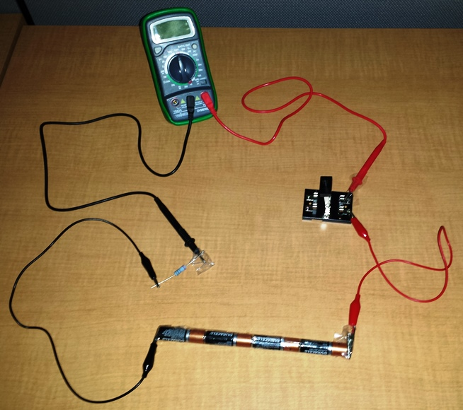
Figure 1: Simple series circuit
- Examine current as voltage changes using a series circuit.
  - Create a series circuit as shown in Figure 1. Make sure the on/off switch is in the off position. With one battery, this will be a 1.5 V circuit. Use a 47 Ω resistor in the circuit and place an ammeter in the circuit.
  - Use Ohm’s law to calculate the theoretical current expected for the following voltages: 1.5, 3.0, 4.5, 6.0, and 9.0 V. Record your results in Table A.
  - If using a multimeter, set the functionality to ammeter (check with your instructor on the proper setting for your instrument), so that you may measure current flow in milliamps.
  - Click the switch on your circuit to turn it on. Check the reading of the ammeter, and record the current in Table A. Most of your readings will be in milliamps, but convert and record the current in amps.
  - Turn your circuit off using the switch. Place a second battery in the battery holder to achieve 3.0 V total. Turn on the current and record the current in amps in Table A.
  - Repeat Step 2e to test current with three batteries (4.5 V total) and four batteries (6.0 V total). Also test the circuit using the single 9 V battery in place of the AA batteries. Record all results in Table A, and then switch off the circuit.

- Examine current as resistance changes using a series circuit.
  - Examine the effect of changing resistance in the circuit. First, use Ohm’s law to calculate the theoretical current expected with a voltage of 6.0 V, using each of the five available resistors (10, 20, 47, 100, and 200 Ω). Record your calculations in Table B.
  - Since you already have the 20 Ω resistor connected, turn the circuit on and verify the current measurement at 6.0 V, which you tested in Step 2.
  - Turn the circuit off, and switch the resistor to the 10 Ω resistor. Record the actual current using the 10 Ω resistor in Table B.
  - Repeat Step 3c to test the other resistors, 47, 100, and 200 Ω. Record all results in Table B, and switch off the circuit.

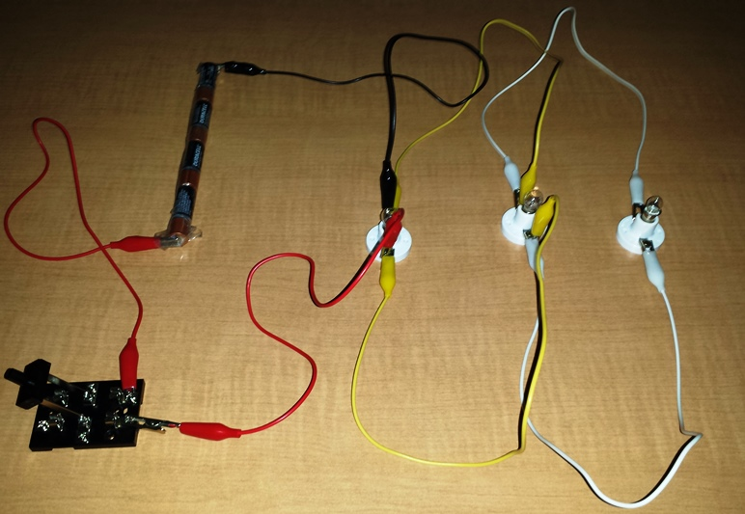
Figure 2: Basic parallel circuit

- Examine current in a parallel circuit by varying voltage and resistance.
  - Now construct a parallel circuit to examine the effects on current. An example parallel circuit is shown in Figure 2. For now, build the circuit using three 20 Ω resistors in place of the lightbulbs.
  - Calculate the total resistance in the circuit. Total resistance in a parallel circuit can be calculated as
1/R = 1/R₁ + 1/R₂ + …

where R₁, R₂, etc. are the resistances of each component. Record the total resistance in Table C.
  - Use the total resistance and voltage to calculate the expected current. Record the calculated current in Table C.
  - Use the switch to turn on the circuit. Use the ammeter at different points along the circuit to test the current. You can do this by connecting the ammeter in the circuit in place of a test lead (wire segment). Record your observations in Table C. Turn off the circuit.
  - Calculate the total resistance if one of the resistors is switched to 200 Ω, and record it in Table C.
  - Use the total resistance and voltage to calculate the expected current. Record it in Table C.
  - Replace one of the 20 Ω resistors with a 200 Ω resistor. Switch the circuit on, and use the ammeter to record the observed current in Table C. Turn the circuit off.
  - To achieve a current of 1.0 A while using the 20, 20 and 200 Ω resistors, what does the voltage need to be? Use Ohm’s law to calculate this new voltage and record it in Table C.
  - Alter the number of batteries to adjust the voltage. Test your calculation by turning the circuit on and observing current using the ammeter. Does the change in voltage achieve the desired current? Record your results in Table C.

- Calculate power used by components in a circuit.
  - Switch off the circuit and replace the resistors with light bulbs as shown in Figure 2. Adjust the number of batteries to achieve a total voltage of 6.0 V.
  - Switch on the circuit and record the current in Table D. Use the ammeter to test the current flowing through each light bulb and record the value in Table D.
  - Calculate the power used by an individual bulb in the circuit. Power can be calculated by the formula
P = IV

where P is power in watts, I is current in amps, and V is voltage. Record the power in watts for a single bulb in the circuit in Table D.
- Clean up the lab area.
  - Make sure the circuit is switched off.
  - Disconnect all circuit components.
  - Return materials to their proper places.

Data
Record your data either in your lab notebook or in the tables below.
Table A
Measuring Current as a Function of Voltage with a 47 Ω Resistor
Voltage  (V) | Current: Calculated  (A) | Current: Experimental  (A)
1.5
3.0
4.5
6.0
9.0
Table B
Measuring Current as a Function of Resistance at 6 V
Resistance  (Ω) | Current: Calculated  (A) | Current: Experimental  (A)
10
20
47
100
200
Table C
Measuring Current in a Parallel Circuit
Resistor Set  (Ω) | Total Resistance  (Ω) | Calculated Current  (A) | Observed Current  (A) | Observed Current through Each Resistor  (A)
20, 20, 20
20, 20, 200
Voltage needed to raise current to 1.0 A (20, 20, 200 resistor set):
Calculated:
Observed:
Table D
Calculating Power of Circuit Components
Observed Total Current  (A) | Current through Each Bulb  (A) | Power Usage per Bulb  (W)

