Pre-Lab Information
Purpose Observe diffraction and explain why it occurs.
Time Approximately 35 minutes
Question How does diffraction occur?
Hypothesis If the wavelength increases, then the diffraction angle will increase because the angle of diffraction is approximately equal to the ratio of the wavelength to the gap width.
Variables Independent Variable: wavelength
Dependent Variable: diffraction angle
Constant: gap width
Summary When a wave encounters a small obstacle or the edge of a barrier, the phenomenon known as diffraction will occur. The wave theory of light can help explain diffraction, although observing diffraction of light directly is difficult due to the very short wavelengths of light. In this lab, you will use a “ripple tank” simulation, which provides a convenient way to study wave diffraction on a larger scale, since the principles of wave diffraction apply to physical waves (such as sound waves and waves in liquid) as well as electromagnetic waves (such as visible light).
As part of the lab, you will use a scenario in which a wave will encounter a barrier with a predetermined gap width, and the wavelength will be varied. To approximate the angle of diffraction, you will use the formula $$\text{θ}\text{ ≈ }\frac{\text{λ}}{\text{L}}$$
where $\text{θ}$ is the diffraction angle in radians, λ is the wavelength, and L is the width of the gap in the barrier. Once diffraction angles are predicted, you will use the simulator to observe wave diffraction and make qualitative observations. Then, you will compare what was observed to what was predicted.

Lab Procedure
- Open the simulation.
  - Be sure to follow all the directions provided in the lab guide as well as on screen during the virtual lab.
  - Open the Gizmo “Ripple Tank,” and familiarize yourself with the controls. Locate the Scenario drop-down menu, the sliders for setting wave parameters, and the control buttons to start, pause, and reset the simulation.
  - Once you have identified the key controls, continue to Step 2 for the experimental setup.
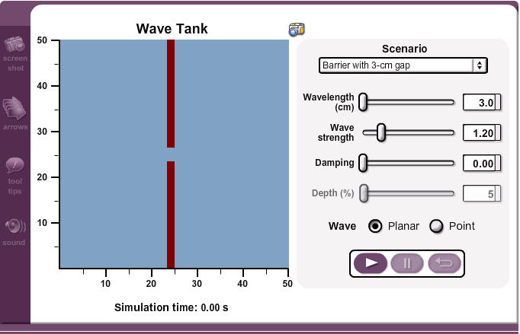

- Observe the effect of a change in wavelength on diffraction.
  - Set the scenario to “Barrier with 3-cm gap.” Move the Wavelength slider to 3.0 cm and make sure the other settings are changed to the following: Wave strength = 1.00, Damping = 0.00, and Planar wave selected.
  - Click the play button to run the simulation. Let the simulation run past the 2-second mark using the screen timer (below the ripple tank), and pause the simulation once the first wave-front reaches the right edge of the ripple tank (the 50 cm mark).
  - Record the relationship of the wave diffraction and the barrier gap. You may do this by including a sketch in Table A, or by using the “snapshot” feature in the gizmo to record the image of the wave tank, which you can print or paste into Table A.
  - Visually estimate the angle of diffraction by studying the wave edge as it propagates around the gap edge. Remember that the wave edge will diffract somewhere between 0° (straight to the right edge of the tank) and 90° (straight up along the barrier). Record the approximate diffraction angle in degrees, in Table A. If it proves difficult to estimate the diffraction angle, you may reset and rerun the simulation as needed.
  - Perform the calculations to predict the diffraction angle for the 3.0 cm wavelength. Use the relationship
$$\text{θ}\text{ ≈ }\frac{\text{λ}}{\text{L}}$$
where $\text{θ}$ is the diffraction angle in radians, λ is the wavelength in centimeters, and L is the width of the barrier gap in centimeters. The diffraction angle will be in radians, which can be converted to degrees by multiplying radians by 180/π. Record your calculations in Table A.
  - Reset the simulation and change the general parameters. Gap width will remain at 3 cm while the wavelength should be 4 cm. Then repeat the experiment (Steps 2b–e) and record the new data in Table A.
  - Reset the simulation again, this time changing the wavelength to 5.0 cm. Follow Steps 2b–e once more to gather your data, and record your results in Table A.
  - You may need to restart the simulation after each trial if you are unable to reset these parameters.
- Analyze the data.
  - Analyze the data from Step 2 by comparing the observed data to the predicted (calculated) data. Record your comparisons in Table B.

Data
Record your data either in your lab notebook or in the tables below.
Table A
Diffraction Observations: Constant Gap Width (3 cm)
Wavelength = 3 cm | Diagram or screen capture image:
Observed/estimated diffraction angle:
Predicted diffraction angle:
Radians:
Degrees:
Wavelength = 4 cm | Diagram or screen capture image:
Observed/estimated diffraction angle:

Predicted diffraction angle:
Radians:
Degrees:

Wavelength = 5 cm | Diagram or screen capture image:
Observed/estimated diffraction angle:

Predicted diffraction angle:
Radians:
Degrees:

Table B
Comparison of Observed Diffraction Angles and Predicted Diffraction Angles

