Virtual Lab: Newton’s Second Law
Student Guide

Pre-Lab Information

Purpose Explore the effect of force and mass on the acceleration of an object.

Time Approximately 50 minutes

Question How do force and mass affect the acceleration of an object?

Hypothesis #1 If the force applied to a cart increases, then the acceleration of the cart increases when the mass of the cart is held constant, because force and acceleration are directly proportional to each other according to Newton’s second law.

Hypothesis #2 If the mass of a cart increases, then the acceleration of the cart decreases when the force applied to the cart is held constant, because mass and acceleration are inversely proportional to each other according to Newton’s second law.

Variables for H1 Independent Variable: force applied to the cart Dependent Variable: acceleration of the cart Constant: mass of the cart
Variables for H2 Independent Variable: mass of the cart

Dependent Variable: acceleration of the cart

Constant: force applied to the cart

Summary This experiment is divided into two parts. For each part, you will use a simulation to measure the position and velocity of a cart as it accelerates along a frictionless surface. A fan on the cart supplies the force needed to move it along the track. For the first part of the experiment, you will examine how the force applied to the cart affects the acceleration of the cart by varying the fan speed on the cart. Varying the fan speed varies the force applied to the cart, causing the cart to accelerate at different rates. For the second part of the experiment, you will examine how the mass of the cart affects the acceleration of the cart by changing the mass of the cart, while keeping the fan speed the same.

Please note that this simulation uses the term “speed” instead of “velocity.” This is because the cart moves in only one direction. For the purposes of this lab, the terms speed and velocity are interchangeable.

Lab Procedure

Step 1: Open the simulation.

a) Be sure to follow all the directions provided in the lab guide as well as on screen during the virtual lab.

b) Open the “Force and Fan Carts” Gizmo, and watch the demo by clicking on the demo icon on the bottom left corner of the activity.

c) When the demo is complete, close it and return to the Experimental setup.

Copyright © Edgenuity Inc.

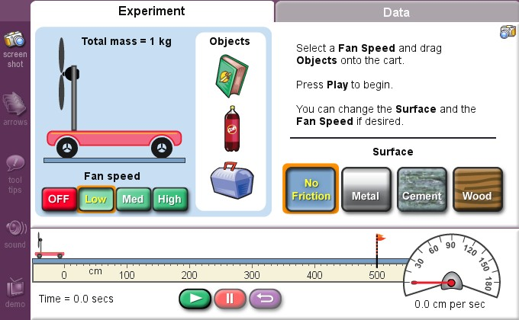

Part I: Changing the Force Applied to the Cart

Step 2: Run the simulation on Low fan speed to determine the acceleration of the cart. a) Select Low for the fan speed, and No Friction for the surface type.
b) Place the textbook on the cart and note that the total mass of the cart and textbook is 2 kg.
c) Open the Data tab and select the Speed and Line graph buttons.
d) Click the Play button. Let the cart run past the finish line.
e) Once the cart crosses the finish line, record the data from the “Speed data” table into your lab guide in Table A in the Low fan speed column. Record the total distance to the finish line (represented by the flag), the total elapsed time (bottom left of the Gizmo), and the final speed (bottom right of the Gizmo) in Table B.

Step 3: Run the simulation on Medium fan speed to determine the acceleration of the cart. a) Open the Experiment tab and select Medium for the fan speed.
b) Click the purple Reset button to place the cart back at the starting point.
c) Open the Data tab and select the Speed and Line graph buttons.
d) Click the Play button. Let the cart run past the finish line.
e) Once the cart crosses the finish line, record the data from the “Speed data” table into your lab guide in Table A in the Medium fan speed column. Record the total distance to the finish line (represented by the flag), the total elapsed time (bottom left of the Gizmo), and the final speed (bottom right of the Gizmo) in Table B.

Step 4: Run the simulation on High fan speed to determine the acceleration of the cart. a) Open the Experiment tab and select High for the fan speed.
b) Click the Reset button to place the cart back at the starting point.
c) Open the Data tab and select the Speed and Line graph buttons.
d) Click the Play button. Let the cart run past the finish line.
e) Once the cart crosses the finish line, record the data from the “Speed data” table into your
lab guide in Table A in the High fan speed column. Record the total distance to the finish line (represented by the flag), the total elapsed time (bottom left of the Gizmo), and the final speed (bottom right of the Gizmo) in Table B.

Step 5: Calculate the change in velocity of the cart for each run.

a) Calculate the change in velocity of the cart for each fan speed. Remember the formula for change in velocity (Δv), which is the difference between the final velocity (vf) and the initial
velocity (vi):

Δv = vf – vi

Be sure to use the initial and final velocities you recorded in Table A to calculate the change in velocity. Record your answers in Table B.

Step 6: Calculate the acceleration of the cart for each run.

a) Calculate the acceleration of the cart for each fan speed. Remember the formula for acceleration (a), which is the change in velocity (Δv) over the total elapsed time (Δt):

a = Δv/Δt

Record your answers in Table B.

Part II: Changing the Mass of the Cart

Step 7: Run the simulation with a mass of 2 kg to determine the acceleration of the cart. a) Open the Experiment tab and select High for the fan speed.
b) Place the textbook on the cart so the total mass of the cart is 2 kg.
c) Open the Data tab and select the Speed and Line graph buttons.
d) Click the Play button. Let the cart run past the finish line.
e) Once the cart crosses the finish line, record the data from the “Speed data” table into your lab guide in Table C in the 2 kg mass column. Record the total distance to the finish line (represented by the flag), the total elapsed time (bottom left of the Gizmo), and the final speed (bottom right of the Gizmo) in Table D.

Step 8: Run the simulation with a mass of 4 kg to determine the acceleration of the cart.

a) Open the Experiment tab and click the Reset button to place the cart back at the starting point.
b) Place the soda bottle on the cart, along with the textbook, so the total mass of the cart is 4 kg.
c) Open the Data tab and select the Speed and Line graph buttons.
d) Click the Play button. Let the cart run past the finish line.
e) Once the cart crosses the finish line, record the data from the “Speed data” table into your lab guide in Table C in the 4 kg mass column. Record the total distance to the finish line (represented by the flag), the total elapsed time (bottom left of the Gizmo), and the final speed (bottom right of the Gizmo) in Table D.

Step 9: Run the simulation with a mass of 6 kg to determine the acceleration of the cart.

a) Open the Experiment tab and click the Reset button to place the cart back at the starting point.
b) Place the box on the cart, along with the textbook and the soda bottle, so the total mass of the cart is 6 kg.
c) Open the Data tab and select the Speed and Line graph buttons.

d) Click the Play button. Let the cart run past the finish line.
e) Once the cart crosses the finish line, record the data from the “Speed data” table into your lab guide in Table C in the 6 kg mass column. Record the total distance to the finish line (represented by the flag), the total elapsed time (bottom left of the Gizmo), and the final speed (bottom right of the Gizmo) in Table D.

Step 10: Calculate the change in velocity of the cart for each run.

a) Calculate the change in velocity of the cart for each cart mass. Remember the formula for change in velocity (Δv), which is the difference between the final velocity (vf) and the initial
velocity (vi):

Δv = vf – vi

a) Be sure to use the initial and final velocities you recorded in Table C to calculate the change in velocity. Record your answers in Table D.
Step 11: Calculate the acceleration of the cart for each run.

a) Calculate the acceleration of the cart for each cart mass. Remember the formula for acceleration (a), which is the change in velocity (Δv) over the total elapsed time (Δt):

a = Δv/Δt

Record your answers in Table D.

Data

Record your data either in your lab notebook or in the tables below.

Table A

Elapsed Time  (s) | Cart Speed  (Low fan speed) (cm/s) | Cart Speed  (Medium fan speed) (cm/s) | Cart Speed  (High fan speed) (cm/s)
0
1
2
3
4
5
6
7
8
9
10

Table B

 | Low Fan Speed | Medium Fan Speed | High Fan Speed
Elapsed time to
finish line
Δt (s)
Total distance
Δx (cm)
Change in velocity
Δv (cm/s)
Acceleration
a (cm/s2)

Table C

Elapsed Time  (s) | Cart Speed  (2 kg mass) (cm/s) | Cart Speed  (4 kg mass) (cm/s) | Cart Speed  (6 kg mass) (cm/s)
0
1
2
3
4
5
6
7
8
9
10
11
12

Table D

 | 2 kg Mass | 4 kg Mass | 6 kg Mass
Elapsed time to
finish line
Δt (s)
Total distance
Δx (cm)
Change in velocity
Δv (cm/s)
Acceleration
a (cm/s2)

