Pre-Lab Information
Purpose Experimentally observe how an object’s position and velocity change while it is moving with a constant acceleration.
Time Approximately 50 minutes
Question How does an object’s position and velocity change as the object accelerates?
Hypothesis If the fan speed increases, then the acceleration of the cart increases, because a greater fan speed supplies more energy to move the cart.
Variables Independent Variable: fan speed
Dependent Variable: acceleration of the cart
Constant: mass
Summary You will use a simulation to measure the position and velocity of a cart as it accelerates along a frictionless surface. Complete three trials using three different fan speeds to move the cart and generate data, and then calculate the average velocity of the cart for each of the three fan speeds. You will also determine the acceleration of the cart from a graph of Velocity vs. Time. Finally, run one more trial in which the acceleration will be removed halfway through the run to interpret how velocity changes.
Please note that this simulation uses the term “speed” instead of “velocity.” This is because the cart moves only in one direction. For the purposes of this lab, the terms speed and velocity are interchangeable.

Lab Procedure
- Open the simulation.
  - Be sure to follow all the directions provided in the lab guide as well as on screen during the virtual lab.
  - Open the Gizmo “Force and Fan Carts” link in the virtual lab and watch the demo by clicking the demo icon at the bottom-left corner of the activity.
  - When the demo is complete, close it and return to the Experiment setup.
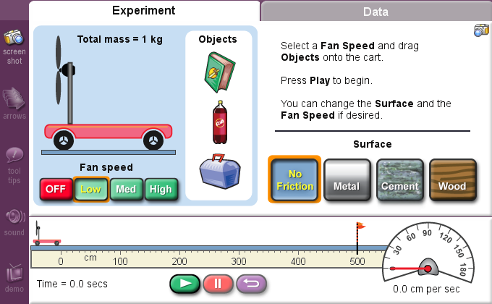

- Run the simulation on Low fan speed to identify changes in position, velocity, and acceleration of the cart.
  - Select Low for the fan speed, and No Friction for the surface type.
  - Open the Data tab and select the buttons Speed and Line graph.
  - Click the Play button. Let the cart run past the finish line.
  - Once the cart crosses the finish line, record the data from the Speed data table into your lab guide in Table A in the Low fan speed column. Record the total distance to the finish line (represented by the flag) and the total elapsed time (bottom left of the gizmo) in Table B.
  - Use the data in Table B to calculate the average velocity of the cart. Average velocity is calculated by dividing the total distance or displacement, Δx, by the elapsed time, Δt:
v_{avg} = Δx/Δt
Record your answers in cm/s in Table B.
  - Look at the Speed vs. Time graph generated in the Gizmo and determine the acceleration of the cart. Remember that the slope of the line gives you the acceleration of the cart. Record your answers in cm/s² in Table B.
  - Select the Position button to view the plot of Position vs. Time. Record a description of the graph in Table C.
  - Select the Speed button again and open the Experiment tab.
- Run the simulation on Medium fan speed to identify changes in position, velocity, and acceleration of the cart.
  - Select Medium for the fan speed. Click the purple Reset button to place the cart back at the starting point.
  - Open the Data tab, and then click the Play button to start the cart.
  - Once the cart crosses the finish line, record the data from the Speed data table into your lab guide in Table A in the Medium fan speed column. Record the total distance to the finish line and the total elapsed time in Table B.
  - Now use the data in Table B to calculate the average velocity of the cart. Average velocity is calculated by dividing the total distance or displacement, Δx, by the elapsed time, Δt:
v_{avg} = Δx/Δt
Record your answers in cm/s in Table B.
  - Look at the Speed vs. Time graph generated in the Gizmo and determine the acceleration of the cart. Remember that the slope of the line gives you the acceleration of the cart. Record your answers in cm/s² in Table B.
  - Now select the Position button to view the plot of Position vs. Time. Record a description of the graph in Table C.
  - Select the Speed button again and open the Experiment tab.
- Run the simulation on High fan speed to identify changes in position, velocity, and acceleration of the cart.
  - Select High for the fan speed. Click the Reset button to place the cart back at the starting point.
  - Open the Data tab again, and then click the Play button to start the cart.
  - Once the cart crosses the finish line, record the data from the Speed data table into your lab guide in Table A in the High fan speed column. Record the total distance to the finish line and total elapsed time in Table B.

  - Use the data in Table B to calculate the average velocity of the cart. Average velocity is calculated by dividing the total distance or displacement, Δx, by the elapsed time, Δt:
v_{avg} = Δx/Δt
Record your answers in cm/s in Table B.
  - Look at the Speed vs. Time graph generated in the Gizmo and determine the acceleration of the cart. Remember that the slope of the line gives you the acceleration of the cart. Record your answers in cm/s² in Table B.
  - Select the Position button to view the plot of Position vs. Time. Record a description of the graph in Table C.
- Run the simulation to achieve a constant velocity.
  - Open the Data tab and select the Speed button. Then open the Experiment tab and change the fan speed to Low. Click the Reset button to place the cart back at the starting point.
  - Open the Data tab and locate the timer, which is found in the bottom-left corner of the Gizmo.
  - Click the Play button to start the cart, and closely watch the time elapse. At 4 seconds, stop the cart and timer by pressing the red Pause button. (Note: You may have to reset the cart a couple of times to get the timer stopped properly.)
  - Open the Experiment tab and turn the fan speed OFF. Return to the Data tab and click on the Play button to resume the cart’s run.
  - Once the cart crosses the finish line, observe the plot of Speed vs. Time. Describe how this graph differs from the earlier trials where the velocity was increasing. How does the slope change, and why? Record your observations in Table D of your Student Guide.

Data
Table A
Record your data either in your lab notebook or in the tables below.
Elapsed Time  (s) | Cart Speed  (Low fan speed)  (cm/s) | Cart Speed  (Medium fan speed)  (cm/s) | Cart Speed  (High fan speed)  (cm/s)
0
1
2
3
4
5
6
7

Table B
 | Low Fan Speed | Medium Fan Speed | High Fan Speed
Elapsed time to finish line
Δt (s)
Total distance
Δx (cm)
Average velocity
v_{avg} = Δx/Δt
(cm/s)
Acceleration
a (cm/s²)

Table C
Fan Speed | Observations of Position vs. Time Graphs
Low
Medium
High

Table D
Fan Speed | Observations of Speed vs. Time Graph
Low/OFF

