Pre-Lab Information
Purpose To understand the methods of classification of rocks and minerals, as well as how rock formation affects classification
Time Approximately 45 minutes
Question How are minerals and rocks classified?
Summary In this virtual lab, you will identify mineral and rock samples by conducting tests and observing properties used to classify minerals and rocks. You will compare your recorded observations to an identification chart to identify the minerals, then use a flowchart to identify the rocks.

Lab Procedure
- Prepare for the lab.
- Read through this guide before you begin, so you know the expectations for this lab.
- If anything is not clear to you, be sure to ask your teacher for assistance.
- Open the virtual lab.
Step 3: Conduct scratch tests.
- Read about minerals and scratch tests. Press the Conduct scratch tests button to determine the relative hardness of the mineral samples.
- Click on gypsum (hardness = 2). Drag Mineral 1 to gypsum. Scratch Mineral 1 against gypsum. Observe what happens. If a scratch appears, this means that Mineral 1 is harder than gypsum.
- Click on a mineral that is harder than gypsum: calcite (hardness = 3). Drag and scratch mineral 1 against calcite. Observe what happens.
- Repeat this process (scratching Mineral 1 against the minerals with known hardness) until no scratch appears. The hardness of Mineral 1 is the same as the mineral with the lowest known hardness where no scratch appears. See example analysis below:
Scratch Test for Mineral 1
When scratched on  gypsum  (hardness = 2) | When scratched on calcite  (hardness = 3) | When scratched on fluorite  (hardness = 4) | Conclusion
A scratch appears. | No scratch appears. | No scratch appears. | Hardness of Mineral 1 = 3
- Record the relative hardness value of Mineral 1 in Table A in the Data section of this guide.
- Repeat Steps B–D to determine the relative hardness of the remaining mineral samples. Be sure to record the hardness of the mineral samples in Table A.
- Move on to the next activity.
Step 4: Conduct streak tests.
- Read about the streak test.
- Press the Conduct streak tests button.
- Drag Mineral 1 to the streak plate. Use the mineral to draw a line on the left side of the streak plate. Move the mineral sample up and down until you get a clear line (about 10 strokes).
- Record the color of the line in Table A.
- Repeat Steps C and D for the remaining mineral samples. Draw lines about an inch from each other.
- Press the Clear button to clear all lines if you need to do the streak tests again.
- Move on to the next activity.
Step 5: Observe other properties of minerals.
- Read about the other properties that mineralogists use to classify and identify minerals.
- Press the Describe minerals button.
- Inspect the minerals based on these properties.
- Color
- How they break (cleavage or fracture)
- Luster (shiny or dull)
- Record your observations in Table A.
- Use the Grid view to see all the minerals.
- Use the Enlarged view to observe the minerals more closely. In this view, use the arrows to move from one mineral to another.
- Move on to the next activity.
Step 6: Identify the unknown minerals.
- Use the data you gathered in Table A and the Mineral Identification Chart below to identify the mineral samples.
- Drag the stickers from the tools panel to the minerals to name the samples. Use the Grid or Enlarged view.
- Press the Check button.
- If an x mark appears, you have incorrectly named a mineral sample. Return the sticker to the Stickers panel. Compare your observations against the information in the Mineral Identification Chart. Drag the stickers to the remaining mineral samples until you have named all the mineral samples correctly.
- When all the mineral samples have been correctly identified, write the name of the minerals in Table A.
- Move on to the next activity.
Step 7: Examine and identify rocks.
- Read about rocks. Press the Identify Rocks button to proceed.
- Examine Rock 1. Use the Rock Identification Flowchart below to identify Rock 1. Use the Grid or Enlarged view of the rocks.
- Drag the correct sticker to Rock 1.
- Repeat Steps B and C for the remaining rock samples.
- Press the Check button.
- If an x mark appears, you have incorrectly named a rock sample. Return the sticker to the Stickers panel. Reexamine the rocks you named incorrectly and use the flowchart to correctly identify them. Drag the stickers to the remaining rock samples until you have named all the rock samples correctly.
- When all the rock samples have been correctly identified, write the name of the rocks in Table B in the Data section of this guide.
- Proceed to the next activity in the Virtual Classroom.

Data
Record your data either in your lab notebook or in the space below.

Table A. Properties and Identities of Mineral Samples
Mineral | Relative hardness  (1–10) | Streak | Color | Cleavage or fracture | Luster  (shiny or dull) | Name of mineral
1
2
3
4
5
6

Table B. Identities of Rock Samples
Rock sample | Name of rock
1
2
3
4
5
6

Mineral Identification Chart

Cleavage or fracture | Streak | Color | Relative hardness (1–10) | Luster  (shiny or dull) | Name of mineral
Cleavage | Yellow or brown | Yellow, brown, or black | 5 | Shiny or dull | Goethite
Cleavage | White, yellow, or brown | White, red, yellow, brown, green, or black | 4 | Dull | Sphalerite
Cleavage | White or gray | Dark green, dark brown, or black | 3 | Dull | Biotite
Cleavage | Black | Black, silver, or gray | 1 | Shiny, sometimes dull | Graphite
Fracture | Brown to black | Brassy yellow | 6 | Shiny | Pyrite
Fracture | Reddish brown | Red-brown, black, or silver | 6 | Shiny or dull | Hematite
Fracture | Black | Black or silver | 6 | Shiny or dull | Magnetite
Fracture | Black or dark gray | Brownish, reddish, bronze, or yellow | 4 | Shiny | Pyrrhotite
Fracture | Greenish black | Brassy yellow | 4 | Shiny | Chalcopyrite
Fracture | Dark gray or black | Black with iridescent colors | 3 | Shiny | Bornite

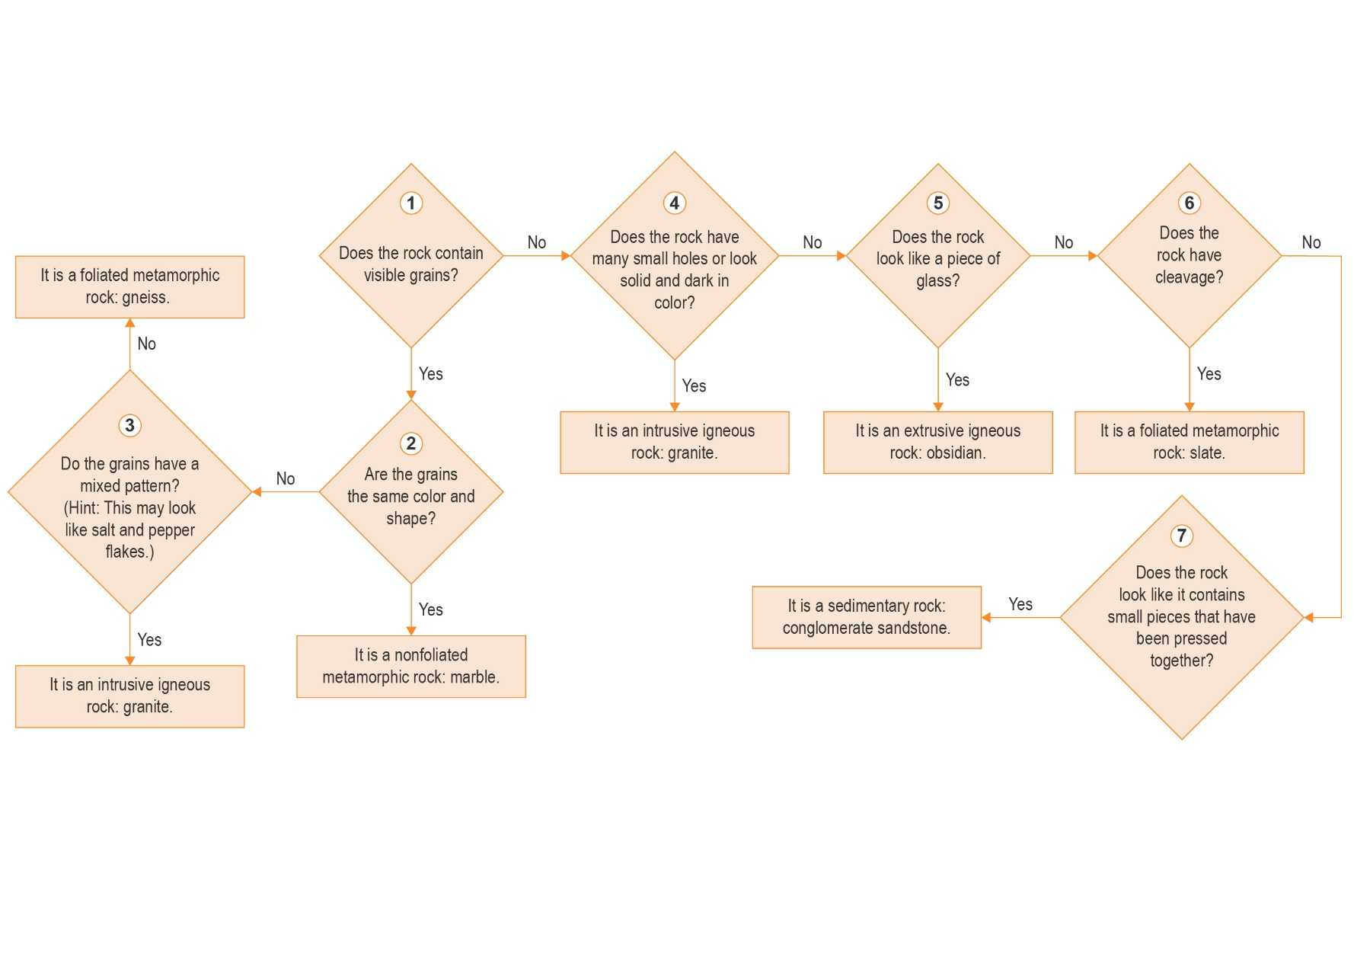
Rock Identification Flowchart
