Pre-Lab Information
Purpose Explore the process of radioactive decay.
Time Approximately 30 minutes
Question How does the number of radioactive atoms change over time?
Hypothesis If the number of half-lives increases, then the number of radioactive atoms decreases, because approximately half of the atoms’ nuclei decay with each half-life.
Variables Independent Variable: number of half-lives
Dependent Variable: number or radioactive atoms
Summary You will use a simulation to explore the process of radioactive decay. You will run two different simulations using two different isotopes and examine how the number of radioactive atoms changes as time progresses.

Lab Procedure
- Open the simulation.
  - Be sure to follow all the directions provided in the lab guide as well as on screen during the virtual lab.
  - Open the Gizmo “Half-life.”
  - Briefly review the functionality of the Gizmo, identifying sliders, buttons, and tabs that you will use to complete the experiment. Ask your teacher about using the Gizmo if there are any questions.
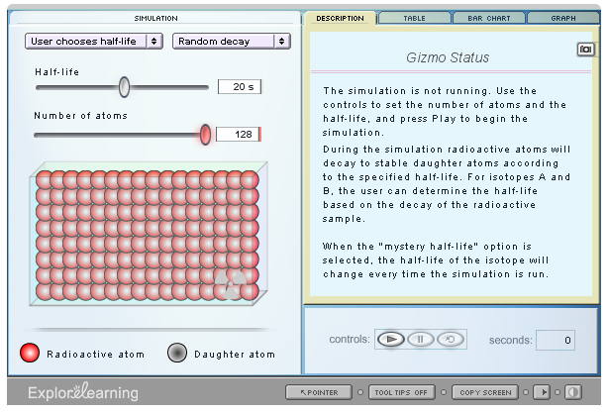

- Set up the first simulation.
  - Select “User chooses half-life” from the drop-down menu in the upper-left corner of
the Gizmo.
  - Immediately to the right, select “Random decay” from the second drop-down menu.
  - Move the slider for Half-life to 15 s.
  - Move the slider for Number of atoms to 128.
  - On the right side of the Gizmo, select the Graph tab.
- Run the first simulation.
  - Click the Play button to watch the simulation. Each arrow represents the decay of one
atom of the radioactive isotope.
  - When the simulation ends, select the Table tab.
  - Record the number of radioactive atoms remaining at selected times in Table A.
- Set up the second simulation.
  - Click the Reset button.
  - Select “User chooses half-life” from the drop-down menu in the upper-left corner of
the Gizmo.
  - Immediately to the right, select “Random decay” from the second drop-down menu.
  - Move the slider for Half-life to 35 s.
  - Move the slider for Number of atoms to 100.
  - On the right side of the Gizmo, select the Graph tab.
- Run the second simulation.
  - Click the Play button to watch the simulation. Each arrow represents the decay of one
atom of the radioactive isotope.
  - When the simulation ends, select the Table tab.
  - Record the number of radioactive atoms remaining at selected times in Table B.

Data
Record your data either in your lab notebook or in the tables below.

Table A
Time (seconds) | Number of Half-Lives | Number of Radioactive Atoms
0 | 0 | 128
15 | 1
30 | 2
45 | 3
60 | 4
75 | 5
90 | 6
105 | 7

Table B
Time (seconds) | Number of Half-Lives | Number of Radioactive Atoms
0 | 0 | 100
35 | 1
70 | 2
105 | 3
140 | 4
175 | 5
210 | 6
245 | 7
280 | 8

