Pre-Lab Information
Purpose Conduct an investigation to explore the different biological molecules found in living organisms.
Time Approximately 45 minutes
Question How are different biological molecules identified?

Summary Living organisms are composed of many biological molecules including DNA, lipids, and carbohydrates. DNA is a nucleic acid that contains genetic information. Carbohydrates are sugars that serve as a quick source of energy. Carbohydrates can be simple or complex. Simple carbohydrates consist of one or two sugars. Complex carbohydrates are a chain of sugars. Lipids include fats and oils that can be used as an extended energy source. Lipids release more energy per gram than carbohydrates or proteins.

In this lab, you will first extract DNA from a strawberry by breaking apart the cells and releasing the DNA. Then, you will test for the presence of carbohydrates and lipids, using different tests that indicate the presence or absence of these molecules. You will test different food sources and compare them to control groups.

Safety
- Always wear a lab coat, safety goggles, and gloves when performing an experiment.
- Do not eat or drink in the lab.
- Make sure that all behavior in the lab is purposeful.
- Be careful not to spill when transferring water or chemicals.
- Check containers, such as beakers, graduated cylinders, and buckets, for cracks or chips prior to use.
- Report all accidents—no matter how big or small—to your teacher.

Procedure
- Gather materials.
- Cheesecloth  - 1 resealable bag  - 1 strawberry  - Cold ethanol  - Extraction buffer (soap, salt, water)  - 1 bamboo skewer or wooden coffee skewer  - 1 funnel | - 7 test tubes  - Benedict’s solution  - 4 mL glucose solution  - 0.05 mL oil  - 4 mL milk  - 4.05 mL honey  - 4 g plain mashed potatoes  - 4 g wheat crackers  - 2.5 g fruit | - 0.05 mL heavy cream  - 0.05 mL yogurt  - 17.05 mL distilled water  - Hot water bath  - Pipettes  - Iodine solution  - 1 brown paper bag

Part I: DNA Extraction
- Remove the stem from the strawberry.
  - Place the strawberry in the resealable bag and close it.
  - Squeeze the strawberry in the bag with your hand until it breaks into little pieces (about two minutes). Be careful not to break the bag open.
- Add the DNA extraction buffer.
  - Add 10 mL of DNA extraction buffer to the bag.
  - Reseal the bag and again smash it all together.
- Set up a filtration apparatus.
  - Place the funnel over one test tube.
  - Wrap the cheesecloth over the funnel.
- Extract the DNA.
  - Cut the corner of the resealable bag and let the contents fall into the filtration apparatus.
  - Fill the test tube until it is about 1/8 full.
  - Remove the funnel and discard the cheesecloth.
  - Slowly pour cold ethanol into the test tube using a pipette until the test tube is ½ full.
  - Dip the skewers into the test tube where the ethanol and the extract meet.
  - Rotate the skewers. The DNA will stick to it.
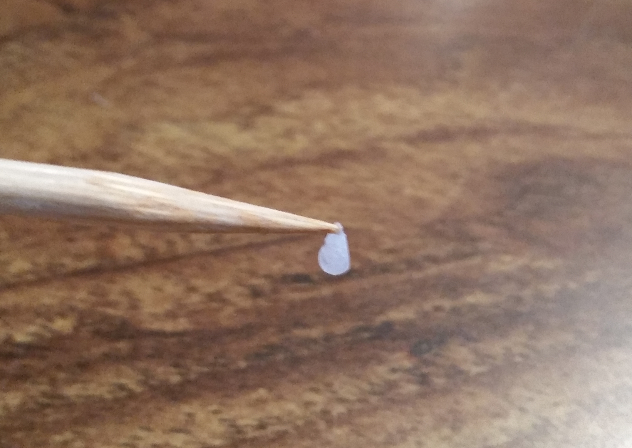

Part II: Carbohydrate Identification
Step 6: Obtain six test tubes and label them 1–6.
    - In the presence of Benedict’s solution, simple sugars will turn orange. In the presence of Iodine, complex sugars will turn black/dark purple.
    - Fill the test tubes based on the chart below. If the substance is a liquid, place about 2 mL of the sample in the test tube. If the substance is a solid, add 2 grams of crumbled-up solid into 2 mL of water.
Test Tube 1 | Water
Test Tube 2 | Glucose solution
Test Tube 3 | Milk
Test Tube 4 | Honey
Test Tube 5 | Plain mashed potatoes
Test Tube 6 | Wheat crackers
  - Add five drops of Benedict’s solution to each test tube.
  - In Table A, write the color of each solution before it is heated. Later, you will record the color of each solution after it is heated.
- Heat up samples.
  - Place the test tubes in a hot water bath. Always use caution when using a heating source.
  - Heat for 3–5 minutes.
- Record color changes.
  - Record any change in color that occurs after boiling and enter it in the Table A.
- Use iodine to test for starch.
  - Clean each test tube and refill each with the same materials. This time, use flour instead of glucose.
  - Add two drops of iodine to each tube.
  - Note the final color change and record it in Table B.

Part III: Lipid Identification
Step 10: Identify lipids.
  - In the presence of lipids, the mark on the brown bag becomes translucent.
  - Draw six squares on the brown paper bag and label them 1–6.
  - Place each material on the bag according to the chart below and leave them there for five minutes. If the food is a liquid, place a drop of the solution on the bag. If the food is a solid, add about 2.5 grams of ground food into 5 milliliters of water. The water will evaporate, leaving the presence or absence of the lipid.
Square 1 | Water
Square 2 | Oil
Square 3 | Fruit
Square 4 | Heavy cream
Square 5 | Honey
Square 6 | Whole milk yogurt

  - Remove the items and hold the paper up to the light.
  - Lipids are present where the paper bag appears translucent.
  - In Table C, check the box for the presence or absence of lipids.

Step 11: Dispose of, clean, and dry off all materials according to your teacher’s directions.
Step 12: Answer the follow-up questions.

Data
Record your data either in your lab notebook or in the space below.

Table A: Color Change Differences for the Simple Carbohydrate Test (Benedict’s Solution)
Test Tube | Initial Color | Final Color
Water
Glucose solution
Milk
Honey
Plain mashed potatoes
Wheat crackers

Table B: Color Change Differences for the Complex Carbohydrate Test (Iodine Solution)
Test Tube | Final Color
Water
Glucose solution
Milk
Honey
Plain mashed potatoes
Wheat crackers

Table C: Presence or Absence of Lipids (Paper Bag Test)
Paper Bag Square | Presence | Absence
Water
Oil
Fruit
Heavy cream
Honey
Whole milk yogurt

Follow-Up Questions
Answer the following questions.
- In Part I, what was the purpose of smashing up the strawberry and adding the extraction buffer?

- In Part II, which substances contained simple carbohydrates? How do you know?

- In Part II, which substances contained complex carbohydrates? How do you know?

- In Part III, which substances contained lipids? How do you know?

