Pre-Lab Information
Purpose Plan an investigation to explore the transfer of thermal energy in a system.
Time Approximately 50 minutes
Question How is entropy related to the transfer of thermal energy in a system?
Summary Use the first and second law of thermodynamics to plan and conduct an investigation that confirms that two objects of different temperatures will reach thermodynamic equilibrium when combined in either an open system or a closed system. Use the law of conservation of energy and the heat equation to mathematically determine the temperature of the equilibrium state. Include a series of detailed drawings of your investigational setup or any device you create for this project. These drawings should include enough information that someone without prior knowledge of your project could reproduce it. Multiple trials should be run and graphed to determine an average value of the heat transferred during this investigation.

Safety
- Ensure that behavior in the lab is purposeful.
- Report all accidents—no matter how big or small—to your teacher.
- Wear goggles and clothing that is appropriate for working in a lab environment.
- Use caution when heating substances on a hot plate or over a Bunsen burner.
- Always use appropriate heating pads or tongs to handle hot objects.
- Wash your hands thoroughly after handling all lab materials.

Background Information
Heat is thermal energy that flows from one substance to another due to a temperature difference. The formula to calculate heat is $\text{Q} \text{=} \text{mc}\text{∆}\text{T}$.
The first law of thermodynamics states that energy can be transformed and transferred but not created or destroyed. This is known as conservation of energy.
The second law of thermodynamics states that when substances of differing temperatures are in contact, thermal energy flows from the substance with the higher temperature to the substance with the lower temperature. This transfer of thermal energy is an irreversible process.

Figure 1:
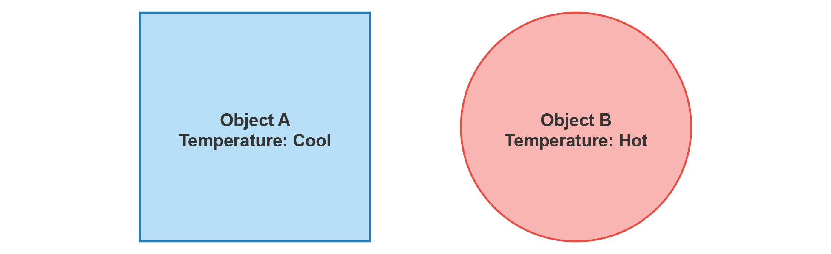
Figure 1: Object B is hotter than Object A.
Figure 2:
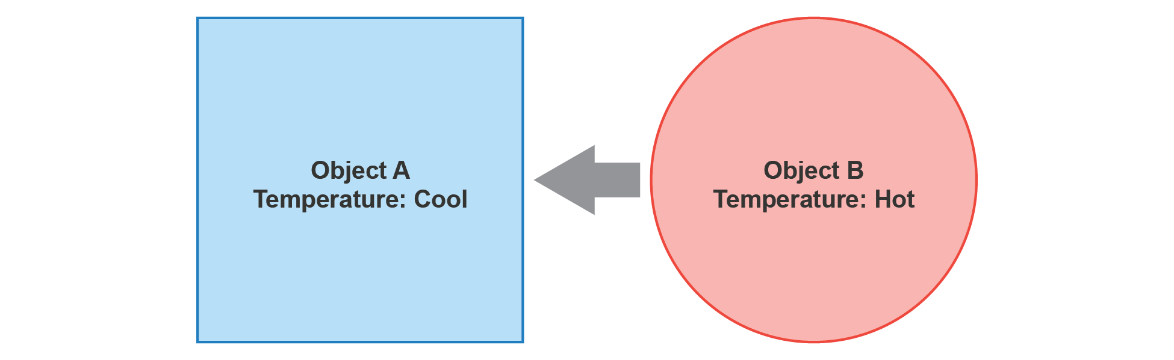
Figure 2: Object B is placed inside of Object A to form a closed system. Heat flows from Object B to Object A during an irreversible transfer of thermal energy.
Figure 3:
Figure 3: After a period of time, Objects A and B have reached a new temperature and are in thermal equilibrium.

Lab Procedure
Here is an outline of the steps you should follow to plan your investigation for this lab. Later in the guide, you will have space to develop your ideas, collect data, analyze and discuss results, and draw conclusions.

- Determine the types of data you will gather and the tools of measurement you will use to collect the data.
How will you gather data for your investigation? If gathering quantitative data, you may want to devise a table in which you can record your results in an organized manner. Also, consider how you will record any qualitative or descriptive data in addition to your numerical results. You should use a pencil to record data.
- Devise an investigation to examine how entropy is related to the transfer of thermal energy in a system.
Develop the main steps and describe how you will run the investigation. Your teacher will guide you on what materials are available for your investigation.
- Stop. Have your teacher sign off on Steps 1 and 2 before you continue the investigation.
- Gather materials and set up your investigation.
Now that you know what you will do, gather the necessary items. Besides the objects you will investigate, make sure you have the necessary equipment to take measurements. If you are working with lab partners, make sure each person knows his or her role in running the investigation. Check your setup and make sure everything is in order before you proceed.
- Run your investigation.
As you proceed with your investigation, make sure you record all the necessary data and, if working in groups, the role each student performed during the investigation. Make sure all elements of your investigation are complete. Do not forget to clean up when you are done!
- Use the High School Lab Report Guide to write your lab report.

Exploring How Entropy Is Related to the Transfer of Thermal Energy in a System
- Determine the types of data you will gather and the tools of measurement you will use to collect the data.
Make a list of the types of data you plan to collect. If gathering quantitative data, you may want to devise a table in which you can record your results in an organized manner.

- Devise an investigation to examine how entropy is related to the transfer of thermal energy in a system.
Write the steps of your investigation. Include multiple detailed sketches of your investigational setup.

- Stop. Have your teacher sign off on Steps 1 and 2 before you continue the investigation.

- Gather materials and set up your investigation.
Gather the necessary items and equipment. If you are working with lab partners, make sure each person knows his or her role in running the investigation. Document the roles here.

Student Name | Role

- Run your investigation.
Record your data and observations in the space below. Do not forget to clean up when you are done!

- Use the High School Lab Report Guide to write your lab report.

