Assignment Information
Purpose To use a computer simulation to help choose the best solution to a real-world problem
Time Approximately 60 minutes
Question Which solution should be used to remove the boulder from the land?
Summary In the first part of the project, you will learn about simple machines. You will then use a computer simulation to choose the best machines to remove a boulder from a piece of land. You will analyze three solutions based on the machines used, impact on the land, the amount of time used to accomplish the task, and cost. You will choose the best solution and justify your choice using your observations and data.
In the second part, you will draw free-body diagrams to represent the forces acting on the boulder and calculate the force needed to change the motion of the boulder. You will then draw a conclusion as to how simple machines affect the force needed to accomplish a task.

Background Information
Simple machines are devices that make work easier. They do this by changing the magnitude or the direction of the force needed to accomplish a task. The six simple machines are the inclined plane, wedge, screw, lever, wheel and axle, and pulley. Images of these machines are shown below.

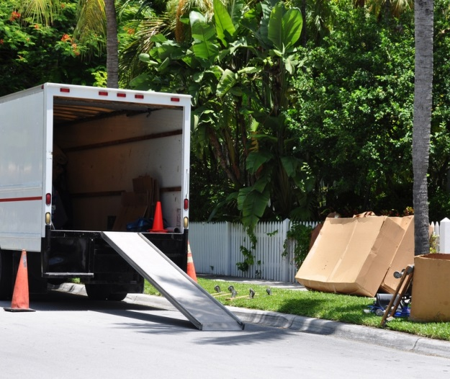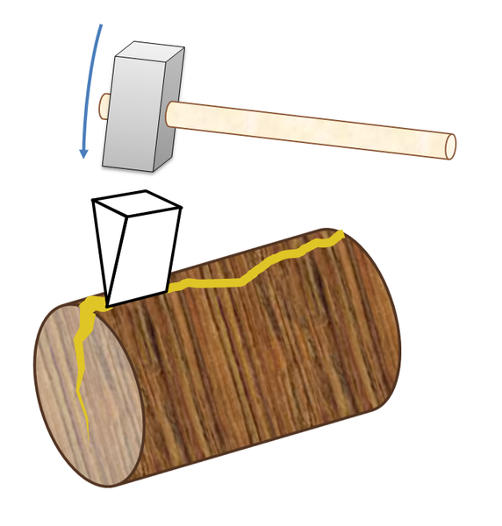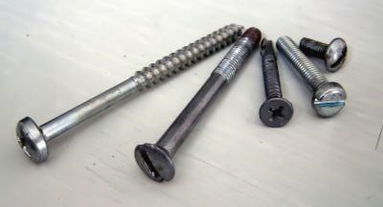

Inclined Plane Wedge Screws

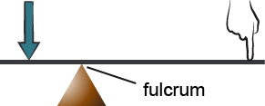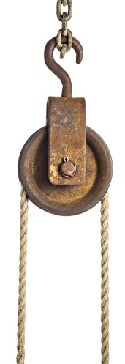

Lever Wheel and Axle Pulley

The inclined plane is a sloping surface, such as a ramp, that is used to lift objects. A wedge looks like two inclined planes placed back to back. It is used to split things apart. A screw can hold things together. A lever is a strong bar that turns about a fulcrum, or fixed point. It can be used to lift heavy objects. A force applied at one end of a lever is transmitted to the other end of the lever. A seesaw is an example of a lever. A wheel and axle consists of two circular objects of different sizes that are connected. This simple machine moves objects across a surface. Roller skates have wheels and axles that can move you from one place to another! A pulley consists of a grooved wheel and a rope. Pulling the rope lifts objects. Flagpoles and cranes have pulleys.
Simple machines have a property called mechanical advantage, which is a measure of how easily a machine can perform a task. A mechanical advantage of 4 means that in the absence of friction, the machine ideally multiplies the applied force by a factor of 4.

Assignment Instructions
- Prepare for the project.
  - Read through this guide before you begin, so you know the expectations for this project.
  - If anything is unclear, be sure to ask your teacher.
- Consider the characteristics of the best one.
  - Gain access to the simulation.
  - Read the introduction, and then select “Next.”
  - Understand the requirement and constraints of the best solution. A requirement is what the best solution is supposed to accomplish and the constraints are the limitations of the best solution. This will guide you in making the best choice.
The requirement of the best solution is the following.
- The solution should use simple machines that can do the task most easily.
The constraints of the solution include the following.
- The solution should limit the work hours used to a minimum of 4.
- The solution should use less money for the use of trucks/tractors.

- Analyze each solution to identify the best one.
  - Read the instructions on the screen.
You must choose the solution that will be the most cost-efficient and minimize the impact on the land. Explore each solution.
  - Select one of the solutions.
  - Observe the images that show the plot of land before and after the machines were used. Observe the before image. Then, use the right arrow to view the after image. Be sure to read the descriptive text so you know what is happening in the images.
  - Select the marker on the land to observe the impact of this solution on the plot of land. Record your observations in Table A in the Data and Analysis section of this document. Select X at the top right of the screen to continue.
  - Select the marker on the truck to determine the number of work hours it took for the task to be accomplished. Record the Start time in Table A. Select the right arrow. Record the End time in Table A. Determine the number of work hours spent by subtracting the End time from the Start time. Work hours refer to the number of hours it took one person to accomplish the task. Record the number of work hours spent in Table A. Select X at the top right of the screen to continue.
  - Select the second marker on the truck to determine the qualitative cost of the solution. Record the Starting fuel level in Table A. Select the right arrow. Record the Final fuel level in Table A. Determine the qualitative fuel cost by using the table below. Record the qualitative cost in Table A. Select “Next” to continue.
Fuel Level Change | Qualitative Cost
Between full to empty | $$$
Between full to half empty | $$
Between full to and three fourths full | $

  - Repeat Steps 3b–3f for the other two solutions.
  - Select “Next” to continue.

- Identify the combination of simple machines that would remove the boulder in the most efficient manner.
  - Read the instruction on the screen. Before you choose the best option, complete step 4b. The information in this step will help you determine the best option.
  - Read the passage about mechanical advantage and fractions.
Recall that mechanical advantage is a measure of how easily a machine can perform a task. The higher the value of the mechanical advantage, the easier it is for the simple machine to accomplish a task.
Recall also that the mechanical advantage of a lever is calculated by dividing a by b or $\frac{\text{a}}{b}$, where a is the length of the lever on the side where the force is applied and b is the length of the lever where the force is being transferred. The mechanical advantage of a ramp is calculated by dividing the length of the ramp (L) by its height (H) or $\frac{\text{L}}{\text{H}}$.
Consider these sets of fractions and their quotients.
Set A:
$\frac{\text{6}}{\text{12}}$ = 0.5 and $\frac{\text{15}}{\text{3}}$ = 5

Set B:
$\frac{\text{12}}{\text{3}}$ = 4 and $\frac{\text{15}}{\text{3}}$ = 5

What observations can you make here? For Set A, if a fraction has a numerator (the number on top) that is lesser than its denominator (the number on the bottom), its quotient (the answer to a division problem) will be lesser than a fraction whose numerator is greater than its denominator. For Set B, if two fractions have different values for the numerator but the same values for the denominator, the fraction whose numerator is greater will result in a greater quotient.
  - Use what you know about the mechanical advantage of levers and ramps and what you learned about fractions to complete this step.
- For the lever, compare the lengths of a and b in all four options and predict which lever has the highest mechanical advantage.
- For the ramp, compare the lengths of L and H in all four options and predict which ramp has the highest mechanical advantage (hint: the height of all the ramps are the same).
- From your analysis, predict which combination will be the most efficient. The combination that has the highest mechanical advantage for the lever and ramp will be the most efficient.
  - Based on your comparisons, choose and select the best option. Click through the scenes of your predicted best option using the right arrows to observe what happens when the lever and ramp is used. Note that the same amount of force is used in pushing the boulder up the ramp in all the four scenarios. Record your observations in Table B. Use this as your guide. Select X to choose another option.

Option 1 | Option 2
Option 3 | Option 4

  - Select the other 3 options to observe what happens to the boulder when the levers and ramps are used. Record your observations in Table B.
  - After you have recorded your observations in Table B, select “Next.”
  - After you have calculated the mechanical advantage of simple machines, select “Next.”

- Construct free-body diagrams.
  - Read the text on the screen. Select “Next” to continue.
  - Construct the free-body diagram of a stationary boulder on a ramp.
- Select each arrow and drag it to the correct position to construct the free-body diagram. Select “Check Position” to check the accuracy of the position of the arrows. Note that for the boulder being pushed onto level ground scenario, the A.F. arrow is fixed.
- Use the feedback to help you adjust the position of your arrows.
- If the positions of your arrows are correct, copy the correct diagram in Table C2. Select “Next” to continue to the next scenario.
  - Repeat Step 5b for the other two scenarios.

- Add the magnitude of forces on the free-body diagrams and break down the gravitational force into its x and y components.
  - Use Table C1 to assign values to the magnitude of the forces in the free-body diagrams that you drew in Table C2. A value is not assigned to F_{N} in the stationary boulder on level ground diagram as you will be determining this value in Step 6c. A value is not assigned to A.F. (applied push force, in this case) in the boulder being pushed onto level ground diagram as you will be determining this value in Step 6d.
  - Use the angle value in Table C1 to break down and assign magnitude values to the x and y components of the gravitational force in the stationary boulder on a ramp diagram.
  - Analyze your stationary boulder on level ground diagram. Determine the magnitude of F_{N}. Remember the gravitational force and the normal force need to cancel each other out in this scenario. Add this value to your diagram.
  - Analyze your boulder being pushed onto level ground diagram. Determine the magnitude of A.F. Add this value to your diagram.
- Compare the forces needed to move the boulder without and with a machine.
  - Use your completed stationary boulder on a ramp diagram and your knowledge about balanced and unbalanced forces to determine the minimum force required to move the boulder up the ramp without and with a machine. Write your answers and explanations in Table D.
  - Use your completed boulder being pushed onto level ground diagram and your knowledge about balanced and unbalanced forces to determine the minimum force required to move the boulder onto level ground with and without the use of a lever. Assume that the mechanical advantage of the lever is 5. Recall that mechanical advantage is a measure of how easily a machine can perform a task. A mechanical advantage of 5 means that the machine ideally, in the absence of friction, multiplies the applied force by a factor of 5. Write your answers and explanations in Table E.
- Answer the follow-up questions at the end of this document.
- Submit your Student Guide in the Virtual Classroom or to your teacher.

Data and Analysis
Record your data/observations and take note of your analysis in the tables below.

Table A. Comparison of Solutions
Solution | Observations/Data
 | Impact on land | Number of work hours | Qualitative cost
Pulley and truck |  | Start time: | Starting fuel level:
 |  | End time: | Final fuel level:
 |  | Number of work hours: | Qualitative cost:
Wedge, hammer, and tractor |  | Start time: | Starting fuel level:
 |  | End time: | Final fuel level:
 |  | Number of work hours: | Qualitative cost:
Lever, ramp, and truck |  | Start time: | Starting fuel level:
 |  | End time: | Final fuel level:
 |  | Number of work hours: | Qualitative cost:

Table B. Observations on Four Options
Option | Observations
1
2
3
4

Table C1. Elements of Free-Body Diagrams to Be Added to the Drawings
Stationary boulder on a ramp
Force/Angle | Magnitude/Value
F_{g} | 250 N
F_{N} | 217 N
F_{fs} | 43 N
θ | 30°
Stationary boulder on level ground
Force | Magnitude
F_{g} | 250 N
Boulder being pushed onto level ground
Force | Magnitude
F_{g} | 250 N
F_{N} | 250 N
F_{f} | 50 N
Table C2. Free-Body Diagrams
Free-body diagram of a stationary boulder on a ramp
Free-body diagram of a stationary boulder on level ground
Free-body diagram of a boulder being pushed onto level ground

Table D. Minimum Force Needed to Move the Boulder without and with a Ramp
Without the ramp | With the ramp
Explanation/calculation

Table E. Minimum Force Needed to Move the Boulder onto Level Ground
Without the lever | With the lever
Explanation/calculation

Follow-Up Questions
Answer the following questions.

  - Based on Table A, which is the best option? Explain why you think it is the best option. Use what you have learned about simple machines, and your observations and data in your explanation.

  - Use Tables D and E to compare the minimum force needed to accomplish tasks without and with a machine. How do the simple machines change the force to make the task easier? Use the results of your calculations to support your answer.

  - Suppose you are able to push the boulder up the ramp with a 300 N force. Would you need help to accomplish this task? Why or why not?

