Pre-Lab Information
Purpose Create a choice chamber and investigate the behavior of fruit flies in response to stimuli.
Time Approximately 90 minutes
Question How do animals respond to stimuli?
Summary In this investigation, you will observe and analyze fruit fly behavior to determine its response to different stimuli. You will construct a choice chamber to observe and collect data. You will design and conduct your own investigation that attempts to answer your own experimental question.

Safety
- Behavior in the lab needs to be purposeful.
- Wear safety goggles when working with sample testing substances.
- Report all accidents—no matter how big or small—to your teacher.

Lab Procedure
- Gather materials.
- 2 plastic bottles  - 6‒8 plastic bottle caps  - Clear tape  - Scissors  - Safety goggles | - Cotton balls  - 30‒40 fruit flies  - Samples (about 20 mL) of testing substances  - Timer  - 6 pipettes
- Construct your choice chamber.
  - Obtain two clean plastic bottles, several caps, tape, and scissors from your teacher.
  - Make sure your plastic bottles are clean and dry. If needed, rinse them and dry thoroughly with a paper towel.
  - Cut off the bottoms of the plastic bottles. Attach the bottoms to one another using tape.
  - Make sure your chamber is tightly sealed with clear tape. You do not want your organisms escaping the chamber.
  - Place caps on both ends of the water bottles. Be sure to have extra caps.
- Transfer the fruit flies into the choice chamber.
  - Obtain a container with 30–40 fruit flies from your teacher.
  - With the lid secured, turn the container of flies upside down. The flies will move toward the side of the container facing up. Then, open the container and quickly invert it with the open end into the choice chamber. The flies will move into the choice chamber. Make sure you secure both containers after you are done transferring the flies.
- Test the fruit flies’ response to gravity.
  - Place the choice chamber with side A toward the ground and side B toward the ceiling. Allow the flies to move around for 5–10 minutes. See the sample in the image below.
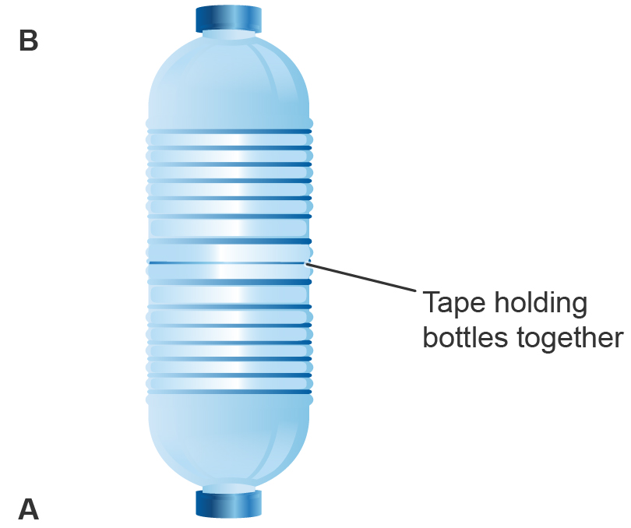
  - Record their position after an additional five minutes.
  - Repeat step (b) for five trials, recording your data in Table A. Record the average for the five trials in the same data table.
- Design your own investigation.
  - Choose a substance or substances to test. Consider different environmental stimuli, such as light or chemicals.
  - Decide how to set up your choice chamber. You will not need more than 20 mL of test substance. Cotton balls can be used to place the substance inside the choice chamber.
  - Make sure you include the following in your design.
      - Question you are investigating
      - Independent, dependent, and controlled variables
      - Setup of your experimental and control groups
      - Setup of each side of your chamber
      - Null hypothesis
      - Timing, trials, and counting methods
      - Data table to collect information (use Tables A and B to help you design your own)
  - Show your experimental design to your teacher for approval.
- Test your substances.
  - Obtain 30‒40 fruit flies from your teacher.
  - With the lid secured, turn the container of flies upside down. The flies will move toward the side of the container facing up. Then, open the container and quickly invert it with the open end into the choice chamber. The flies will move into the choice chamber. Make sure you secure both containers after you are done transferring the flies.
  - Decide on a test area for your choice chamber. Make sure that light, gravity, temperature, and any other variables are the same for both sides.
  - Test each substance, using the methods outlined in your experimental design. Record your results in Table B. Calculate and write the average for the three sets of data (number of flies at side A, in the middle, and at side B) in the same data table.
- Analyze your data and write a conclusion
  - Conduct a chi-square analysis using the average data from Table B. Record the chi-square value and the degrees of freedom in Table C.
  - Include your calculations and null hypothesis in your lab report.
- Clean up your area.
  - Return unused materials and dispose of any trash according to your teacher’s directions.

Data
Record your data either in your lab notebook or in the space below.
Table A: Geotaxis Results for the Fruit Fly
Trial | Side A  (Toward Ground) | Side B  (Toward Ceiling)
1
2
3
4
5
Average

Table B:
Note: You will need one of these tables for each test you perform.
Trial | Side A (Unripe) | Middle | Side B (Ripe)
1
2
3
4
5
Average

Table C:
Note: You will need one of these tables for each test you perform.
Number of Flies | Observed | Expected | (Observed – Expected)² | (Observed ‒ Expected)²/  Expected
Side A (unripe)
Middle
Side B (ripe)
Degrees of freedom: |  |  |  | X² =

Critical Values of the Chi-Square Distribution

Probability (p) | DEGREES OF FREEDOM (df)
 | 1 | 2 | 3 | 4 | 5
0.05 | 3.84 | 5.99 | 7.82 | 9.49 | 11.1
0.01 | 6.64 | 9.21 | 11.3 | 13.2 | 15.1
0.001 | 10.8 | 13.8 | 16.3 | 18.5 | 20.5

Follow-Up Questions
Answer the following questions:

- What conclusion can you make about how fruit flies respond to gravity? Use your data to support your answer.

- Use your data to construct a conclusion with claim, evidence, and reasoning components. Your claim should attempt to answer your question. Evidence should include data you collected and analyzed. Your reasoning should include scientific reasoning for your results.

- Identify and discuss at least one potential source of error. Explain how this may have affected your data and propose at least one improvement to your experiment to eliminate this error. Predict how this improvement might affect future data collection.

