Assignment Summary
For this assignment, you will construct and analyze cladograms and phylogenetic trees to determine evolutionary relationships among organisms.

Background Information
Phylogeny is the study of the evolutionary history of organisms and their relationships to one another. Those who study phylogenetics depict their hypotheses of species’ evolutionary relationships through phylogenetic trees. Similar to a family tree, a phylogenetic tree can depict how organisms are related to each other through their common ancestors. These diagrams can be constructed through various types of evidence, such as shared anatomical traits, biochemical evidence or gathered fossil evidence. In the past, scientist often relied on the physical traits of organism to place species on a phylogenetic tree; however, in more modern times, we rely on DNA and protein similarities to hypothesize the evolutionary history of organisms. Through determining how related species are to one another, we can classify and group organisms more accurately.
Phylogenetic trees are organized through a branching diagram, with each branch representing the evolutionary history of that species. The branching patterns can be analyzed to determine how closely related species are to one another and when speciation events occurred. Common ancestry is represented on the diagram through a two-way branching pattern. Each split into two branches on the tree represents a speciation event, and the branch point represents the common ancestor. Due to this pattern, species with branches that are closer in proximity to one another on the diagram can be inferred to be more closely related. Longer branches indicate more genetic divergence from the speciation event.
Along with phylogeny, scientists can use other models to depict evolutionary relationships among organisms, and even classify organism based on their ancestry. Cladistics is a way to classify organisms based on common ancestry. This branch of phylogenetics produces a diagram called a cladogram. Cladograms show relationships among organisms and their ancestors. They can indicate that humans are more related to chimps compared to gorillas, but cladograms do not indicate the amount of genetic differences between other organisms and their ancestors. Cladograms are typically constructed from anatomical evidence of derived characteristics of the organisms. Cladograms are tree diagrams where each branch point, or node, represents two groups splitting from a common ancestor. When using this method, biologists attempt to place organisms into clades where each clade includes an ancestral species and all of its descendants. In cladograms, the length of each branch is the same, and the branches do not infer an evolutionary time scale.

Materials

- Writing and drawing supplies (colored pencils, paper, etc.)
- Access to the Internet, lesson, student edition, and other reference materials

Assignment Instructions
For this project, you are expected to submit:
- A completed version of this guide, featuring your labeled diagrams and written analysis.

Step 1: Prepare for the project.
- Read through the guide before you begin so you know the expectations for this project.
- If there is anything that is unclear to you, ask your teacher.
Step 2: Complete Activity 1.
- Using the table of anatomical characteristics, sequentially order organisms according to shared characteristics to construct a cladogram.
- Write the order of organisms from the left, which would include those having the least shared characteristics, to the right, which would include those with the most shared characteristics. Do this underneath the table.
Step 3: Complete Activity 2.
- Analyze the data set, and determine the order of species based on biochemical similarities.
- Construct a cladogram based on the data.
Step 4: Complete Activity 3.
- Label the organism that is least related to the gray wolf.
- Label the organism that is most related to the gray wolf.
- Circle the common ancestral species among all the organisms represented.
Step 5: Complete Activity 4.
- Analyze the data set using your understanding of genetic mutations and evolutionary time. Assume the more differences in biochemical characteristics, the more time the two species have been isolated from each other.
- Using the data set from step 3, construct a phylogenetic tree using your understanding of evolutionary time and branching patterns.
Step 6: Complete the questions in the Written Analysis section.
Step 7: Evaluate your project using this checklist.
If you can check each box below, you are ready to submit your project.
- Did you order the organisms based on the data table of shared characteristics?
- Did you construct the cladogram based on the biochemical data set?
- Did you analyze the phylogenetic tree to identify the most recently related and the most distantly related species to the gray wolf?
- Did you circle the common ancestor of the gray wolf and all of the other species present in the phylogenetic tree?
- Did you construct a phylogenetic tree based on data set in step 3?
- Did you answer the Written Analysis questions?
Step 8: Revise and submit your project.
- If you were unable to check off all of the requirements in the checklist, go back and make sure that your project is complete. Be sure to save your project before submitting it.
- Turn in your model and written analysis to your teacher. Make sure that your name is on it.
- Congratulations! You have completed your project.

Activity 1: Data set of shared derived characteristics

Using the table of anatomical characteristics, sequentially order organisms according to shared characteristics to construct a cladogram. Construct your cladogram underneath the table and include the shared characteristics in your diagram.
Construct your cladogram in the space below:

Activity 2: Construct a cladogram

Multiple sequence alignment is a method that can be used to compare three or more biological sequences to determine homology and evolutionary relationships between species. This is done by selecting a target protein or DNA sequence (consensus) and comparing it across other species’ sequences. Conservation is a statistical analysis that describes how much the target sequence is observed across the selected group of species. A higher conservation score indicates that the protein or gene is more ancient or more critical across species.
Construct a cladogram using the multiple alignment of a protein sequence found below.

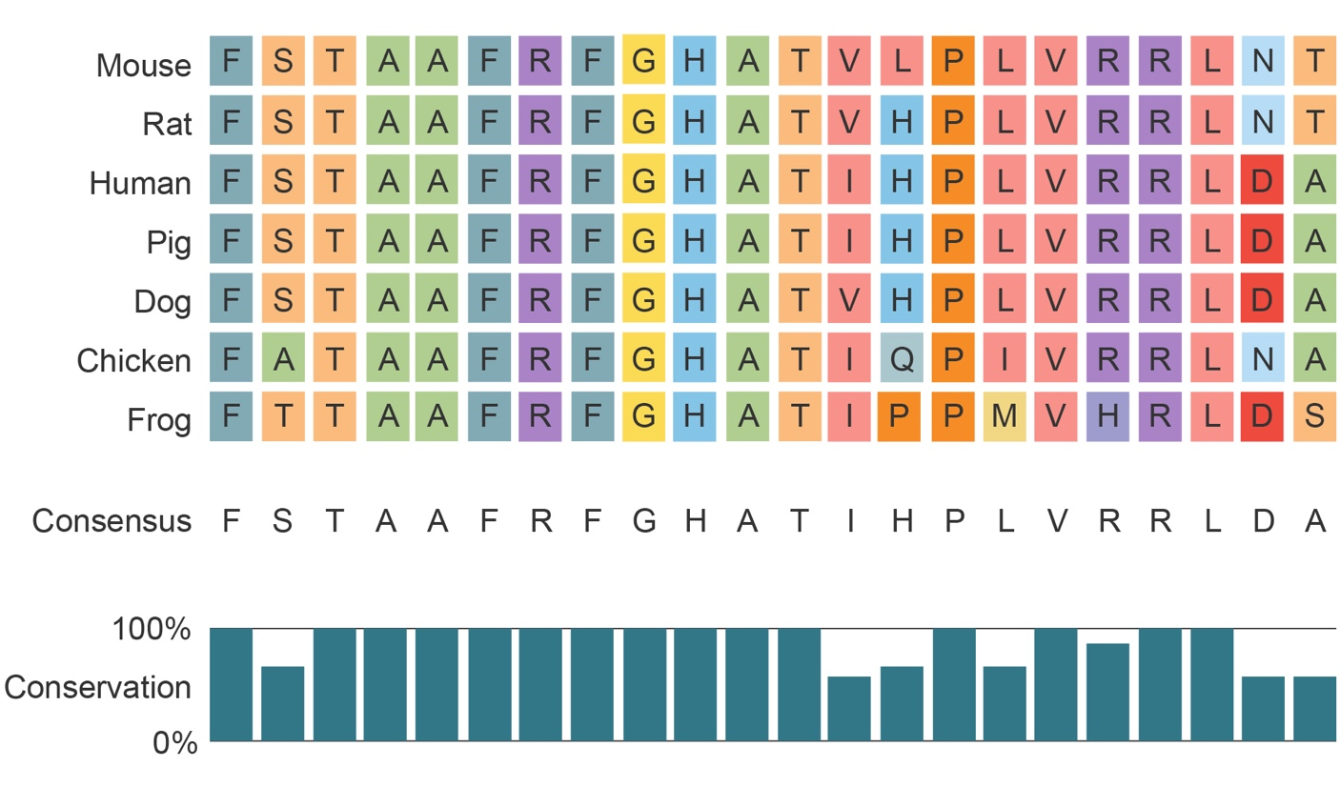

Construct your cladogram in the space below:

Activity 3: Interpret a Phylogenetic Tree

Complete an analysis of the phylogenetic tree below by doing the following:
- Label the organism that is least related to the gray wolf.
- Label the organism that is most related to the gray wolf.
- Circle the common ancestral species among all the organisms represented.

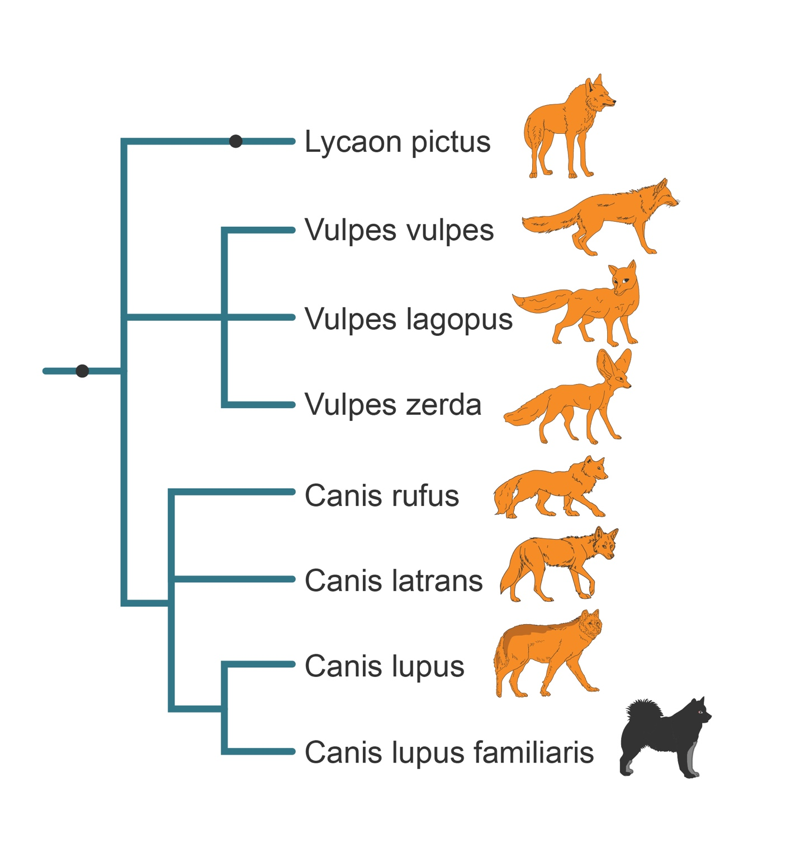

Activity 4: Construct a Phylogenetic Tree

Using the data set from step 3, construct a phylogenetic tree based on your understanding of branching patterns and evolutionary time. Assume the more differences in biochemical sequences, the less related are the two species.

Written Analysis

Answer the questions below.
- Using the data table in step 1, explain how you organized your cladogram by ancestral and derived traits. Based on your organization, does your cladogram have an outgroup? Explain.

- When constructing a cladogram in step 3, how did you make sure to follow the rule of maximum parsimony? Explain.

- Compare and contrast the cladogram you created in step 3 and the phylogenetic tree you created in step 5. How is the information presented in both diagrams similar and different? What additional information would help you refine your phylogenetic tree?

