Assignment Summary
For this assignment, you will interpret and analyze models of the formation of the first biological molecules on early Earth.
Background Information
Based on geological observations and analysis of meteorites, scientists have been able to approximate the age of Earth: 4.6 billion years old. Earth in those early years was drastically different, with a hostile environment and constant bombardment by asteroids and other celestial objects. It is believed that once the atmosphere on Earth cooled from its high temperatures and water vapor could condense, the first biological molecules might have been able to form—around 3.9 billion years ago. It is hard to imagine how the precursors of life appeared in this type of environment, which is why biologists and biochemists attempt to recreate early Earth using experimental models.
There have been multiple hypotheses of the components of Earth’s early atmosphere and which biological molecules were synthesized first; however, many follow the framework developed in the Oparin-Haldane hypothesis. This hypothesis suggests that life arose gradually from inorganic molecules, with molecules like amino acids forming first and then combining to make complex polymers. The hypothesis then suggests that following the formation of complex polymers, these molecules would have then been organized into systems with biological order, such as protocells. Oparin and Haldane first predicted that the early environment was a reducing environment; thus, it was more hydrogen rich than oxygen rich. The energy for the synthesis of organic compounds came from lightning and UV radiation. While many models differ in their atmosphere composition and first biological molecules, many incorporate the idea that simple building blocks of life formed first, followed by more complex molecules and eventually cells.
In 1953, Stanley Miller and Harold Urey set up an apparatus to test the hypothesis of Oparin and Haldane. The apparatus included a closed system simulating a reducing environment with hydrogen-rich compounds that might have existed in the early atmosphere of Earth. This model also supports the notion that a reducing environment is conducive to forming organic molecules from inorganic material in the presence of free energy. For the atmosphere, they used the compounds water, methane, ammonia, and hydrogen gas, along with sparks fired between electrodes to simulate lightning. After a week, their apparatus formed more than 20 distinct amino acids with some that do not occur naturally on Earth. While many scientists now think that Earth’s environment then was not reducing, the results from this experiment show that organic molecules were able to be synthesized from nonorganic molecules. Current researchers are now moving toward the hypothesis that Earth’s atmosphere was not as hydrogen rich as previously proposed, but rather the atmosphere was more like our current atmosphere.
Materials

- Writing and drawing supplies (colored pencils, paper, etc.)
- Access to the internet, lesson, Student Guide, and other reference materials

Assignment Instructions
For this project, you are expected to submit a completed version of this guide, featuring your labeled diagrams and written analysis. Follow these steps.
Step 1: Prepare for the project.
- Read through the Student Guide before you begin so you know the expectations for this project.
- If anything is unclear to you, be sure to ask your teacher.
Step 2: Analyze the experimental design.
- Analyze and explain the apparatus in the Miller-Urey experimental design.
- Based on your understanding of macromolecules and the origin of life, identify and explain the purpose of the two experimental variables. Complete this in the table below the diagram.
Step 3: Modify the Miller-Urey Model.
- Review the model of the experimental setup in step 2.
- Based on the experimental design and your understanding of the major biological molecules, identify three possible experimental changes that can be made to the Miller-Urey model to support current researchers’ hypotheses of early Earth. Write your answers in the table in the Activity 2 section of this document.
Step 4: Make predictions using the Miller-Urey Model.
- From the list you generated in step 3, identify one item that most reasonably could have been a feature of early Earth.
- Create a null hypothesis for how these changes would impact the model’s results. Following your null hypothesis, make a prediction of the outcome of the results based on the change and your understanding of the formation of organic material. Write your answers in the table in the Activity 3 section of this document.
Step 5: Complete the questions in the Written Analysis section.
Step 6: Evaluate your project using this checklist.
If you can check each box below, you are ready to submit your project.
- Did you complete the table identifying the purpose of each variable in the Miller-Urey experiment?
- Did you identify two to three modifications that could be made to their model to support current research of early Earth?
- Did you explain why those modifications are necessary in step 3?
- Did you identify one change that is probably most supported to be a feature of early Earth?
- Did you create a hypothesis that identifies the relationship between your changed variable and the outcome?
- Did you answer the Written Analysis questions?
Step 7: Revise and submit your project.
- If you were unable to check off all of the requirements in the checklist, go back and make sure that your project is complete. Be sure to save your project before submitting it.
- Turn in your model and written analysis to your teacher. Make sure that your name is on it.
- Congratulations! You have completed your project.
Activity 1. Analyzing an Experimental Design
Analyze the apparatus used to test the Miller-Urey hypothesis. Below the diagram, choose the two experimental variables in the model that most directly contribute to the formation of amino acids in early Earth based on the hypothesis. Next to the two variables, provide a brief explanation for why that variable is necessary in the development of organic molecules of early Earth.

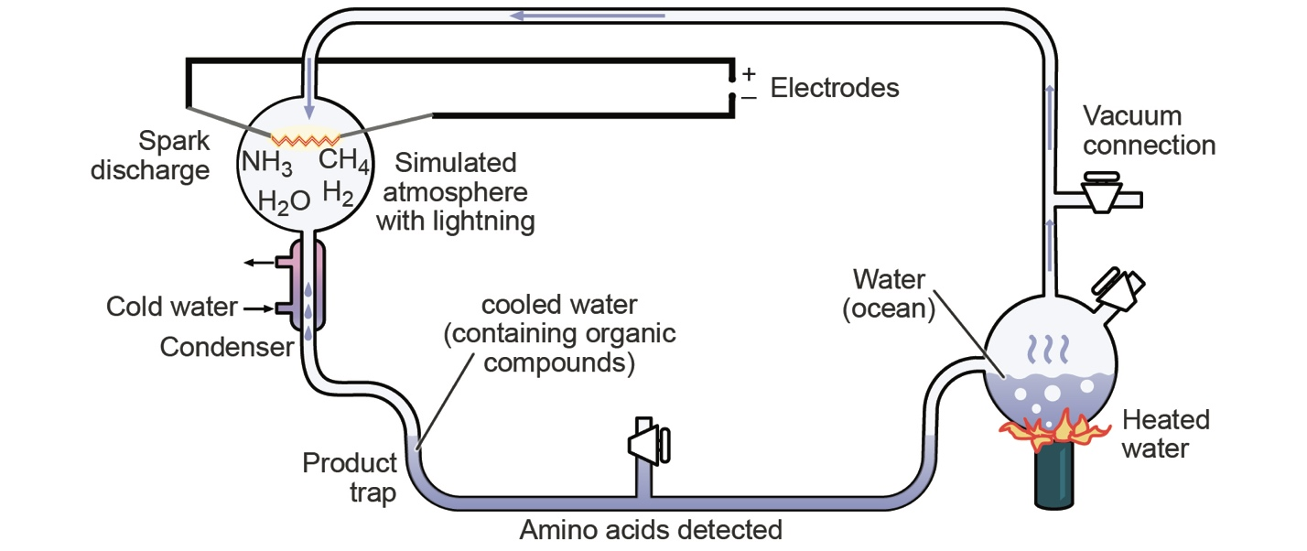

Experimental Variable | Explanation

Activity 2. Modifying the Miller-Urey Model
- Review the model of the experimental setup in Activity 1.
- Based on the experimental design and your understanding of the major biological molecules, identify one experimental change that can be made to the Miller-Urey model to support current researchers’ hypotheses of early Earth.
- Next to the proposed change, explain why that is necessary.

Modification to Design | Explanation

Activity 3. Making Predictions Using the Miller-Urey Model
- Review your change to the Miller-Urey model and the background information provided.
- Construct a null hypothesis for the relationship between your change and the formation of organic molecules.
- Following your null hypothesis, make a prediction for how this change would affect the outcome of the experiment based on your understanding of how organic material forms.

Null hypothesis:

Prediction:

Written Analysis

Answer the questions below.
- Based on the text and information provided, what major modification did modern researchers make with the Miller-Urey hypothesis? What type of evidence do you expect supported this change?

- The Miller-Urey model and other prior hypotheses of early Earth were based on the notion that life began in the ocean, acting as a “primordial soup.” Explain how this idea alone does not fully account for how simple monomers eventually formed complex polymers. In your explanation, consider how polymers are synthesized from monomers.

- Consider the environment needed to jumpstart the formation of organic molecules from inorganic molecules. What other models or hypotheses must be considered for the origins of organic molecules in a less reducing atmosphere?

