Assignment Summary
For this assignment, you will respond to a long free-response question (FRQ).

Free-Response Question
Yeasts are single-cell microbes that usually reproduce asexually by a process called budding. Budding occurs when part of the cell is pinched off and develops into an identical cell.

Yeast cells sometimes reproduce sexually by mating. Yeast cells mate by initiating a signaling pathway that leads to the production of shmoo cells (see Model 1). This occurs when one cell of each sex join together, mate, and then move apart again. This process involves producing a nodule, called a shmoo, which the cells use to join together. The process takes about two hours.

Model 1. Signaling Pathway in Yeast Mating

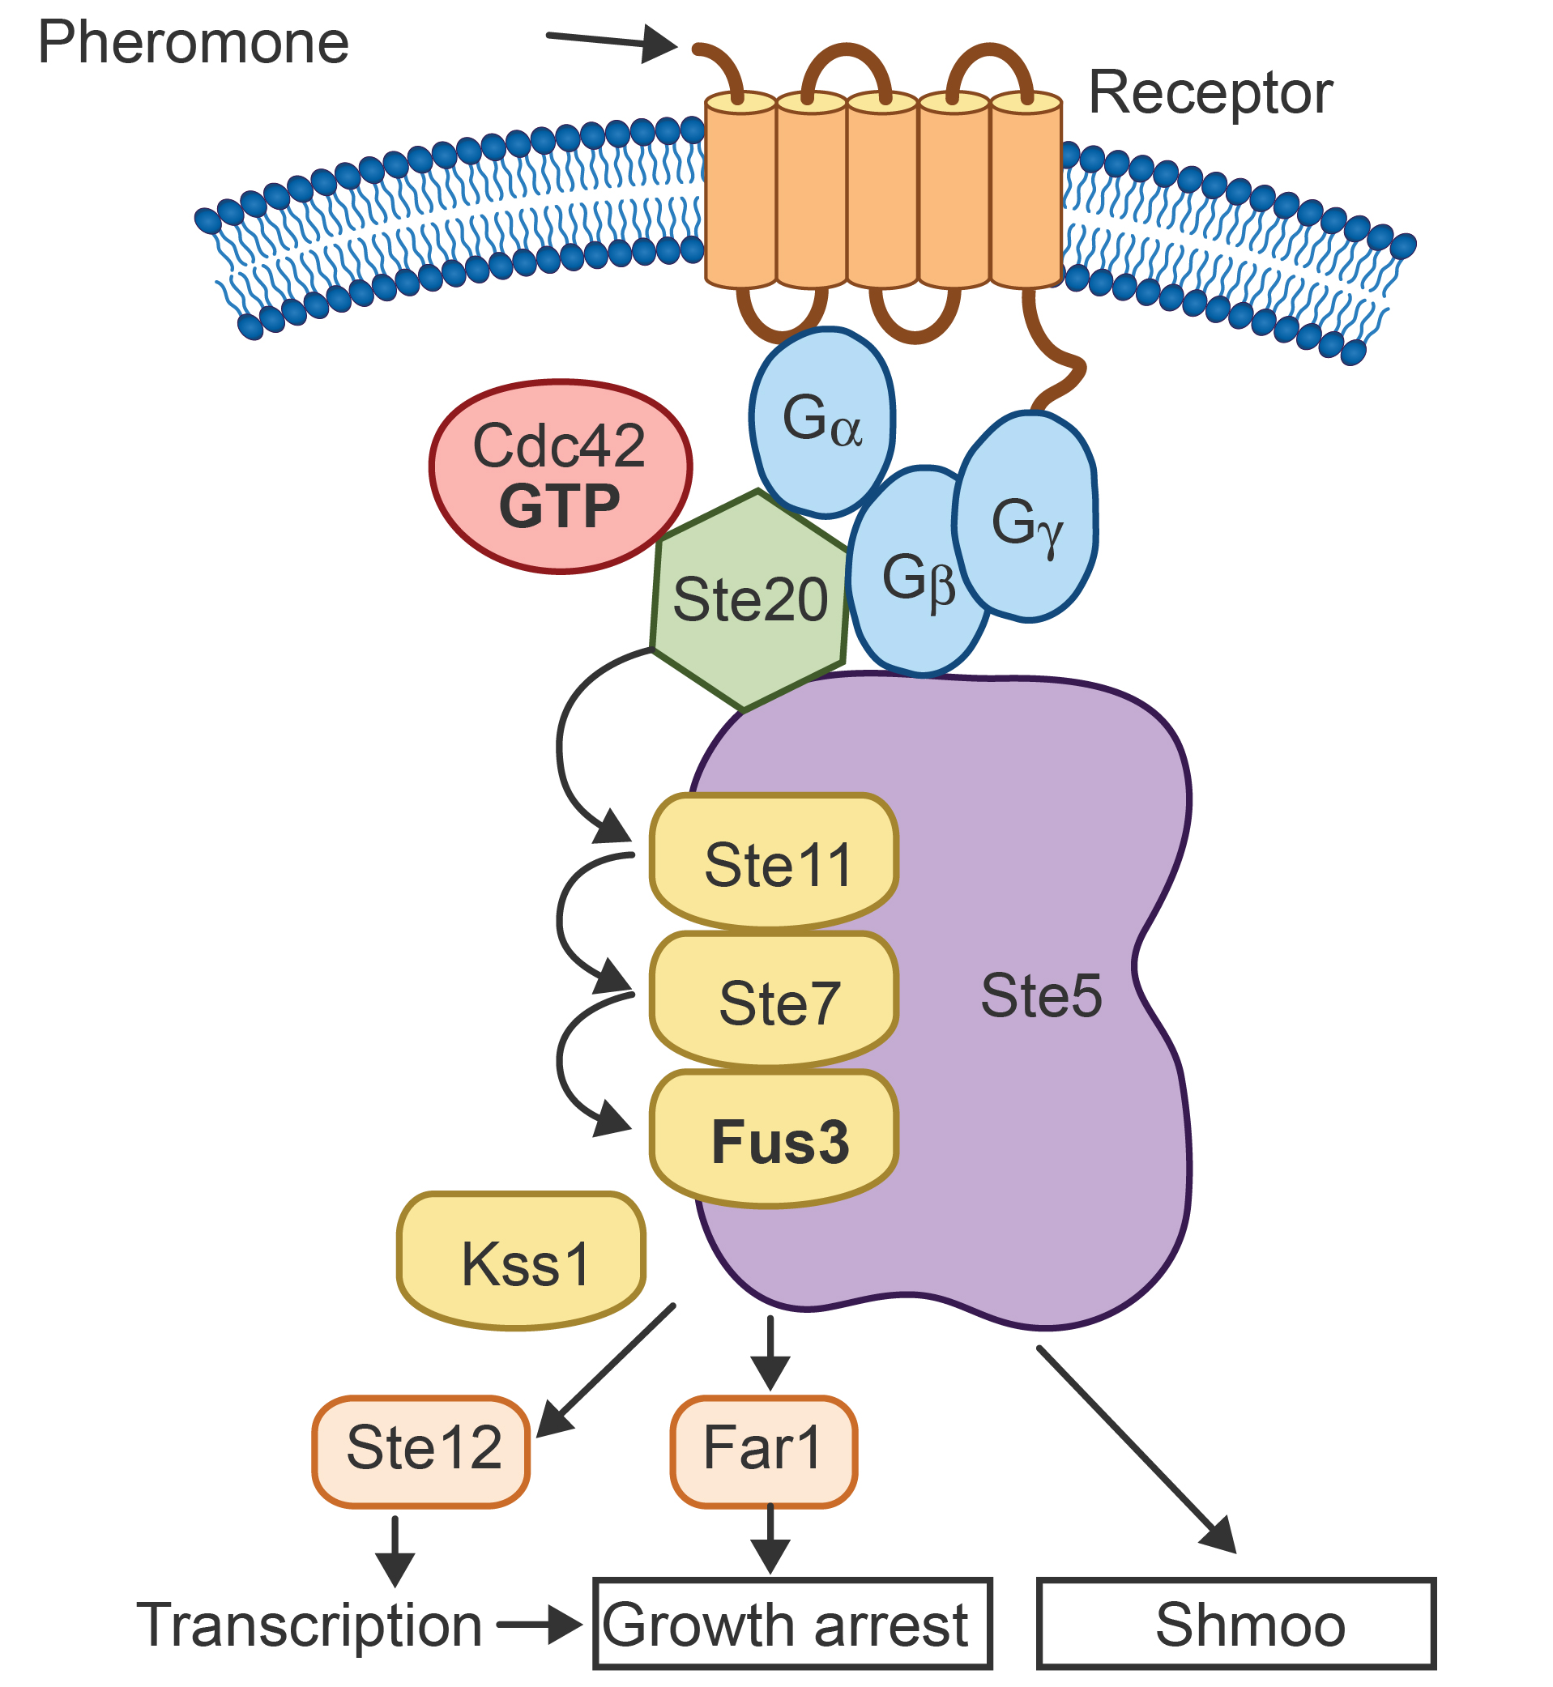

A scientist noticed that not all variants of yeast mate at the same rates. She decided to conduct an experiment to determine how a pheromone affects the mating rates of different variants of yeast. She tested three types of yeast, and treated them with different types of pheromones. See her procedure and results in the charts below. Then, answer the questions that follow.

Experimental Procedure and Results
These results show how many cells of each type of yeast showed mating structures after being exposed to three different yeast mating pheromones.
For each yeast cell type, a group of 1000 cells were given the Wild Type-created pheromone. Then, another group of 1000 cells were given the Variant 1-created pheromone, and then another group of 1000 cells were given Variant 2-created pheromone. The same concentration of pheromone was given to each group. After 48 hours, the cells were observed. Cells that had differentiated by showing mating structures were counted.

Table 1. Effect of Different Pheromone Treatments on Wild Type Yeast Cell Differentiation
Pheromone Treatment | Number of Cells That Differentiated
Wild Type-created | 450
Variant 1-created | 606
Variant 2-created | 50

Table 2. Effect of Different Pheromone Treatments on Variant 1-Type Yeast Cell Differentiation
Pheromone Treatment | Number of Cells That Differentiated
Wild Type-created | 203
Variant 1-created | 411
Variant 2-created | 21

Table 3. Effect of Different Pheromone Treatments on Variant 2-Type Yeast Cell Differentiation
Pheromone Treatment | Number of Cells That Differentiated
Wild Type-created | 120
Variant 1-created | 81
Variant 2-created | 100

- Identify a signaling molecule from the model presented. Explain how receptors play a role in cell differentiation.

- Identify the dependent variable and two controls the experimenters used when conducting this experiment.

- Evaluate if the number of Variant 1-Type cells with mating projections was significantly different from those of the Wild Type. Use chi-square analysis.

- Scientists propose that a mutation has occurred that either changed the mating pheromone or receptor site on the Variant 1-Type yeast cells. Predict where the mutation occurred. Justify your prediction with evidence from the experiment and scientific reasoning, based on your knowledge of cell-signaling pathways.

