Assignment Summary
For this assignment, you will explore and analyze evidence for evolution.

Background Information
Evolution refers to the change in genetic makeup of a population over time. There are various types of evidence that support the theory of evolution. Data can be morphological, which focuses on the physical features (shape, structure, appearance, etc.) of an organism. There is biochemical data that relies on substances found in living things, such as protein and DNA sequences. Lastly, geological data is also available where scientists use the physical features of Earth to provide evidence of evolution. When studying morphologies, analyzing similar structures is important. They provide evidence for common ancestry between organisms, or of convergent evolution. It is sometimes difficult to know which unless there are other types of evidence present.
One example of convergent evolution studied in a variety of insects is the evolution of the mandibles, or crushing organs, in the mouthparts of insects. Mandibles are responsible for chewing food. Insects that consume similar plant species or plant parts have similar mandible morphology, suggesting that the structure of the mandibles is adaptive. One example is the mandibles of grasshoppers that eat different grasses. Almost identical mandibles with sharp incisor regions and ridged molar regions have evolved in at least eight species of grasshoppers. Their enlarged closer muscles enable these insects to eat tough grass blades, but this change in muscle size has the tradeoff of limiting how wide the mandible can open. How wide a mouth can open is called its gape. A small gape limits the thickness of leaves that can be bitten.

In this project, you will analyze how two grasshopper populations evolved by natural selection due to their food source. These insects are most effective at obtaining food when their gape matches the thickness of the grass they are feeding on. Scientists used gape size to evaluate mandible adaptations that this insect species has developed over time. In this activity, you will predict and graph how the two grasshopper populations will evolve if their food sources change.

Materials

- Graphs of grasshopper gape lengths
- Sheets of paper
- Pencils

Assignment Instructions
For this project, you are expected to submit the following:
- A graphic organizer analyzing graphs of grasshopper gape lengths in populations A and B
- A prediction of grass thickness for populations A and B
- A graph of grasshopper gape length for population A after two generations if grass thickness remains stable
- A graph of grasshopper gape length for population B after two generations if grass from environment A moves into environment B
Step 1: Prepare for the project.
- Read through the guide before you begin so you know the expectations for this project.
- If anything is unclear to you, be sure to ask your teacher.
Step 2: Analyze the graphs of grasshopper gape lengths.
- Analyze the graphs of grasshopper gape lengths for populations A and B.
- Complete the graphic organizer.
Step 3: Predict the thickness of grass in each environment.
- Use the graph to predict the thickness of grass in environments A and B.
Step 4: Predict how populations will change over time if food sources change.
- Invasive grasses from environment A move into environment B. Environment A remains the same.
- Predict how environmental change and stability will affect gape size in populations A and B.
- Draw a graph of expected gape size in population A after two generations.
- Draw a graph of expected gape size in population B after two generations.
Step 5: Evaluate your project using this checklist.
If you can check each box below, you are ready to submit your project.
- Did you analyze the graphs of grasshopper gape lengths for populations A and B and complete the graphic organizer?
- Did you predict the grass thickness in each environment?
- Did you predict how the populations will change or remain stable when thick grasses move into environment B?
- Did you draw graphs predicting the gape size of populations A and B after two generations following environmental change?
- Did you include titles, scales, and labels on your graphs?
Step 6: Revise and submit your project.
- If you were unable to check off all of the requirements on the checklist, go back and make sure that your project is complete. Save your project before submitting it.
- Turn in your hypothetical graphs to your teacher. Be sure that your name is on it.
- Submit your graphs predicting gape size through the Virtual Classroom.
- Congratulations! You have completed your project.

Analyzing Graphs of Grasshopper Gape Size

Analyze the graphs of grasshopper gape lengths for populations A and B. Then complete the graphic organizer below.
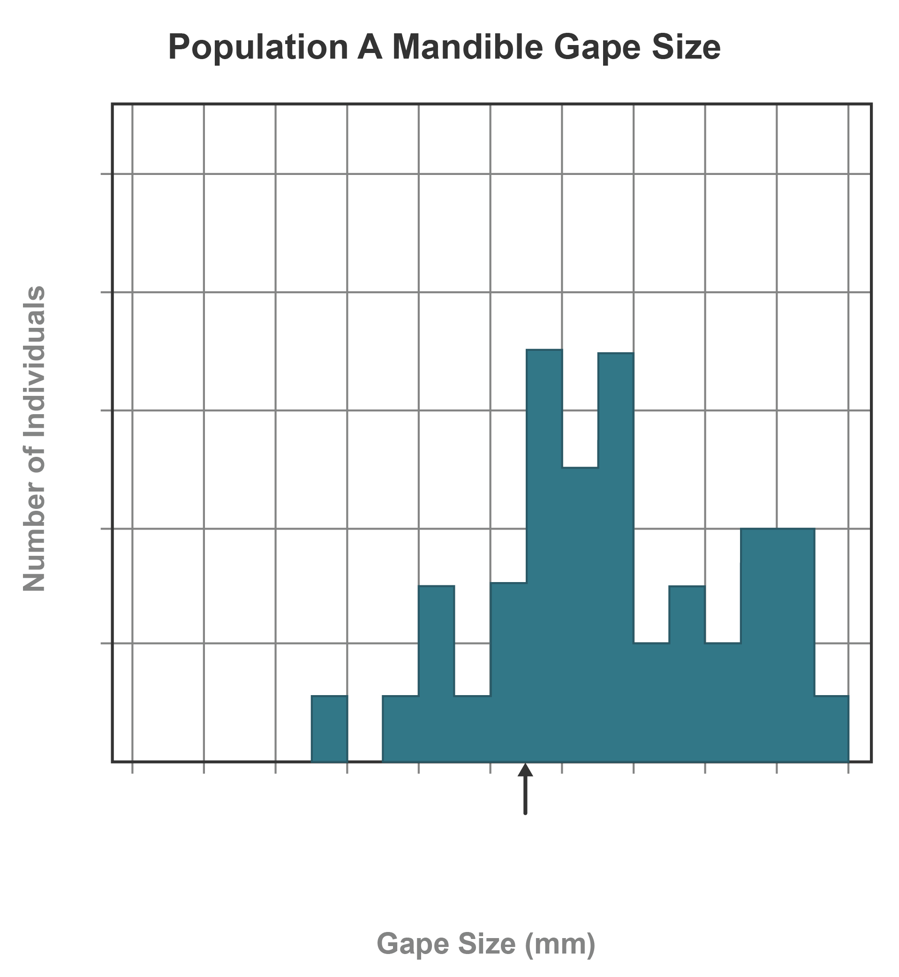

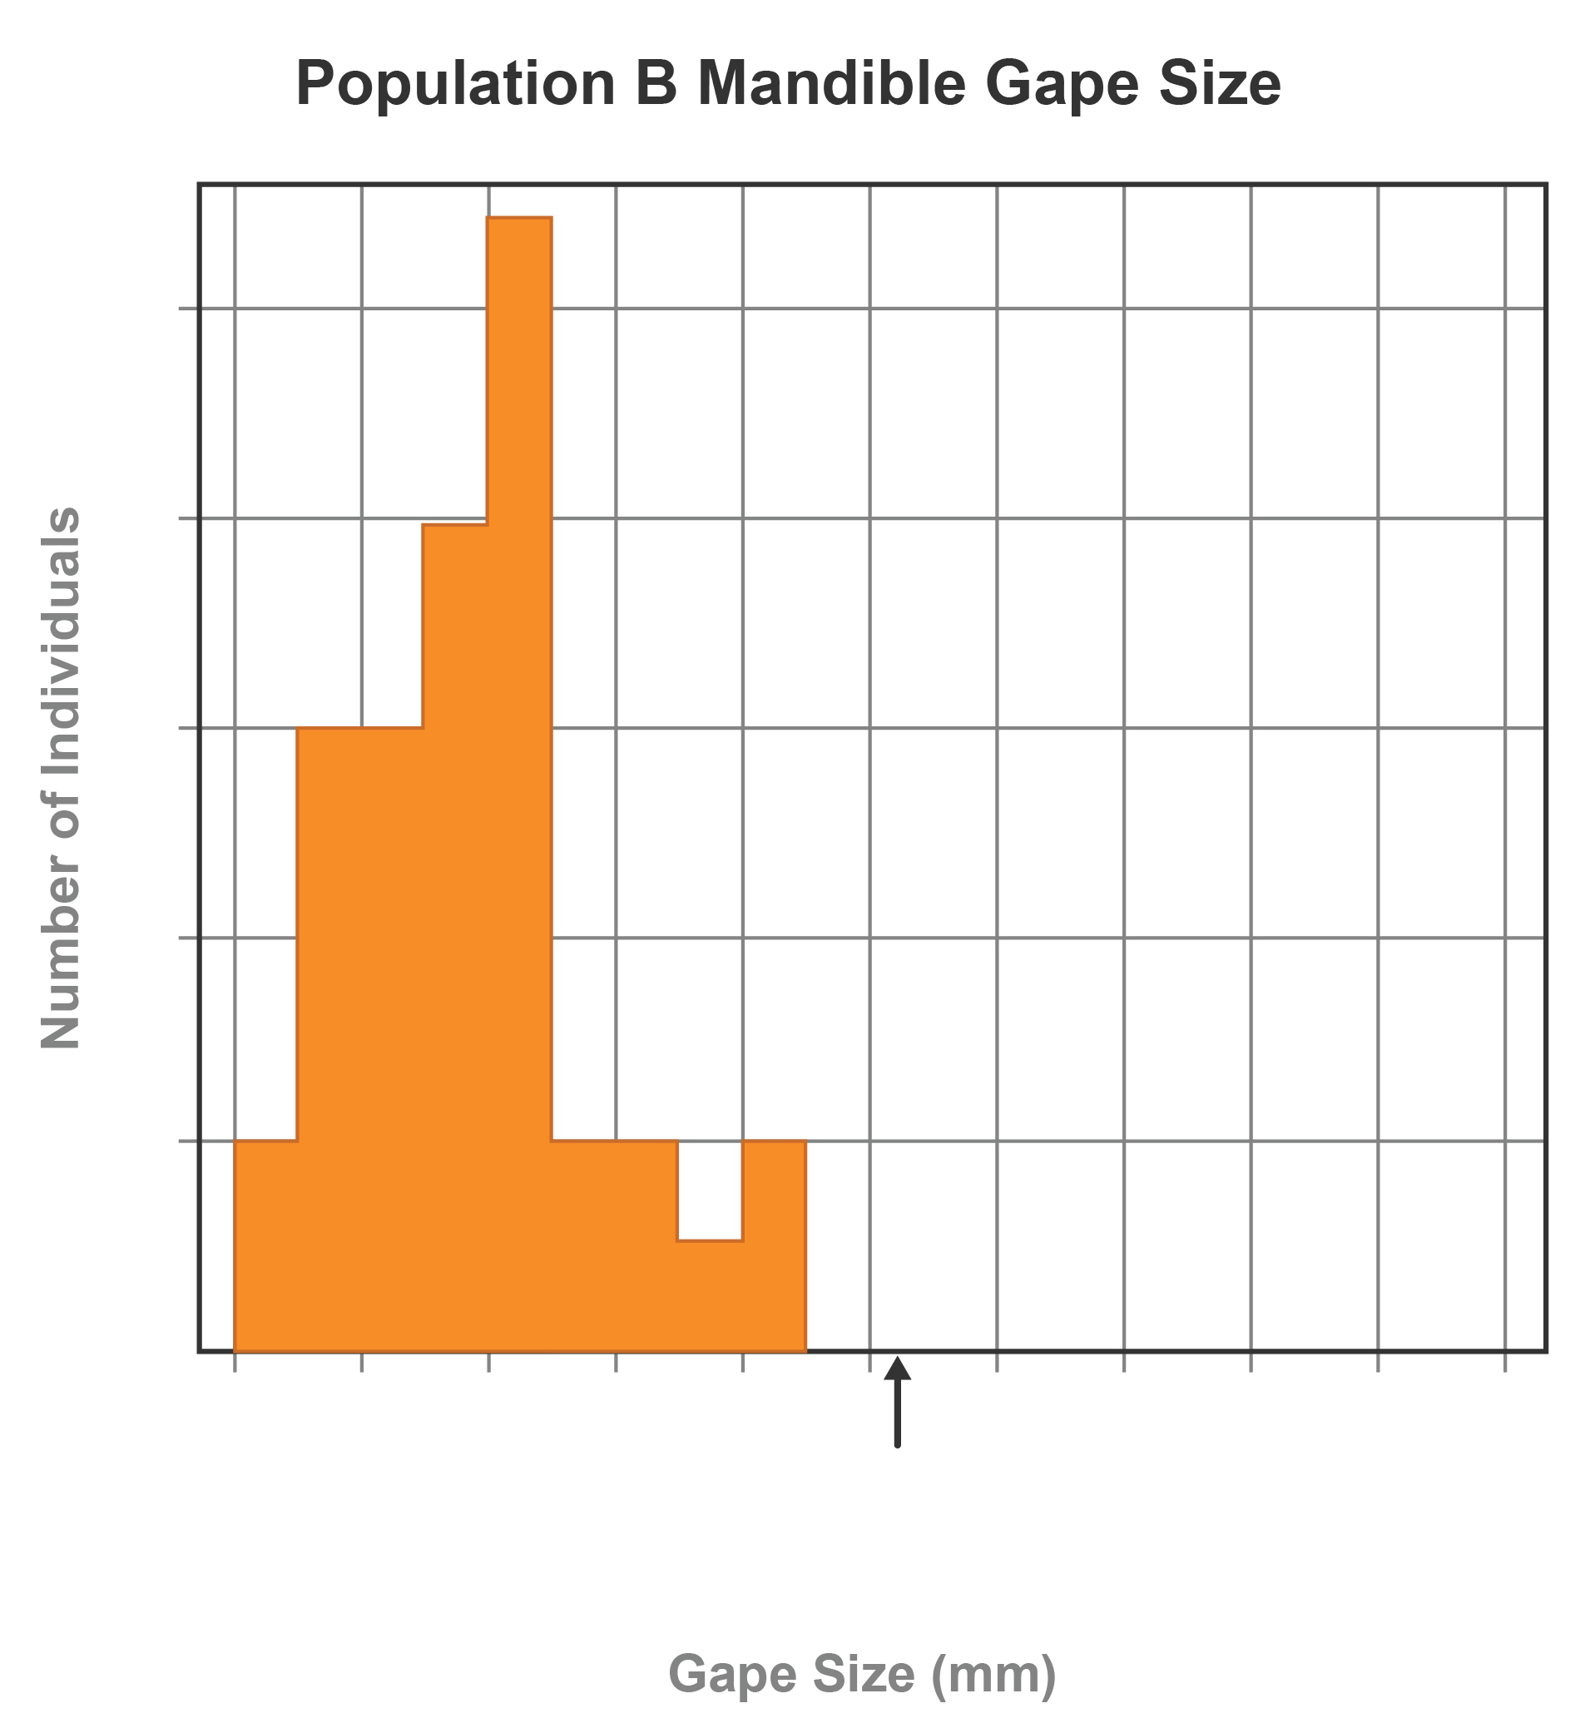

Analyzing Gape Length in Two Populations

Independent variable in both graphs
Dependent variable in both graphs
In population A, the range of gape size
In population A, the gape size with the most individuals

In population B, the range of gape size
In population B, the gape size with the most individuals

Predicting Grass Thickness in Two Environments

- Predict the range in grass thickness in the environment for grasshopper population A. Explain your reasoning.

- Predict the range in grass thickness in the environment for grasshopper population B. Explain your reasoning.

Predicting the Effects of Environmental Stability and Change

Invasive grasses from environment A move into environment B. Environment A remains the same.

- Predict how environmental stability will affect gape size in population A over two generations. Explain your reasoning.

- Invasive grasses from environment A move into environment B. The invasive grasses from population A slowly replace the grasses from population B over time. Predict how the environmental change will affect gape size in population B over two generations. Explain your reasoning.

- Draw a graph of expected gape size in population A after two generations.

- Draw a graph of expected gape size in population B after two generations.

