Pre-Lab Information
Purpose To calculate biomass and net primary productivity for Wisconsin Fast Plants®
Time Approximately 90 minutes, over several days
Question How does net primary productivity change over time?
Summary In this investigation, you will plant 30 plants and periodically measure their mass. Then, you will calculate the biomass and net primary productivity. Finally, you will design an additional experiment to test how certain factors affect the net primary productivity of plants.

Safety
- Behavior in the lab needs to be purposeful.
- Handle all plants carefully and follow the teacher’s directions.
- Report all accidents—no matter how big or small—to your teacher.

Lab Procedure
- Gather materials.
- 40–50 seeds  - Scale  - Drying oven  - Calculator | - Planters  - Water  - Soil
- Prepare your seeds.
  - Plant your seeds using the directions given by your teacher. You will need about 30 plants for this experiment, so plant 50 seeds to make sure enough will germinate.
  - Label your planters and place under lights for the duration of the experiment. Follow any specific directions given by your teacher for planting your seeds.
  - Check the moisture of the soil each day. Provide the plants with enough water to keep the soil moist but not soggy. You will likely water them every other day.
- Mass your plants.
  - After seven days, carefully remove 10 plants from your planter.
  - Carefully remove the plants from their containers, and then clean the roots and remove the soil.
  - Mass the plants using the scale. You can mass all 10 plants together. This is the wet mass. Record the wet mass in Table A.
  - You will need to find the dry mass as well. Place the plants on a metal tray, and then place them on one of the shelves of the drying oven. Keep them in the drying oven for at least 24 hours until they are completely dry. You will be able to mass the dry plants the following day. Record the dry mass in Table A.
  - Repeat this step for 10 more plants after 14 days and then again for 10 more plants after 21 days. Record the wet and dry masses in Table A.

- Calculate the percent biomass and net primary productivity.
  - Using the wet and dry masses, calculate the percent biomass after 7, 14, and 21 days. Record your calculations in the Table A.
  - Calculate the net primary productivity for each time period. Remember, the dry mass is the biomass needed to calculate energy. Then, use the calculated energy to determine the net primary productivity per plant per day. Record the net primary productivity in Table A.
  - Graph the net primary production over time in Graph A space below. Your x-axis will be column 1 from your table. Column 6 will be your y-axis. Make sure you include a title for your graph.
- Clean up your area.
  - Return unused materials and dispose of any trash according to your teacher’s directions.
Step 6: Complete and submit your lab.
    - Did you complete all data tables and calculations?
    - Did you complete all analysis questions?

Data
Record your data either in your lab notebook or in the space below. Then create a graph using your data.

Table A: Net Primary Productivity for Wisconsin Fast Plants
Time (Days) | Wet Mass (10 Plants) | Dry Mass (10 Plants) | Percent Biomass | Energy (dry mass x  4.35 kcal/10 Plants) | Net Primary Productivity (per Plant per Day)
7
14
21

Graph A:

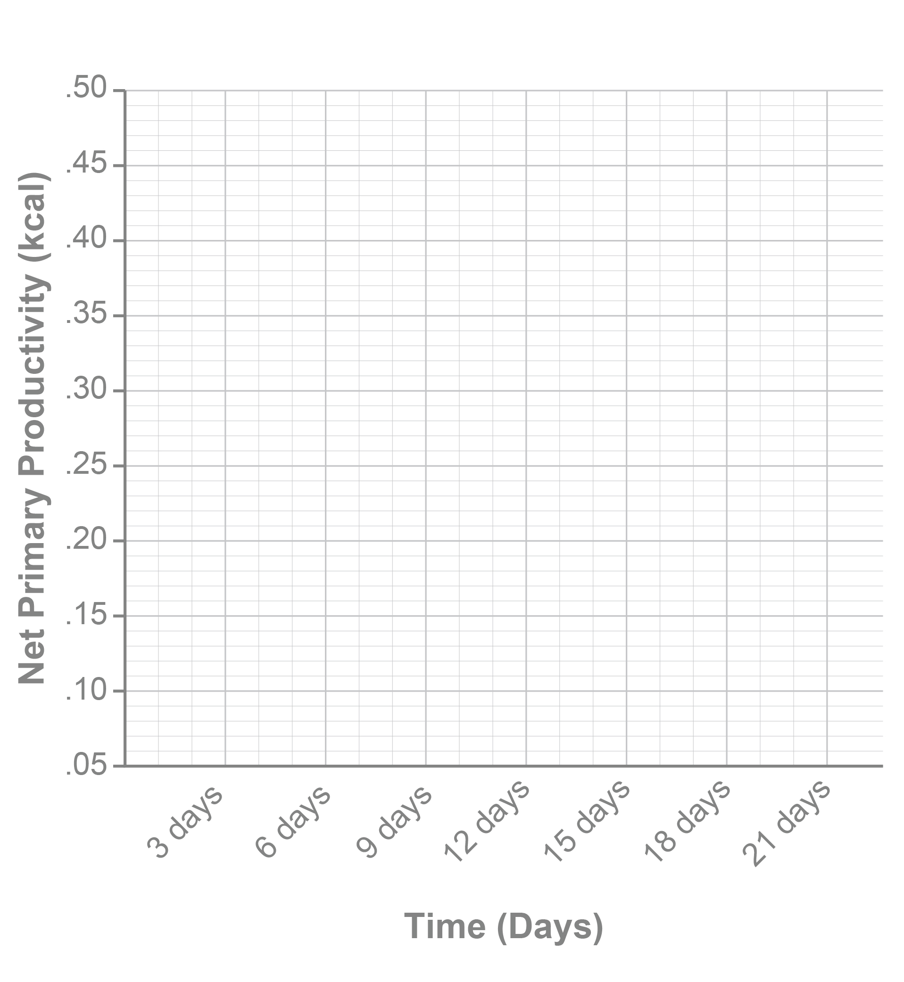

Follow-Up Questions
Answer the following questions.
- Explain the net primary productivity of the plants after 7, 14, and 21 days. Why do you think productivity increased over time?

- Make a prediction about how the amount of light would affect the net primary productivity. Then, predict how this would affect the rest of the ecosystem. Be sure to justify your answer.

- Design an additional experiment to test how certain factors (choose one: humidity, amount of light, or type of plant) affect the net primary productivity of plants. Explain how you would conduct this experiment. Include a description of the control and experimental groups, and how you would conduct the experiment.

