Assignment Summary
For this essay, you will respond to a long free-response question (FRQ) similar to those asked on the AP Biology examination.

Free-Response Question
A scientist studies the effects of growth factors on cell division. She sets up several experiments with mammalian cultured HeLa cells and epidermal growth factor, EGF. In the first experiment, she finds that when the cells in limited media are grown with the addition of EGF, they divide and proliferate at normal rates, and those grown without EGF divide at much slower rates. She repeats the experiment with normal cells and cancer cells. She arranges a third experiment to compare HeLa cells treated with different concentrations of EGF and the resulting cell division and growth. See her results in the charts below.
Model 1. Epidermal Growth Factor Pathway
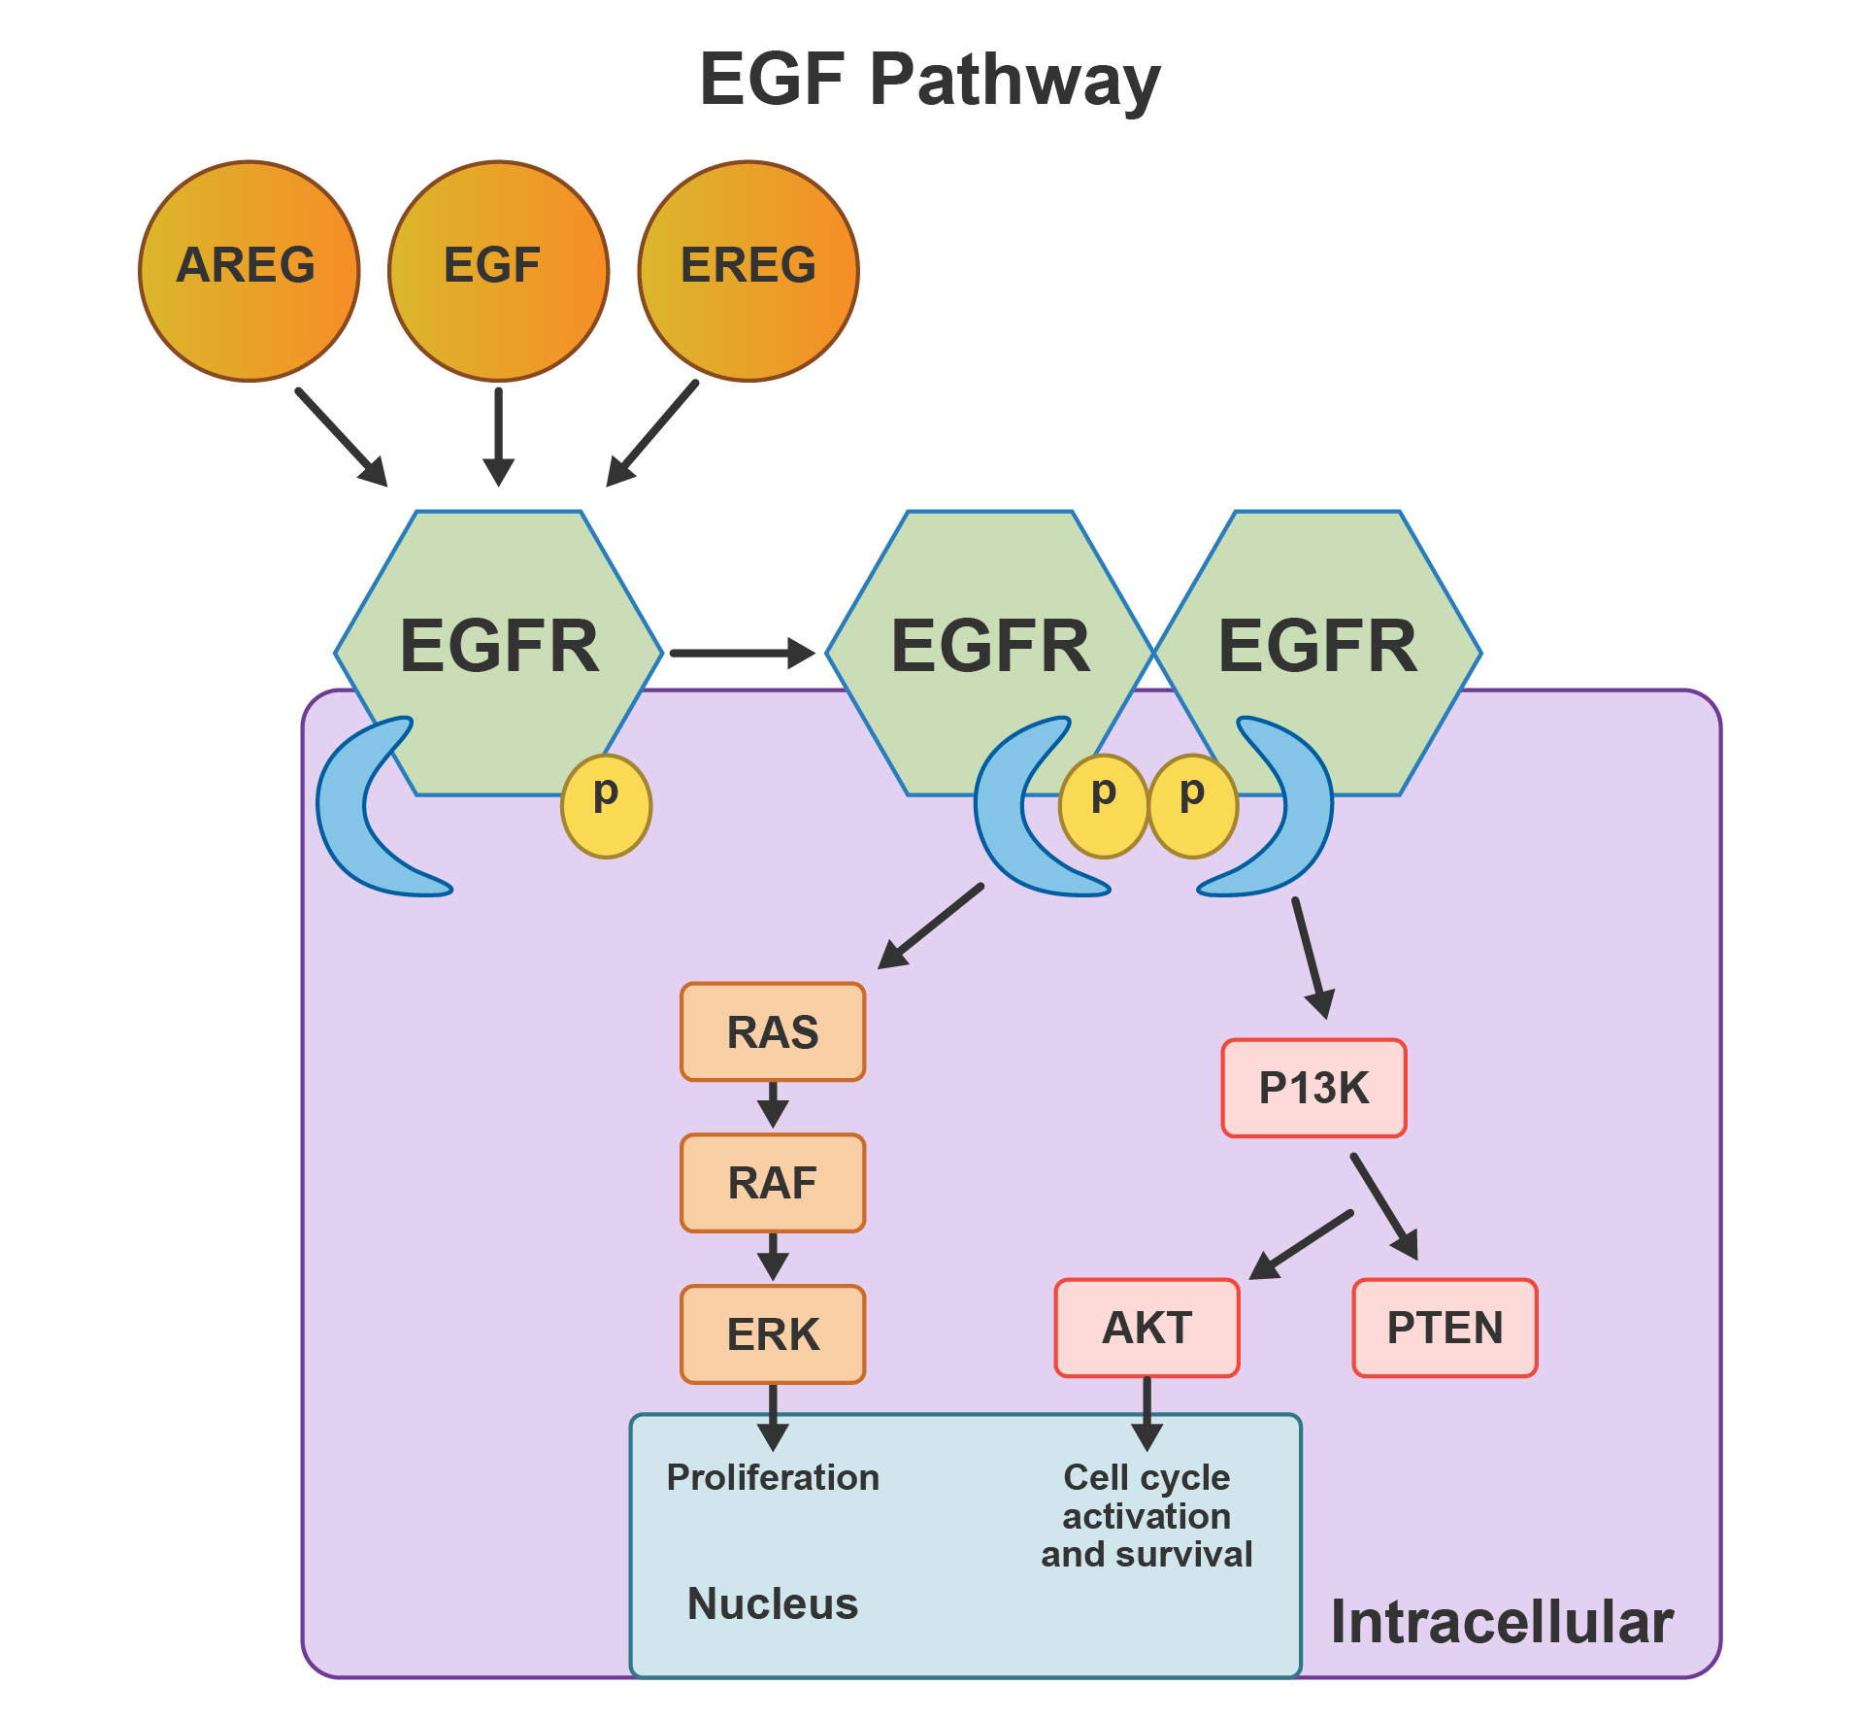
Table 1. Experiment 2 Results
Cell Type | EGF Treatment (ug) | Time: 0  Cells in M Phase | Time: 0  Total Cells | Time: 24h  Cells in M Phase | Time: 24h  Total Cells
HeLa | 0 | 7 | 50 | 2 | 57
HeLa | 10 | 8 | 50 | 29 | 90
Cancerous | 0 | 22 | 50 | 4 | 60
Cancerous | 10 | 27 | 50 | 286 | 465

Table 2. Experiment 3 Results
Cell Type | EGF Treatment (ug) | Time: 0  Cells in M Phase | Time: 0  Total Cells | Time: 24h  Cells in M Phase | Time: 24h  Total Cells
HeLa | 0 | 11 | 75 | 8 | 73
HeLa | 0.5 | 15 | 75 | 23 | 104
HeLa | 5 | 18 | 75 | 45 | 160
HeLa | 10 | 9 | 75 | 68 | 188
HeLa | 25 | 13 | 75 | 105 | 235

- Describe how EGF affects cell division.

- Identify the role of each experiment in determining the difference in how cancer and normal cells respond to EGF.

- Calculate the mitotic index (number of cells in mitosis divided by total cells) for each kind of cell. Compare the mitotic rates for each cell type

- Predict the cause of rapid growth in the cancer cells observed in experiment 2. Justify your answer with evidence and reasoning.

