# Assignment Summary

For this assignment, you will analyze data and draw conclusions about how biodiversity affects the stability of ecosystems and individual species.

# Background

Ecology not only involves looking at how factors interact in an ecosystem, but also how Earth’s constantly changing environments affect its ecosystems. Numerous factors can cause the environment to change, including climate patterns, human activity, and industrialization. One aspect of an ecosystem that can determine the impact of these changes is biodiversity. Biodiversity is determined through both the diversity among all species in an ecosystem as well as the genetic diversity within an individual species’ population. High variation in species allows the population to better adapt to a changing environment. This results in a population undergoing natural selection. In turn, natural selection decreases genetic diversity by selecting for specific, advantageous traits in the population.

Humans can have one of the largest impacts on the biodiversity of an ecosystem and eventual sustainability. Humans accelerate change at a local and global event. This occurs through habitat loss, overharvesting, agriculture, and the introduction of nonnative species. Habitat loss often occurs due to increased industrialization, resulting in forestry loss and increased land use through agriculture. This in turn destroys the biodiversity of an ecosystem and contributes to global climate change with the removal of carbon sinks. Humans can also affect ecosystems through purposeful and often accidental introduction of a non-native species to an ecosystem. Non-native species become invasive species when they outcompete the native species for resources and have very few limiting factors to keep them in check. This results in a species that grows rapidly and uncontrollably, which can completely destroy an ecosystem over time. Because humans are having such a negative impact on ecosystems, more research has been allocated to the conservation of habitats and biodiversity.

Materials

* Writing and drawing supplies (colored pencils, paper, etc.)
* Access to the internet, lesson, student edition, and other reference materials

# Assignment Instructions

For this project, you are expected to submit:

1. A completed version of this guide, featuring your labeled diagrams and written analysis.

**Step 1: Prepare for the project.**

1. Read through the guide before you begin so you know the expectations for this project.
2. If there is anything that is not clear to you, be sure to ask your teacher.

**Step 2: Complete Activity 1.**

1. Review and analyze the information and research data provided.
2. Select a hypotheses to reject and a hypotheses to accept for both figures A and B.
3. Explain why those hypotheses are rejected and accepted using evidence from the graphs.

**Step 3: Complete Activity 2.**

1. Using the graphic organizer, identify 1-2 reasons why the trend between the two variables is observed in Figure A. Do this for Figure B as well.
2. Beside each reason, provide an explanation using ecological concepts for why that reason is appropriate.

**Step 5: Complete the questions in the Written Analysis section.**

**Step 6: Evaluate your project using this checklist.**

If you can check each box below, you are ready to submit your project.

* Did you reject a hypothesis and accept a hypothesis for Figure A?
* Did you reject a hypothesis and accept a hypothesis for Figure B?
* Did you explain your selection of hypotheses using evidence from Figure A and B?
* Did you identify 1-2 reasons to explain the trends seen in both Figure A and B?
* Did you further explain your reasons using ecological concepts?
* Did you answer the **Written Analysis** questions?

**Step 8: Revise and submit your project.**

1. If you were unable to check off all of the requirements in the checklist, go back and make sure that your project is complete. Be sure to save your project before submitting it.
2. Turn in your student guide with written analysis to your teacher. Make sure that your name is on it.
3. Congratulations! You have completed your project.

Activity 1: Assessing Stability in Ecosystems

Researchers at Cedar Creek Science Reserve have been exploring the relationship between biodiversity and stability in ecosystems through numerous studies. In 1995, David Tilman and his colleagues conducted a study involving plant diversity in terrestrial ecosystems. They set up 168 experimental land plots that varied in number of perennial plant species. Plots either received 1, 2, 4, 8, or 16 species and were observed over a ten-year period. The climate varied significantly throughout each year over the ten-year period.

The figures below show the data. Figure A shows the data measuring the relationship between species number and ecosystem stability while Figure B shows the relationship between species number and species stability (within an individual species population). Data points represent specific time points of data collection for the various plots over the ten-year span. Stability can be described as low variability from a system’s average state despite changing environment over time. Researchers measured this by assessing the constancy of biomass production annually for each plot or for each species within the plot. A linear regression model was run for both data sets to describe the relationship between the variables for predictive analysis purposes (seen through the regression line).

**Figure A:**



**Figure B:**

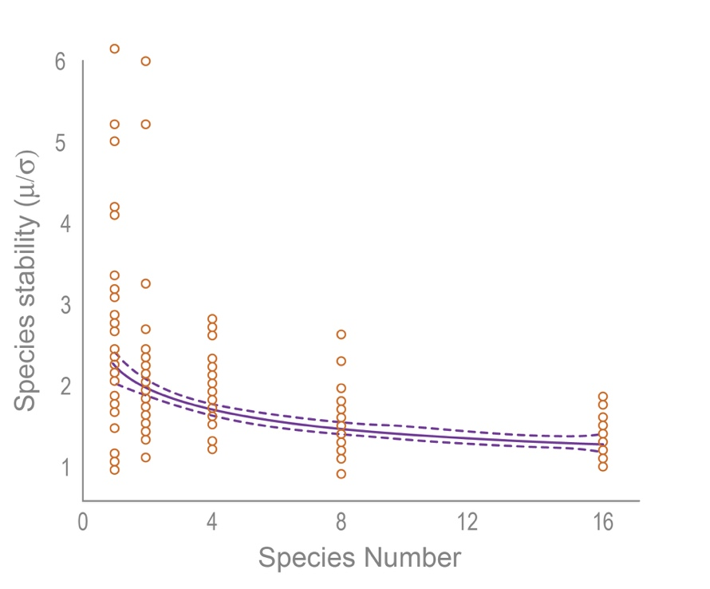

Based on the information and data provided, evaluate the null and alternative hypotheses below that describe the possible relationships between the tested variables. For each figure provided, state which hypotheses can be accepted or rejected based on the figure’s data. Explain the accepted/supported and rejected hypotheses using supporting evidence from the data.

1. There is no relationship between species diversity and ecosystem stability.
2. There is a relationship between species diversity and ecosystem stability.
3. There is no relationship between species diversity and species stability.
4. There is a relationship between species diversity and species stability.

|  |  |
| --- | --- |
| **Figure A** | |
| Hypotheses |  |
| Explanation |  |

|  |  |
| --- | --- |
| **Figure B** | |
| Hypotheses |  |
| Explanation |  |

Activity 2: Reasoning using Ecological Concepts

For each data set in activity 1, provide 1-2 possible reasons for the observed relationships. Explain your reasons using ecological concepts.

|  |  |
| --- | --- |
| **Figure A** |  |
| **Figure B** |  |

Written Analysis

Answer the questions below.

1. Numerous research studies have been conducted on how a non-native species can possibly affect the health of an ecosystem. This issue has become more prevalent over the past century due to increased globalization. When looking at the data that shows the relationship of species richness and the number of non-native species across all latitudes, a distinct pattern emerges: non-native species occur in higher amounts closer to the poles and in fewer closer to the equator. Based on the activities you completed, explain why this difference might be seen in high- and low-diverse ecosystems.
2. Environmental impact has also been seen through human activity with agriculture. This is due to the high amounts of monoculture farming. Although having large agricultural fields of one crop can be efficient, it results in attracting a higher number of pests, which, in turn, results in a high use of pesticides. Identify a solution that would possibly remedy this issue and explain why that action would be beneficial.