Pre-Lab Information
Purpose Explore Newton’s first two laws of motion using a laboratory procedure.
Time Approximately 60 minutes
Question How can Newton’s laws be experimentally verified?
Hypotheses Part I: If an object is in motion, then the object will stay in motion because the object has inertia.
Independent Variable: whether or not the car hits the barrier
Dependent Variable: the velocity of the washer after the car hits the obstacle
Part II: If force is applied to a car, then its acceleration will change proportionally, as predicted by Newton’s second law, F = ma.
Independent Variable: the force applied to the car
Dependent Variable: the acceleration of the car
Summary Students will build a simple track for a toy car. In Part I, students will place a washer on top of the toy car and observe the motion of the washer as the car encounters a barrier. In Part II, students will apply forces to the car on a flat plane and measure the car’s acceleration.

Safety
- Always wear a lab coat and safety goggles when performing an experiment.
- Behavior in the lab needs to be purposeful. Use caution when releasing the cars and measuring their motion.
- Report all accidents—no matter how big or small—to your teacher.
- Set up your track in an area that has enough room to take measurements, but is not so large as to interfere with other people in the area.

Lab Procedure
- Gather materials.
- Toy car or physics cart  - 3/8-inch metal washers  - 1 m of string  - Stopwatch  - Marker | - Track  - Textbooks  - Pulley  - Protractor | - Metric tape measure  - Masking tape  - Paper clip  - Mass balance

Part I: Newton’s First Law of Motion
- Set up the experimental track.
  - Use the textbooks to set up the track. The first track will be a ramp with an angle of approximately 30°. See Figure 1.

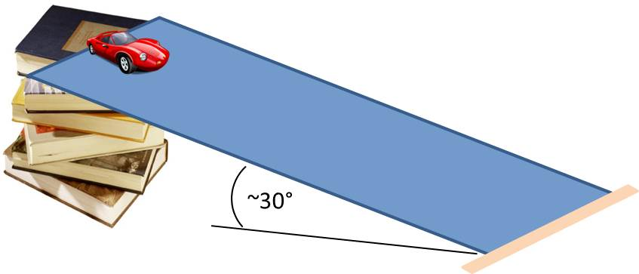
Figure 1
  - Place a piece of masking tape at the bottom of the ramp to make a smooth transition from the ramp to a flat surface (desk, table, floor, etc.).
  - Use masking tape to form a small cradle for a washer on top of the toy car. The edge of the masking tape lip should be the same height as the washer. See the tape cradle on the toy car in Figure 2 for reference.

Figure 2

  - Add a 3/8-inch washer to the top of the car, placing it in the masking tape cradle created in the previous step. Do not tape down the washer; rather, allow it to rest on top of the car.
  - Perform a few trial runs to ensure that the car transitions smoothly and the washer remains on top of the car. Release the car at the top of the ramp, making sure not to push it or add any additional force to it. The transition should be smooth enough that the washer stays in place. Once you have determined an ideal starting point, mark this position on the ramp so that the car can begin at the same position for each trial.
  - Measure and record the height of the ramp at its start (the height of the book stack) in Table A.
  - Use a mass balance to determine the mass of the car/washer system, and record this total mass in Table A.
- Establish a baseline for comparison.
  - Release the car from the marked starting position at the top of the ramp. Measure the total distance it travels from the start and past the end of the ramp, and record in Table A whether or not the washers maintained their position.
  - Repeat Step 3a two more times, and then average the three distances to serve as a baseline for comparison.
- Explore Newton’s first law of motion.
  - Place a textbook at the bottom of the ramp so that it crosses the path of the car. See Figure 3 for reference.

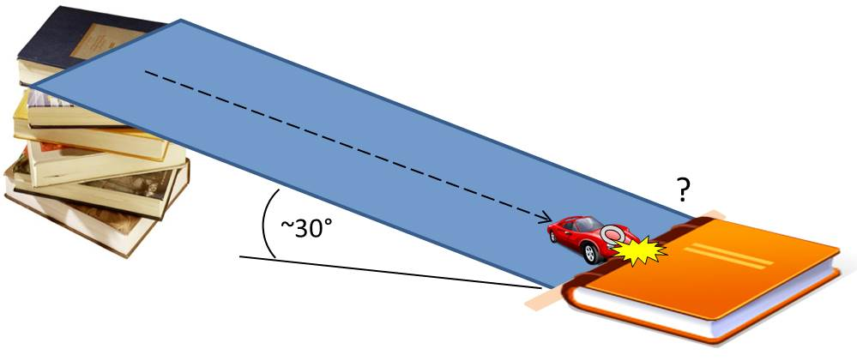Figure 3

  - Release the car from the top of the ramp.
  - Observe what happens to the washer after the car hits the textbook. Measure the distance the car traveled to the textbook and record this distance in Table B.
  - Measure how far the washer traveled. This is the total distance from the top of the ramp to the washer’s resting point. Record the distance in Table B.
  - Repeat Steps 4b–4d two times, and then average the distances that the car and washer traveled.
  - In Table B, write down in your own words what happened to the washer when the car was stopped by the textbook.

Part II: Newton’s Second Law of Motion
- Reconfigure the track.
  - Remove the textbook from the track.
  - Lay the track flat on a table. Mark the track at 0.25 m and 0.50 m.
  - Place a pulley beyond the end of the track, at the edge of a table. Attach a string to the front of the car, and run the string over the pulley so that the string hangs over the edge of the table. Attach a paper clip to the opposite end of the string, as shown in Figure 4. When the car is placed at the start of the track, the paper clip should hang at about equal height to the table top. Adjust the string length as needed.

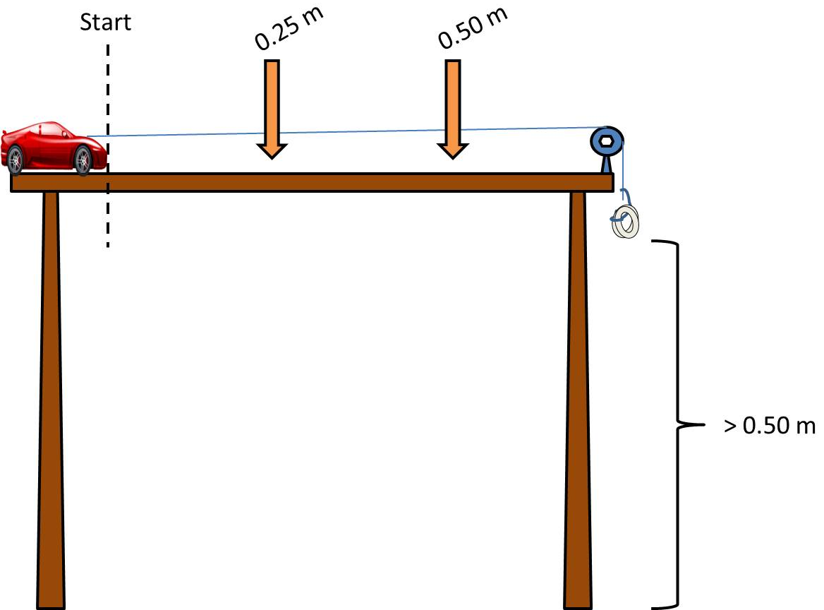
Figure 4

- Establish a baseline for comparison.
  - Measure the mass of a washer. Record the mass in the first column of Table C.
  - Add the washer to the end of the string by feeding the paper clip through the center of the washer and hooking it onto the clip to act as a weight for the car.
  - Reset the stopwatches, and align the car at the starting point.
  - Release the car. In Table C, record the time it takes for the car to pass the 0.25 m and 0.5 m marks.
  - Repeat Steps 6c–6d twice more, and then calculate the average of the three trials.
- Explore the effect of adding more mass to the string.
  - Take the second, third, and fourth washers and measure the mass of each. Calculate the total washer mass for two, three, and four washers. Record these masses in Table C.
  - Place two washers on the paper clip. Reset the stopwatches and align the car at the starting point.
  - Release the car. In Table C, record the time it takes for the car to pass the 0.25 m and 0.5 m marks.
  - Repeat steps 7b–7c for two more trials, and then calculate the average of the three trials.
  - Run two more sets of trials. Use three washers for the one set of trials, and four washers for the other set. Record the times and calculate the averages to complete Table C.
- Calculate the applied force for each set of conditions.
  - In Table D, list the mass of the washers in grams and convert to kilograms. Using the mass of the washers in kilograms, calculate the force of gravity on the washers (acceleration due to gravity is provided in Table D). Assuming this force is translated through the pulley to the car, record the force of the washers on the car for each set of washers.
- Calculate the acceleration for each set of conditions.
  - Calculate the first velocity using the equation v₁ = 0.25 m / t₁. This is the distance from start to the first checkpoint, divided by the time taken by the car to reach it. Record this value, rounded to two decimal places, in Table E.
  - Calculate the second velocity using the equation v₂ = 0.25 m / (t₂– t₁). This is the distance from the first checkpoint to the second, divided by the time taken by the car to travel between the two. Record this value, rounded to two decimal places, in Table E.
  - Calculate the acceleration of the car using the equation a = (v₂ – v₁) / (t₂ – t₁). Record this value, rounded to two decimal places, in Table D.
- Disassemble the ramp and clean up all materials according to your teacher’s directions.

Data
Record your data in your lab notebook or in the space below.

Part I: Newton’s First Law

Table A: Baseline for Comparison
Height of ramp = ____ cm  Mass of the car and washer = ___ g | Distance of car  (cm) | Distance of washer  (cm)
Trial #1
Trial #2
Trial #3
Trial average

Table B: Demonstration of Newton’s First Law
 | Distance of car  (cm) | Distance of washer  (cm)
Trial #1
Trial #2
Trial #3
Trial average
Qualitative
observations

Part II: Newton’s Second Law

Table C: Demonstration of Newton’s Second Law
Number of washers | Trial | Time to travel 0.25 m  t₁ (s) |  | Time to travel 0.50 m  t₂ (s)
1 washer  mass = ___ g | Trial #1 |  | Average |  | Average
 | Trial #2
 | Trial #3
2 washers  mass = ___ g | Trial #1 |  | Average |  | Average
 | Trial #2
 | Trial #3
3 washers  mass = ___ g | Trial #1 |  | Average |  | Average
 | Trial #2
 | Trial #3
4 washers  mass = ___ g | Trial #1 |  | Average |  | Average
 | Trial #2
 | Trial #3

Table D: Force of the Washers on the Car
Number of  washers | Mass of washers  m_{w} (g) | Mass of washers  m_{w} (kg) | Acceleration due to  gravity  a_{g} (m/s²) | Force of gravity  on the washers  F_{g} (kg ● m/s²) | Applied force  of washers  on the car  F_{wc} (kg ● m/s²)
1 |  |  | 10
2 |  |  | 10
3 |  |  | 10
4 |  |  | 10

Table E: Calculations of Acceleration
Number of  washers | Initial velocity  (from 0 to 0.25 m)  v₁ = 0.25 m / t₁  (m/s) | Final velocity  (from 0.25 to 0.50 m)  v₂ = 0.25 m / (t₂ – t₁)  (m/s) | Acceleration  a = (v₂ – v₁) / (t₂ – t₁)  (m/s²)
1
2
3
4

