Pre-Lab Information
Purpose Explore the connection between magnetic and electric fields using a laboratory procedure.
Time Approximately 60 minutes
Question How can magnetic and electric fields be demonstrated?
Hypothesis If a magnetic or electric field is present, materials that generate these fields will interact by attracting or repelling each other because of their magnetic or electric properties.
Variables Part I: Independent Variable: the type of material
Dependent Variable: an observable magnetic field or attraction
Part II: Independent Variable: the presence of charged materials
Dependent Variable: an observable electric field
Part III: Independent Variable: the movement of the magnet
Dependent Variable: an electric current
Part IV: Independent Variable: an electric current
Dependent Variable: a magnetic field

Summary In Part I of the experiment, students will first explore then map a magnetic field using bar magnets, a compass, and iron filings. In Part II of the experiment, students will investigate the concept of charge and demonstrate the interactions of electric fields. In Part III, students will examine how magnetic fields can generate an electric current. In Part IV, they will demonstrate how electric current can generate magnetic fields.

Safety
- Always wear a lab coat and safety goggles when performing an experiment.
- Behavior in the lab needs to be purposeful. Use caution when connecting electric circuits to avoid risk of electric shock.
- Dropping magnets can decrease their strength over time.
- Do not bring bar magnets near computers, computer monitors, audio tapes, or other such magnetic devices. Strong magnets can destroy materials with magnetic properties.
- Always disconnect circuits when not in use to prevent loss of charge and overheating.
- Report all accidents—no matter how big or small—to your teacher.

Lab Procedure
- Gather materials.
- Paper clips  - Aluminum wire or can  - Plastic ruler  - Wooden pencil  - Metal stapler  - 2 bar magnets | - 1 small compass  - Blank paper  - Iron filings  - 2 rubber balloons  - Access to a water faucet  - Clear packing tape | - 6 V flashlight bulb  - 9 V battery  - 2 insulated, 16-gauge copper wires, 2’ long  - Screwdriver  - Cylindrical object (plastic tube or broom handle)

PART I: Demonstrating and Describing Magnetic Fields
- Determine which materials are magnetic.
  - Gather together a paper clip, aluminum wire, plastic ruler, wood pencil, and metal stapler.
  - Use the bar magnet to see which of the above materials are attracted to the magnet, and which seem to have little, or no, interaction with the magnet. Record these interactions and your observations in Table A.
- Determine the polarity of the magnets.
  - Use two bar magnets and move them closer together with their ends aligned. Observe what happens. Record your observations in Table A.
  - Next, rotate one bar magnet so that its ends are reversed relative to the other bar magnet. Repeat the process of moving the bar magnets closer to each other. What happens? Record your observations in Table A.
  - Use a handheld compass to determine which of the poles the needle points to. Move it along the length of the bar magnet and each pole at various distances from 2 cm to 10 cm. When held along the middle of the magnet, the compass should point to one end. Designate the end of the magnet to which the compass needle points as the “north pole” of the magnet.
  - Use the picture of the bar magnet in Figure 1 to label the poles and the direction of the compass needle at the indicated points on the diagram. Do you see a pattern in the compass needle directions that indicate magnetic field lines? Draw some proposed magnetic field lines that would be consistent with the compass needle directions.
- Visualize the magnetic field lines of the magnet.
  - Place the bar magnet on a clean piece of blank paper.
  - Gently shake the container of iron filings over the bar magnet and paper, including the area around the magnet.
  - Use Figure 2 to draw the pattern created by the iron filings. Do you see a pattern in the iron filings that indicates magnetic field lines?
PART II: Demonstrating and Describing Electric Fields
- Observe an electric field caused by static charges.
  - Fully inflate two rubber balloons and tie off the ends.
  - Take one balloon and rub one side of it against the hair on your head vigorously for approximately ten seconds.
  - Turn on a faucet of running water so that it comes out slowly and steadily in a very thin stream of water (the thinner, the better). Bring the side of the balloon you rubbed on your head a few centimeters away from the stream of water. Slowly move it closer to the stream (without touching the stream) until you see an effect. Record your observations in Table B.
  - Recharge the balloon by rubbing it against the hair on your head for another ten seconds. Now, take the side of the balloon you rubbed and place it on the wall. Record what happened in Table B.
- Observe the interaction of electric fields.
  - Charge both balloons by rubbing them against the hair on your head.
  - Hold the balloons by the tied ends and rotate them so that the charged sides (rubbed sides) face each other. Slowly move them closer together and observe what happens as they get close to each other. Record your observations in Table B.
- Test for magnetic fields.
  - Charge one of the balloons again by rubbing it against your hair.
  - Observe your compass and see that it is pointing toward magnetic north. Move the compass near and around the charged ballon. Does the static charge create a detectable magnetic field around the balloon? Record your observations in Table B.
PART III: Examining How Magnetic Fields Generate Electric Current
- Detect electric current with a coil and simple galvanometer.
  - A galvanometer is a device for detecting electric current. It does this by detecting the magnetic field generated as current flows through a wire. Using a section of wire, make a simple galvanometer by wrapping the wire a few times around your compass. Leave three or four inches of each end of the wire unwrapped. You may need to secure the wrapped wire with some tape, but be sure you can see the compass needle.
  - Using another section of wire, wrap the wire tightly around a cylindrical object, such as a plastic tube or broom handle, to create a coil. The diameter of the coil needs to be wide enough that a bar magnet could pass through it. Use a piece of packing tape to secure the loops of the coil together, and slide the cylindrical object out, leaving a hollow coil.
  - Twist the ends of the wire section together to connect them and create a circuit. Arrange the circuit and compass so that magnetic north is aligned and parallel with the wire loops around the compass. Make sure that your coil is as far away from the galvanometer as possible. See Figure 8 below for reference.
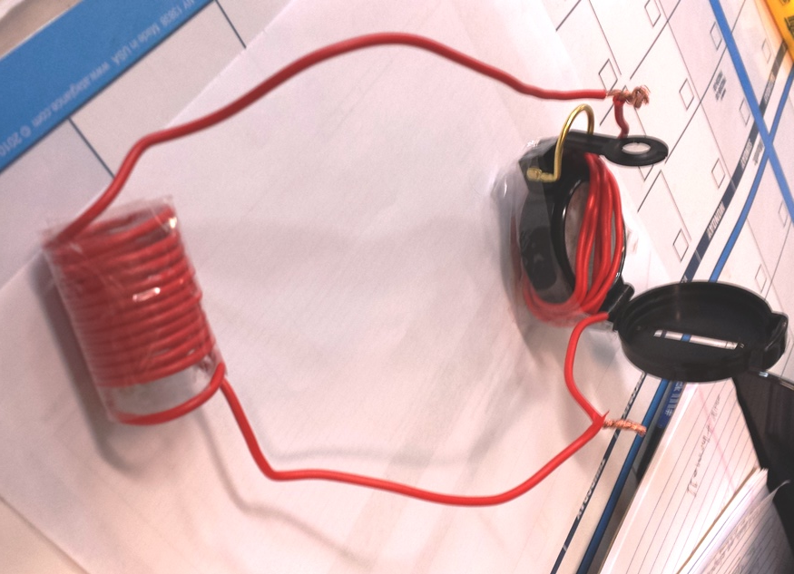
Figure 8
  - Slide the bar magnet through the coil of the circuit and observe the compass needle in your galvanometer. Faster movements may produce more current. Record your observations in Table C.
  - Slide the bar magnet back through the coil in the other direction. Record any changes in Table C. Allow the magnet to sit stationary in the coil. Does your galvanometer detect any current when the magnet is not moving?
  - Place the bar magnet a good distance away from the coil such that no current is registered. Now, use the wooden pencil or plastic ruler in place of the bar magnet, and slide it through the center of the coil as a negative control. Record any changes in current in Table C.
  - Detach and uncoil the wire sections and remove the tape from the compass for use in the next steps.
Part IV: Examining How Electric Currents Create Magnetic Fields
- Construct a simple circuit.
  - Refer to Figure 9a below. Connect a wire section to each terminal on a nine-volt battery. Secure the connections by wrapping the wire around the terminals and placing tape over them to hold the connections in place. Make sure the wires do not touch between the terminals.
  - Place the end of one of the wires against the top of the light bulb’s metal base, and secure it in place with tape. Test your circuit by touching the end of the unattached wire to the bottom of the bulb. It should light up. If not, check your connections and make sure the metal has been exposed on the end of each wire to make a good connection.
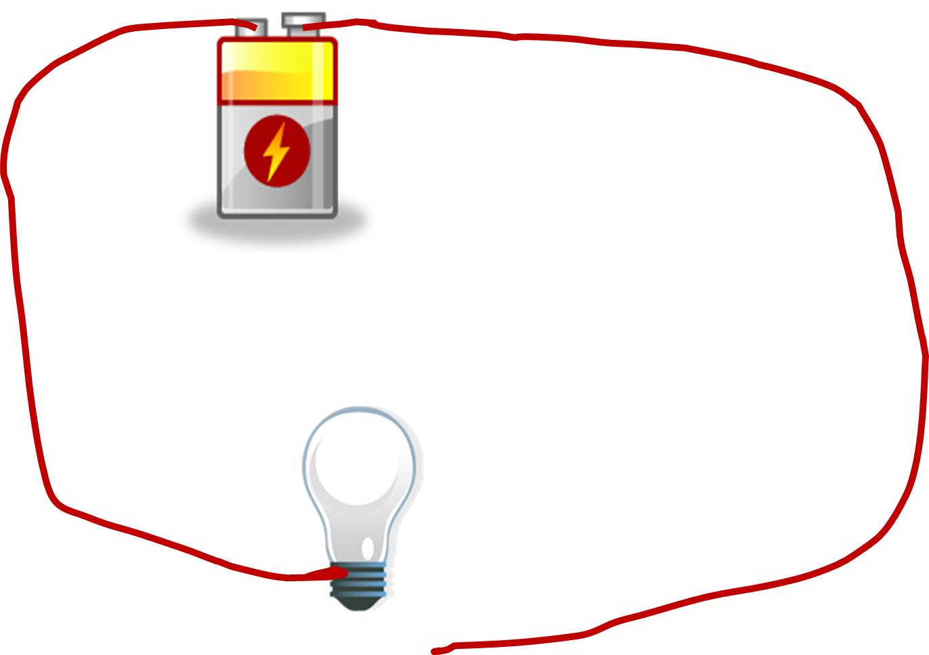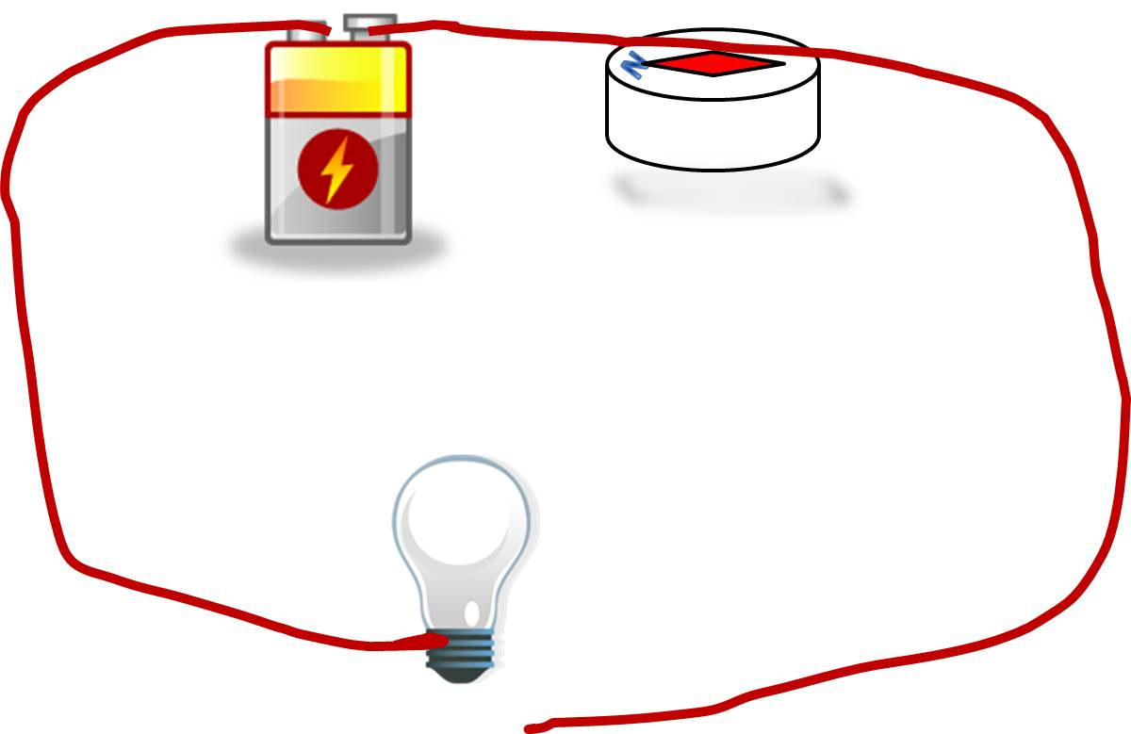
Figure 9a Figure 9b

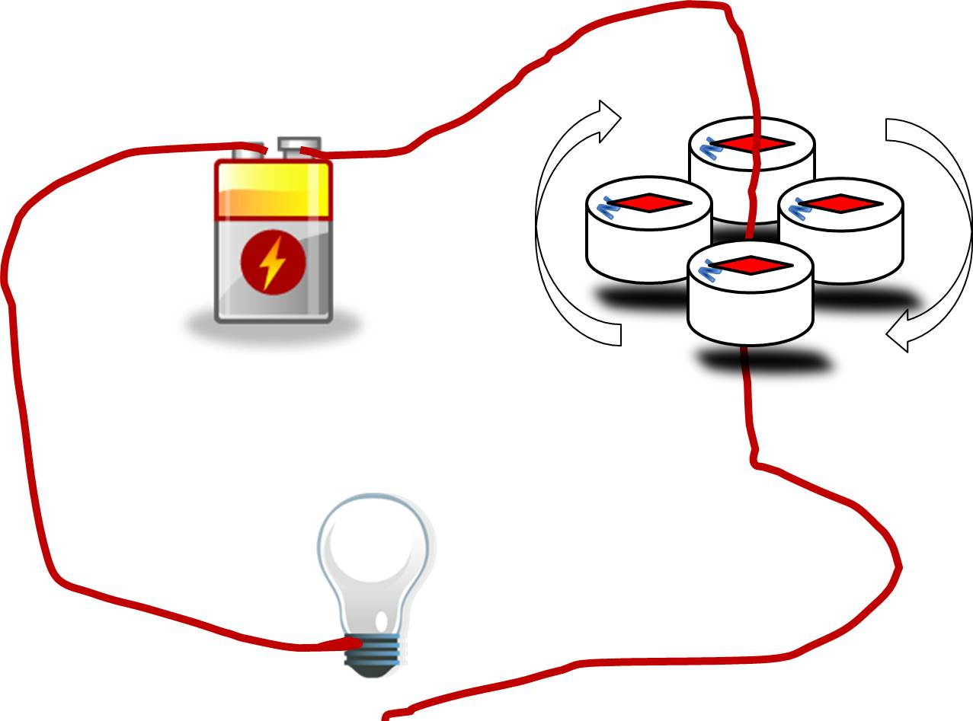
Figure 9c

  - With the circuit switched “off” (the wire is not touching the bulb and it is not lit), use your compass to see if there are any magnetic fields present along the circuit. Make sure your compass is very far away from any magnets or other electric circuits.
  - Hold the wire to the bulb bottom again and the light bulb should illuminate, indicating an electric current. Use the compass to once again check for a magnetic field along the circuit.
  - With the wire detached and the light off, place your compass below a straight section of wire, and orient the setup so that the wire runs over the top of the compass and its needle indicates north. See Figure 9b above for reference.
  - Again, hold the wire to the bulb bottom to light the bulb, and observe the compass. Does the compass needle move? Record your observations in Table D, and include a sketch of the compass and wire when current is applied.
  - Arrange your circuit and bend a portion of the wire to create a vertical section. This will allow you to move your compass around the wire closely to detect changes in the magnetic field. See Figure 9c above for reference.
  - Move your compass around the vertical section of wire, first with the circuit switched “off” and then with the circuit switched “on.” Record your observations in Table D. Include a sketch that shows the compass direction at four points around the wire, both with current off and on.
  - Detach all components of your circuit for use in the next step.

- Apply the relationship between electric current and magnetism to make an electromagnet.
  - Take a normal screwdriver and test its magnetism by moving it close to some paper clips or the metal stapler. Does it attract those objects? Record your observations in Table E.
  - Using a section of wire, coil the wire tightly around the shaft of the screwdriver, leaving several inches of loose wire at each end. Secure the coil on the screwdriver with tape.
  - Attach one end of the wire to a battery terminal and secure the connection. When you are ready to test your electromagnet, attach the other end of the wire to the other battery terminal.
  - Reexamine the magnetism of the screwdriver by bringing it near to the paper clips and the metal stapler. Is there any attraction now? Record your observations in Table E.
  - Repeat the same technique (Steps 10a through 10d) with the wooden pencil instead of the screwdriver.
    - Will the pencil attract the metallic objects when there is no current?
    - Will the pencil attract the metallic objects where a current is applied?
Record your observations in Table E.
- Disassemble all circuits and dispose of all materials according to your teacher’s directions.

Data
Record your data either in your lab notebook or in the space below.
Table A. Magnetic Attraction between Materials
Material | Interaction with the Bar Magnet | Observations
Paper clip | Attracted Repelled No Interaction
Wooden pencil | Attracted Repelled No Interaction
Plastic ruler | Attracted Repelled No Interaction
Aluminum wire | Attracted Repelled No Interaction
Metal stapler | Attracted Repelled No Interaction
Two magnets  (first attempt) | Attracted Repelled No Interaction
Two magnets  (second attempt) | Attracted Repelled No Interaction

Figure 1. Sketch of Bar Magnet and Compass Observations
Observations:

Figure 2. Sketch of Bar Magnet and Magnetic Field Lines
Observations:

Table B. Static Charges and Electric Fields
Scenario | Interaction | Observations
Balloon and running water | Attracted Repelled No Interaction
Balloon and wall | Attracted Repelled No Interaction
Two balloons  (charged sides facing) | Attracted Repelled No Interaction
Charged balloon and compass | Observations:

Table C. The Effects of a Magnet on Electric Current
Scenario | Observations of Compass Needle Movement in  Galvanometer
Magnet moving right to left
(or top to bottom)
Magnet moving left to right
(or bottom to top)
Magnet stationary in coil
Pencil moving right to left
(or top to bottom)
Pencil moving left to right
(or bottom to top)

Table D. The Effects of Electric Current on Magnetic Properties
Scenario | Observations and Sketches of Compass Direction Relative to Wire
Compass under wire with no current
Compass under wire with current
Compass around vertical wire with no current
Compass around vertical wire with current

Table E. Making an Electromagnet
Scenario | Magnetic Properties and Observations
Screwdriver without current | Attracted Repelled No Interaction  Observations:
Screwdriver with current | Attracted Repelled No Interaction  Observations:
Pencil without current | Attracted Repelled No Interaction  Observations:
Pencil with current | Attracted Repelled No Interaction  Observations:

