Pre-Lab Information
Purpose Explore the relationship between mass, speed, and kinetic energy using a laboratory procedure.
Time Approximately 45 minutes
Question How do mass and speed affect kinetic energy?
Hypothesis #1 If the mass of an object increases, then its kinetic energy will increase proportionally because mass and kinetic energy have a linear relationship when graphed.
Hypothesis #2 If the speed of an object increases, then its kinetic energy will increase proportionally because speed and kinetic energy have a linear relationship when graphed.
Variables PART I: Changing Mass to Affect Kinetic Energy
Independent Variable: mass of the soda bottle and the liquid it contains
Dependent Variable: kinetic energy of the beanbag
PART II: Changing Speed to Affect Kinetic Energy
Independent Variable: speed of the soda bottle
Dependent Variable: kinetic energy of the beanbag

Summary In the first part of this activity, students will drop a soda bottle carrying a variable amount of water from a uniform height and measure its effect on the kinetic energy of a beanbag, as launched from a simple lever. In the second part of the experiment, the same setup is used, but they will drop a consistent bottle mass from varying heights to achieve different speeds.
Sometimes in science, a reasonable hypothesis may not be supported by the data. One of the two hypotheses stated above is false. Once the data have been collected from both parts, students will plot the data on graphs to examine and compare results from the two scenarios. One hypothesis will not be supported by the results, and will require revision in the analysis.

Safety
- Always wear a lab coat and safety goggles when performing an experiment.
- Behavior in the lab needs to be purposeful. Use caution when dropping objects and/or launching them into the air.
- Use the right gear, such as only the soda bottle, lever, and beanbags that your teacher provides.
- Check the soda bottle and its cap for cracks and chips prior to use.
- Use only water in the soda bottle, not carbonated liquids, to prevent increased pressure that could lead to ruptured bottles and spills.
- Report all accidents—no matter how big or small—to your teacher.

Lab Procedure
- Gather materials.
- 2 or 3 meter sticks  - Mass balance  - Packing tape, clear plastic  - Graduated cylinder  - 2” diameter cylinder (wooden or plastic)  - Wooden board ¼” x 2” x 2’ (about 61 cm long) | - Plastic soda bottle, 1 L  - Water  - Funnel  - Beanbag, 125 g  - Marker  - Metric tape measure
- Prepare the experimental setup.
  - Measure the length of your wooden board in centimeters to divide it in half, and mark the board at its midpoint. Lay the board on its midpoint across the 2” diameter cylinder, and securely tape the cylinder to the board using the packing tape. This creates a simple lever in which both arms of the lever are equal in length.
  - Mark the board at 7.5 cm from each end. Draw a circle, an “X”, or place a piece of tape at these points to serve as targets.
  - Measure 200 mL of tap water with a graduated cylinder and transfer it to an empty 1 L soda bottle, using a funnel if needed. Ensure that the cap is screwed back on the bottle securely.
  - Place a beanbag so that it is centered on one end of the board at the target.
  - Practice dropping the soda bottle on the target at the other end of the board, until you develop a method in which the beanbag pops straight up and can be easily measured by your lab partner, using the meter sticks for reference. The meter sticks should be placed end to end and upright near the end of the lever, possibly taped against a wall. This will provide a height reference scale to measure the height the beanbag is thrown.
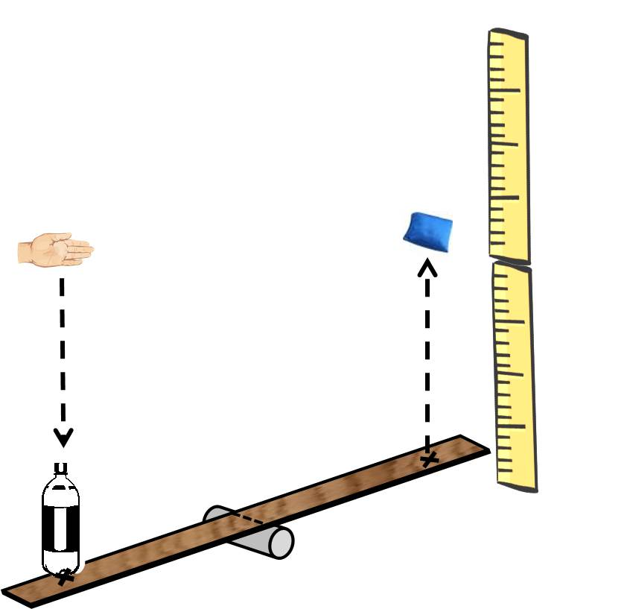
PART I: Changing Mass to Affect Kinetic Energy

- Calculate the predicted change in kinetic energy.
  - Assume that the velocity of the soda bottle falling from a height of 0.8 m will be 4 m/s. Record this velocity for each mass in Table A, and use it in calculating the predicted kinetic energy of the soda bottle for the masses of 0.125 kg, 0.250 kg, 0.375 kg, and 0.500 kg using the equation:
$$KE=\frac{1}{2} mv^{2}$$
When solving for kinetic energy (KE), m is mass, and v is the speed (or velocity). Record these calculations in Table A.

- Observe how changes in bottle mass affect beanbag height.
  - Review the following relationship for mass and volume of water:
1 mL = 0.001 kg
This means that 200 mL of water in the plastic bottle has a mass of 0.2 kg.
  - Pour out some of the water from your soda bottle to adjust the total mass of water and bottle to 0.125 kg (125 g). You can set your soda bottle on the balance, and carefully add or remove water as needed to adjust the total mass.
  - Place the beanbag on the target at the end of the lever, closest to your vertical meter sticks.
  - Measure a height of 0.8 m above the other end of the lever. This is the end that you will drop the soda bottle on. You can mark this height in some way for reference, or hold another meter stick upright, alongside your lever.
  - Make sure the bottle cap is tight. Drop the 0.125 kg bottle from the 0.8 m mark onto the target at the end of your lever. If the bottle misses or the lever does not function properly, reset the lever and beanbag, adjust your targeting method, and repeat the bottle drop until the beanbag is consistently propelled upward.
  - Record the approximate maximum height of the beanbag as it is propelled into the air in Table A.
  - Repeat two more times at this height (0.8 m) and this bottle mass (0.125 kg), for a total of three beanbag height measurements.
  - Average the three measurements you recorded in Table A. Round your answers to two decimal places.
  - Repeat steps 4a–g for three more bottle masses: 0.250 kg, 0.375 kg, and .500 kg. Use your balance and more water to measure these total masses.

- Confirm the effect of mass on kinetic energy
Make an observation about the average height of the beanbag for each mass dropped. How does it compare with your calculated kinetic energies for each mass? When the bottle is more massive, does the beanbag seem to travel to greater heights? Record your general observations in Table A.

PART II: Changing Speed to Affect Kinetic Energy

- Calculate the predicted kinetic energies of the falling bottle.
You will be using the same mass, 0.250 kg, for each trial in this part of the experiment; record this mass in Table B for each velocity. Using this mass, calculate the expected kinetic energy for the soda bottle as it impacts the lever, at each speed. Again, use the equation:
$$KE=\frac{1}{2} mv^{2}$$
Record your calculations in Table B.

- Establish the heights from which to drop the bottle.
The goal is to drop the bottle/water mass so that it hits the lever at different speeds. Since an object in free fall is accelerated by gravity, you need to determine the heights necessary to drop the bottle and achieve certain speeds. Use the following equation to calculate the height necessary to achieve the speeds 2 m/s, 3 m/s, 4 m/s, 5 m/s, and 6 m/s:
$$Ht=\frac{v^{2}}{2g}$$
When solving for height (Ht), v is the speed (or velocity) and $g$ is the gravitational acceleration, which is 9.8 m/s². Record these heights in Table B.

- Observe how changes in bottle speed affect beanbag height.
  - Pour out some of the water from your soda bottle to adjust the total mass of water and bottle to 0.250 kg (250 g). You can set your bottle on the balance, and add or remove water as needed to adjust the total mass.
  - Place the beanbag on the target at the end of the lever, closest to your vertical meter sticks.
  - Measure the height you calculated for the speed of 2 m/s, above the other end of the lever. You can mark this height in some way for reference, or hold another meter stick alongside your lever.
  - Make sure the bottle cap is tight. Drop the 0.250 kg bottle from the 2 m/s height onto the target at the end of your lever. Again, adjust your bottle-dropping technique as needed to achieve a consistent result of the beanbag being propelled upward.
  - Record the approximate maximum height of the beanbag as it is propelled into the air in Table B.
  - Repeat two more times at this height, for a total of three beanbag height measurements.
  - Average the three measurements you recorded in Table A.
  - Repeat steps 8a–g for the next four heights, corresponding to the speeds 3 m/s, 4 m/s, 5 m/s, and 6 m/s. Be sure to mark each drop height in some way so that your bottle drops are as consistent as possible.
- Confirm the effect of speed on kinetic energy.
Make an observation about the average height of the beanbag. How does it compare with your calculated kinetic energies for each speed? Does the height of the beanbag increase in equal increments with each step up in speed? Record these qualitative observations in Table B, before you confirm by plotting the data in the next step.

- Plot your data for Part I to visualize the relationship between mass and kinetic energy.
  - Plot a graph of kinetic energy as a function of mass using the data you collected in Table A. Mass will be on the horizontal axis and the calculated kinetic energy will be on the vertical axis. Insert a trend line, which best demonstrates the relationship between the variables. Is the trend line straight (linear) or curved (nonlinear)?
  - Plot a graph of average beanbag height recorded in Table A for each mass. Mass will be on the horizontal axis and the average beanbag height will be on the vertical axis. Insert a trend line, which best demonstrates the relationship between the variables. How does this plot compare with your plot of kinetic energy vs. mass?

- Plot your data for Part II to visualize the effect of changing speed on kinetic energy.
  - Plot a graph of kinetic energy as a function of speed using the data you collected in Table B. Speed will be on the horizontal axis and the calculated kinetic energy will be on the vertical axis. Insert a trend line, which best demonstrates the relationship between the variables. Is the trend line straight (linear) or curved (nonlinear)?
  - Plot a graph of average beanbag height recorded in Table B for each speed. Speed will be on the horizontal axis and the average beanbag height will be on the vertical axis. Insert a trend line, which best demonstrates the relationship between the variables. How does this plot compare with your plot of kinetic energy vs. speed?

- Dispose of all materials according to your teacher’s directions.

Data
Record your data either in your lab notebook or in the space below.

Table A. Predictions of Kinetic Energy and Resulting Beanbag Height for Varying Masses
Mass  (kg) | Velocity  (m/s) | Kinetic Energy  (kg∙m²/s²) | Height of Beanbag  (m) | Average Height of Beanbag  (m)
0.125
0.250
0.375
0.500
Observations

Table B. Predictions of Kinetic Energy and Resulting Beanbag Height for Varying Speed

Velocity of Bottle  (m/s²) | Mass of Bottle  (kg) |  | Height to Drop Bottle  (m) | Estimated Kinetic Energy  (kg∙m²/s²) | Height of Beanbag  (m) | Average Height of Beanbag  (m)
2
3
4
5
6
Observations

