Assignment Summary
In this assignment, you will use simulations to analyze how climate, resources, and habitat size affect carrying capacity. You will then look at another simulation to analyze the effects of certain factors that affect biodiversity and populations. Finally, you will write and revise a conclusion on how human activity affects biodiversity.

Background Information
Population growth is the change in size of a group of organisms of the same species over time. It is affected by four factors: birth rate, death rate, immigration, and emigration.

Carrying capacity is the maximum total population that an area can support. Carrying capacity limits population growth and is affected by competition for food, water, shelter, or mates, and threat of predators, disease, and parasites. Carrying capacity may be affected by one or a combination of these factors.

Biodiversity is the total variety of organisms that live in the biosphere. Biodiversity is affected by the loss of habitat, introduction of invasive species, pollution, and/or human activities.

Materials
- Computer with Internet access
- Notebook
- Pens

Assignment Instructions
Part I. Prepare for the project.
Step 1. Write your name on the top right corner of the Student Worksheet.
- The Student Worksheet can be found at the end of this document after the assignment instructions.
Step 2. Read the entire Student Guide before you begin this project.
- If anything is not clear to you, ask your teacher for assistance before you begin.
Step 3. Gather the materials you will need to complete this project.
Step 4. Complete Part I of the Student Worksheet (Quick Check).

Part II. Analyze factors that affect carrying capacity.
Step 1. Launch the Gizmo Rabbit Population by Season.
- Be sure to follow the instructions in this guide and the Gizmo.
- Locate the important buttons and tabs you will be using in this simulation so you can familiarize yourself with the Gizmo.
Step 2: Set up and run the first simulation.
- Under Land, choose Little.
- Move the simulation speed to Fast.
- Do not select any of the Conditions.
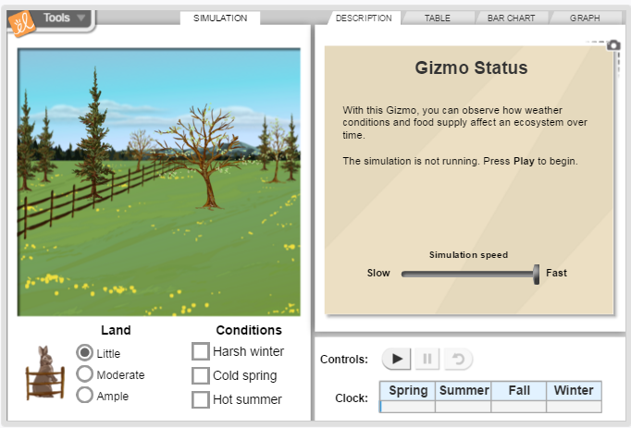
- Click the Graph tab on the top right.
- Zoom the graph out by clicking the – symbol on the right side of the graph until the graph shows 0–45 years on the x-axis.
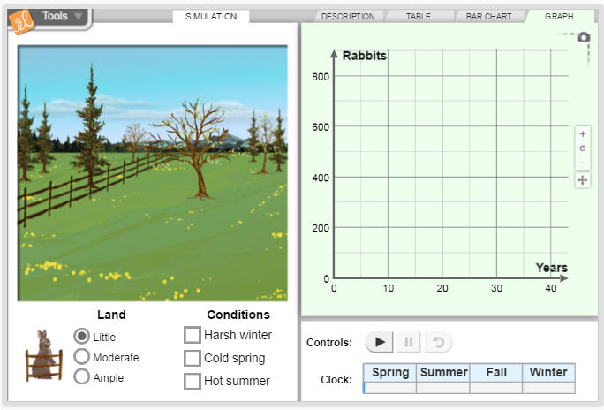
- Click Play (►) and let the simulation run until the line on the graph reaches 15 years.
- Pause ( ll ) the simulation.
- Under Land, choose Moderate.
- Click Play and let the simulation run until the line on the graph reaches 30 years.
- Pause the simulation.
- Under Land, choose Ample.
- Click Play and let the simulation run until the line on the graph reaches 45 years.
- Stop the simulation.
- Take a snapshot of your graph by clicking on the camera on the right top part of the graph. Copy and paste the graph in the empty space under Graph A: The Effects of Land Size on Carrying Capacity in the Student Worksheet.
Step 3: Set up and run the second simulation.
- Reset the simulation.
- Under Land, choose Ample.
- Under Conditions, choose Harsh winter.
- Click Play and let the simulation run until the line on the graph reaches 15 years.
- Pause the simulation.
- Keep Harsh winter checked and click Cold spring under Conditions.
- Click Play and let the simulation run until the line on the graph reaches 30 years.
- Pause the simulation.
- Keep Harsh winter and Cold spring checked and click Hot summer under Conditions.
- Click play and let the simulation run until the line on the graph reaches 45 years.
- Stop the simulation.
- Copy and paste graph in the empty space under Graph B: The Effects of Different Conditions on Carrying Capacity in the Student Worksheet.
Step 4: Complete Part II of the Student Worksheet.

Part III. Analyze factors that affect biodiversity.
Step 1. Launch the Gizmo Coral Reefs 1 – Abiotic Factors.
- Be sure to follow the instructions in this guide and the Gizmo.
- Locate the important buttons and tabs you will be using in this simulation so you can familiarize yourself with the Gizmo.
Step 2: Set up and run the first simulation.
- Click the Data tab and select all populations except Red lionfish and Crown-of-thorns starfish.
- Zoom the graph out by clicking the – symbol on the right side of the graph until the graph shows 0–100 years on the x-axis.
- Increase the Ocean temperature by 1°C so that it reads 28°C.
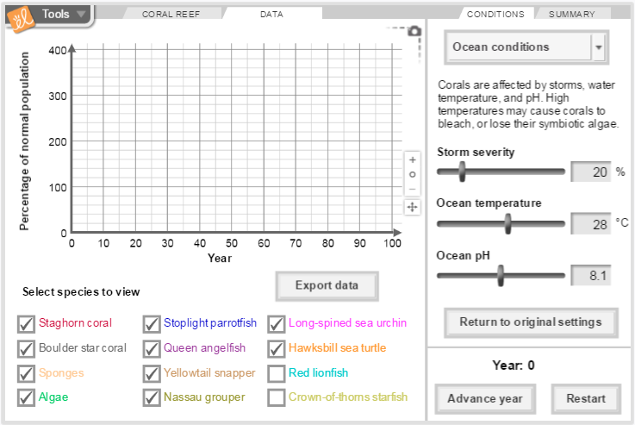
- Click Advance year until the lines on the graph reach 100 years.
- Copy and paste graph in the empty space under Graph C: Effect of 1°C Increase in Ocean Temperature on Biodiversity in the Student Worksheet.
- Click Export data. Save and title the worksheet Effect of 1°C Increase in Ocean Temperature on Biodiversity. You will use data from this table when you complete Part III of the Student Worksheet.
Step 3: Set up and run the second simulation.
- Click Return to original settings and Restart.
- Increase the acidity of the habitat by decreasing the Ocean pH value to 7.9.
- Click Advance year until the lines on the graph reach 100 years.
- Copy and paste graph in the empty space under Graph D: Effect of a Small Change in pH on Biodiversity in Student Worksheet.
- Click Export data. Save and title worksheet Effect of a Small Change in pH on Biodiversity. You will use data from this table when you complete Part III of the Student Worksheet.
Step 4: Set up and run the third simulation.
- Click Return to original settings and Restart.
- Increase the acidity of the habitat even more by decreasing the pH value to 7.6.
- Click Advance year until the lines on the graph reach 100 years.
- Copy and paste graph in the empty space under Graph E: Effect of a Big Change in pH on Biodiversity in the Student Worksheet.
- Click Export data. Save and title worksheet Effect of a Big Change in pH on Biodiversity. You will use data from this table when you complete Part III of the Student Worksheet.
Step 5: Complete Part III of the Student Worksheet.
- Highlight information in the spreadsheet you used to support your answers.

Part IV. Write and revise a conclusion.
Step 1: Set up and run a simulation.
- Use the Gizmo “Coral Reefs 1 – Abiotic Factors” from Part III.
- Click Return to original settings and Restart.
- Set the storm severity to 30%, ocean temperature to 28°C, and pH to 7.9.
- Click Advance year until the lines on the graph reach 100 years.
- Copy and paste graph in the empty space under Graph F: Effect of Human Activity on Biodiversity in the Student Worksheet.
Step 2: Make a conclusion about the effect of human activity on biodiversity.
- Read the paragraph in Part IV of the Student Worksheet.
- Then, use the information from the paragraph and the graph to answer questions 9-10 in the Student Worksheet.
Step 3: Conduct research on human activities that affect biodiversity in a positive way.
- Think about ways human activity can affect biodiversity in a positive way.
- Conduct research to find more information about this topic.
Step 4: Revise the conclusion based on new information.
- Use the information from your research to answer question 11 in the Student Worksheet and revise your conclusion on the effect of human activities on biodiversity.
- List sources used to revise your conclusion in the Student Worksheet.
Step 5: Complete Part IV of the Student Worksheet.
- Complete Quick Check.

Part V: Submit work and clean up work space.
Step 1: Upload Student Worksheet and spreadsheets.
- Make sure you have done all the Quick Checks in the Student Worksheet.
- Make sure you have properly labeled all worksheets you used to support your answers.
- Make sure that information you used in spreadsheets is properly highlighted.
- Include your name at the top of each document.
Step 2: Clean up work space.

CONGRATULATIONS! YOU HAVE COMPLETED YOUR PROJECT!

Student Worksheet Name:
Part I. Prepare for the Project
Quick Check: Did you complete steps 1–4? If not, go ahead and complete them. Then continue on to Part II. Be sure to follow the steps in Part II of the Student Guide.

Part II. Analyze Factors That Affect Carrying Capacity
Graph A: The Effects of Land Size on Carrying Capacity

Question 1: How does increasing the size of the habitat affect carrying capacity? Explain your answer. Recall the scenarios: 0–15 years, Little land; 15–30 years, Moderate land; 30–45 years, Ample land.

Graph B: The Effects of Different Conditions on Carrying Capacity

Question 2: How and why did changes in the environmental conditions affect carrying capacity in this scenario? Recall the scenarios: 0–15 years, Harsh winter; 15–30 years, Harsh winter and Cold spring; 30–45 years, Harsh winter, Cold spring, and Hot summer.

Study the table.
Habitat Size | Little | Moderate | Ample | Larger Than Ample
Carrying Capacity | 150 | 300 | 400 | 100
Question 3: If there were no other changes in the habitat, would the value under Larger than Ample be correct? Why or why not?

Question 4: Suppose that there were changes in the habitat that caused this actual value, what might a combination of those changes be?

Quick Check: Did you paste graphs A and B and answer questions 1–4? If not, go ahead and complete this part. Then you may proceed to Part III of the project. Be sure to follow the steps in the Student Guide.

Part III. Analyze Factors That Affect Biodiversity
Graph C: Effect of 1°C Increase in Ocean Temperature on Biodiversity

Question 5: How would you describe the effect of a 1°C increase of temperature on the biodiversity of the habitat in terms of number of populations and number of individuals in the populations? Use evidence from your graph and table to support your answer.

Question 6: What is the average number of staghorn corals within this time frame?

Question 7: What conclusions can you make about how a change in the condition of the ocean affects the different species in coral reefs?

Graph D. Effect of a Small Change in pH on Biodiversity

Graph E. Effect of a Big Change in pH on Biodiversity

Question 8: How would you describe the effect of different magnitudes of the same factor on the number of individuals within a population? Use evidence from the graph and table (average values) to support your answer.

Quick Check: Did you paste graphs C–E and answer questions 5–8? If not, go ahead and complete this part. Then you may proceed to do Part IV of the project. Be sure to follow the steps in the Student Guide.

Part IV. Make and Revise a Conclusion
Changes in storm severity, ocean temperature, and ocean pH may be a result of human activity. Global warming, which is a result of man’s increased use of fossil fuels as an energy source, may change these factors.
Graph F: Effect of Human Activities on Biodiversity

Question 9: What conclusion can you make regarding how humans affect biodiversity? Use evidence from the graph to support your answer.

Question 10: If this scenario continues, what do you think will happen to the populations in the next 100 years? Why do you think this might happen?

Question 11: After conducting research, does your conclusion need revision? Why? Support your revision with evidence from literature.

Works Cited:

Quick Check: Have you pasted graph F, made a conclusion, and revised your conclusion using new information from your research? Did you list the sources you used to revise your conclusion? If not, go ahead and complete this part. You may then submit your work. Make sure you follow the steps of Part V on the Student Guide to do this.

