Pre-Lab Information
Purpose Plan an investigation to explore how owl pellets are used to study ecology.
Time Approximately 60 minutes
Question How are owl pellets used to study ecology?
Summary In this lab, you will dissect an owl pellet. As you pull the pellet apart, you will find many different types of bones from the animals the owl ate. You will then match these bones to a bone chart to determine which animals the bones came from. This will help you draw conclusions about what the owl ate.

Safety
- Behavior in the lab needs to be purposeful.
- Use caution when handling dissecting needles and forceps.
- Wear gloves and goggles throughout this dissection.
- Treat all animal material with respect.
- Wash hands after completing the lab.
- Report all accidents—no matter how big or small—to your teacher.

Introduction
Ecosystems are made up of a variety of living things that interact in many different ways. Diagrams, such as food webs, make visible the feeding relationships in an ecosystem. Owls are predators that eat a wide variety of prey: mice, gophers, snakes, and even other birds.
Owls cannot digest all of the pieces of their prey. Parts like teeth, bones, fur, and exoskeletons remain in the owl’s stomach. These parts are compressed into a ball that is regurgitated, or spit out, from the owl’s stomach. This ball is called an owl pellet.
An owl pellet can be dissected and the bones from the pellet used to determine what the owl was eating.

Lab Procedure
Here is an outline of the steps you should follow to plan your investigation for this lab. Later in the guide, you will have writing space to develop your ideas, collect data, analyze and discuss results, and draw conclusions.
- Determine the types of data you will gather and what tools of measurement will be used to collect the data.
What kind of data will you gather in this experiment? Will you record observations of the pellet before and during the dissection? Will you record any quantitative data like the mass of the owl pellet or the names or numbers of certain types of bones you find? What equipment will you use to gather this data? How will you organize your data? Do you need a table to organize the information you gather? How will you decide what prey animal your owl ate?

- Devise an experiment to explore the contents of an owl pellet in order to determine the type of prey the owl ate.
List the main steps needed to run the experiment. Your teacher will demonstrate how to dissect an owl pellet, list the equipment available, and explain how to handle the materials for dissection.
- Gather materials and set up your experiment.
Obtain your owl pellet, dissecting tray, dissecting needle, forceps, and paper towel from your teacher.
Now that you know what you will do, gather the necessary items. Besides the objects you will experiment with, make sure you have the necessary equipment to take measurements. If you are working with lab partners, make sure each person knows his/her role in running the experiment. Check your setup and make sure everything is in order before you proceed.
- Run your experiment.
Dissect your owl pellet. As you proceed with your experiment, make sure you record all the necessary data and that each student is performing his/her role in running the experiment. Make sure all elements of your experiment are complete. Do not forget to clean up when you are done!
- Use the Middle School Lab Report Guide to write your lab report.

Part I: Dissecting Your Owl Pellet
- Determine the types of data you will gather and what tools of measurement will be used to collect the data.
Use this space to describe the types of data you will collect in this lab and the tools necessary to record these measurements. Provide a sample of any data table you might be using to record and organize your data.

- Devise an experiment to explore the contents of an owl pellet in order to determine the type of prey the owl ate.
Use this space to list the main steps needed to run the experiment.

Stop. Show these first two steps to your teacher and gather approval on your experimental design. Your teacher will then give you the materials you need to proceed with your investigation.
- Gather materials and set up your experiment.
Obtain your own pellet, dissecting tray, dissecting needle, forceps, and paper towel from your teacher.
- Run your experiment.
Record your data and observations in the space below. Do not forget to clean up when you are done, and be sure to wash your hands!

Part II: Identifying What the Owl Is Eating
Compare the bones that you found in your owl pellet with the shapes of the bones in this chart.
Figure A
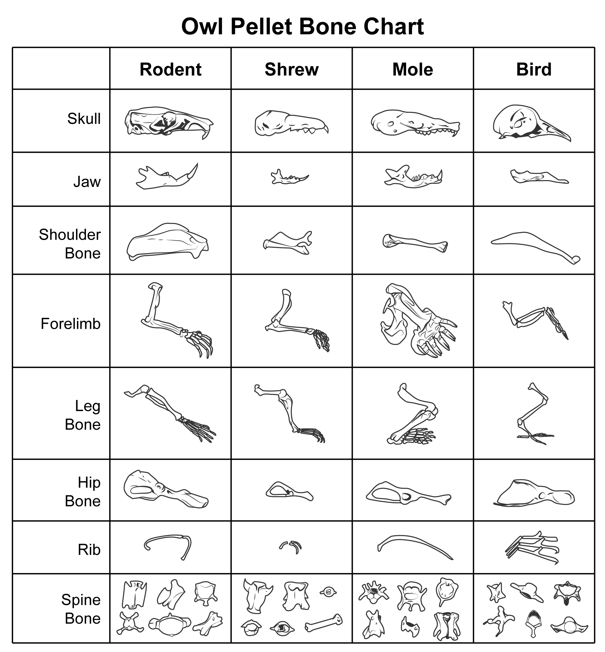

Step 5: Use the Middle School Lab Report Guide to write your lab report.

