Assignment Summary
For this assignment, you will first make a model of the digestive system using materials provided by your teacher. Instructions in this guide will help you do this. You will then model what happens to food after it is eaten by adding cut out shapes to your model. Finally, you will describe how food changes as food moves through the different structures of your model and into the cells of your body.

Background Information
The function of the digestive system is to break down food we eat so that it can be transformed into smaller molecules that cells can use to maintain life. The main structures involved in the digestion of food are the mouth, esophagus, stomach, small intestine, large intestine, and rectum. Other organs that help in the breakdown of food are the liver, gall bladder, and pancreas.
Before food can be transformed into smaller molecules, it has to undergo a series of changes, both physically and chemically. Physical changes break the food down into smaller pieces. Chemical changes result in the formation of new and simpler molecules. For example, proteins are broken down into amino acids. These changes occur as food moves through the structures of the digestive system.
The digestive system not only breaks down food, it also absorbs the smaller molecules produced from digestion. These smaller molecules are carried to the cells where they recombine to make new molecules. For example, amino acids recombine to make new proteins.

Safety
- The materials to be used in this project are only for creating the model of the digestive system and are not to be played with.
- Always use scissors with care.
- All actions while doing this project should be purposeful.
- Wash your hands after completing this project.

Materials

- 1 poster board (22" x 28", white)  - 1 piece of blue construction paper  - 1 piece of red yarn (0.5 ft)  - 1 piece of green yarn (1 ft)  - 1 piece of brown yarn (2 ft) | - 1 piece of pink yarn (3 ft)  - 1 zippered plastic bag (17.7 cm x 19.5 cm)  - 1 brown paper bag (4 lb)  - 3 cotton balls  - 1 small green balloon | - 5 index cards  - scissors  - glue  - tape  - pencil or marker

Assignment Instructions
Step 1 Prepare for the project.
- Read steps 2 through 8 so you know what you are expected to do during this project. Pay particular attention to the instructions needed to create your model. If there is anything that is not clear to you, be sure to ask your teacher.
Step 2: Gather materials for the digestive system model.
- Collect the materials from your teacher. Handle materials only when you need to use them.
Step 3: Create the digestive system model.
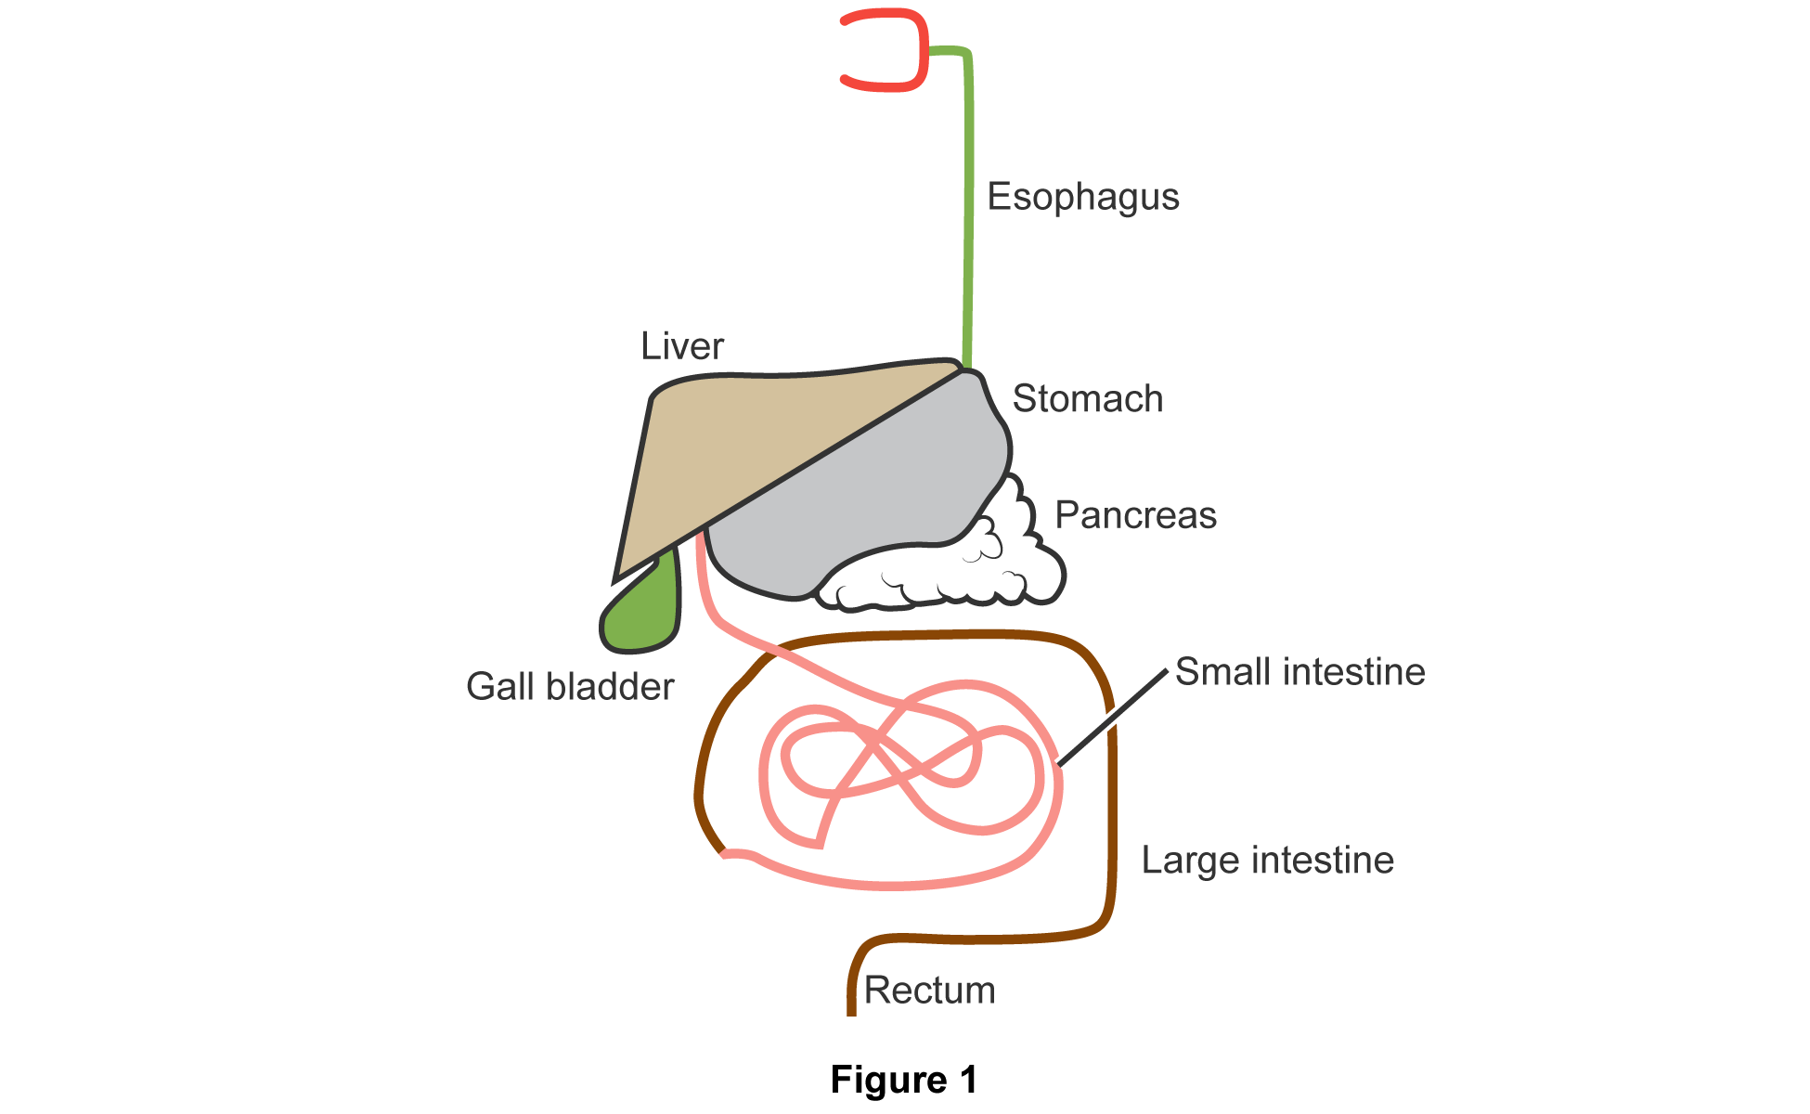

- Use Figure 1 and the instructions below to create the model.
- Make the mouth.
  - Shape the red yarn into a backward C.
  - Glue the mouth-shaped yarn onto the upper part of the poster board. Leave enough space for the other structures of the digestive system.
- Make the esophagus.
  - Glue the end of the green yarn to the middle of the outer curved part of the mouth.
  - Extend the green yarn downward. Glue it to the poster board. Leave a half inch of the yarn unglued.
- Make the stomach.
  - Blow air into the plastic bag.
  - Insert the unglued end of the green yarn into the upper right corner of the bag.
  - Zipper the plastic bag and position it on the poster board, as shown in the diagram.
- Make the liver.
  - Cut the brown paper bag from the lower left bottom corner to the top right corner, as shown in Figure 2. You will end up with two triangle parts. Use part 2 and put part 1 aside.

  - Glue one side of the the bag on the poster board with the open part of the triangle touching the top side of the Ziploc bag.
- Make the gall bladder.
  - Blow air into the green balloon.
  - When the ballon takes a limp shape, tie the end of the ballon so the air cannot escape.
  - Glue the end of the ballon with the knot under the flap of the brown paper bag to the left corner of the plastic bag.
- Make the pancreas.
  - Loosen the three cotton balls and shape the balls as shown in the diagram. Glue the cotton under the plastic bag.
  - Secure the plastic bag by taping it completely onto the poster board.
- Make the small intestine.
  - In between the green ballon and the plastic bag, glue one end of the pink yarn. Shape it like the small intestine in the diagram.
  - Secure the pink yarn by gluing it onto the board. Leave a half inch at the end of the yarn unglued.
- Make the large intestine.
  - Tie one end of the brown yarn to the unglued part of the pink yarn.
  - Shape the brown yarn around the pink yarn as shown in the diagram. Leave an inch of the brown yarn unglued.
- Make the rectum.
  - Position the unglued part of the brown yarn vertically.
  - Glue the yarn to the board.
- Label the structures in your model.

Step 4: Model what happens to food in the digestive system.
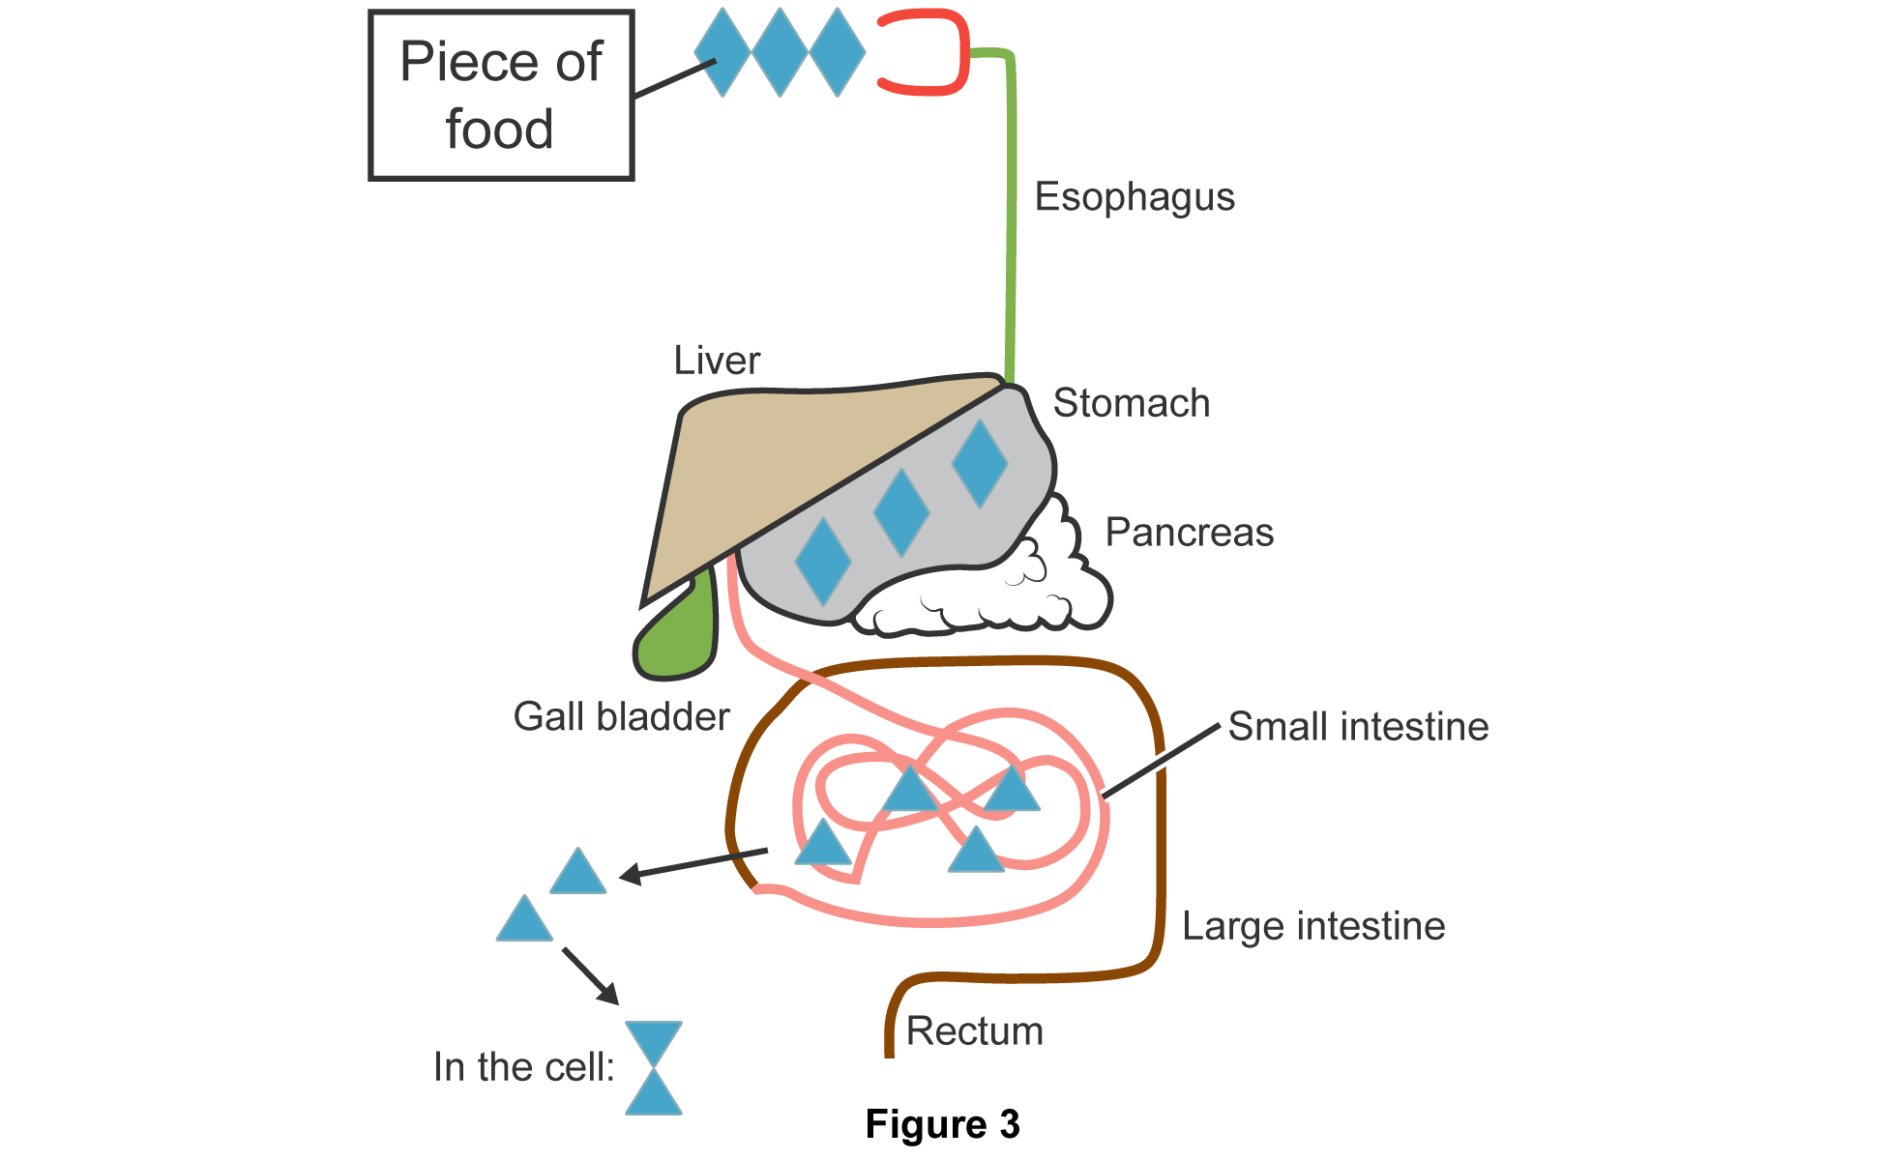
- Use Figure 3 and the instructions below to show what happens to food after it is eaten.
- Cut out six diamond shapes and eight triangles from the blue construction paper. Glue these shapes as shown in Figure 3.
- Add the two arrows as shown in Figure 3.
- Add the label In the cell: as shown in Figure 3.
- On an index card, write the phrase Piece of food. Glue this index card beside the three diamonds near the mouth. Draw a line between the index card and the blue diamonds.
Step 5: Descibe what happens to food in the digestive system and in the cells.
- Describe how food changes in the stomach.
  - Using your model, study how the food changes in the stomach.
  - On an index card, write a sentence that describes this change.
  - Glue this index card near the stomach.
- Describe how food changes in the small intestine.
- Using your model, study how the food changes in the small intestine.
- On an index card, write a sentence that describes this change.
- Glue this index card near the small intestine.
- Explain what happens to digested food in the small intestine.
- Study the two triangles under the gall bladder.
- On an index card, explain what happens to digested food in the small intestine.
- Glue this index card near the two triangles under the gall bladder.

- Explain how cells use digested food.
- Using your model, study what happens to digested food in the cell.
- On an index card, write a sentence that describes this change.
- Glue this index card near the In the cell label.
Step 6: Evaluate your model using this checklist.
If you can check each criterion below, you are ready to submit your project.
- Does your model show all the structures of the digestive system (mouth, esophagus, stomach, small intestine, liver, gall bladder, pancreas, large intestine, and rectum)?
- Are all labels in place?
- Are the two arrows in place?
- Are all index cards complete?
- Are all components of your model glued properly and secured on the poster board?
- Did you use complete sentences on the index cards?
- Did you write neatly on the index cards?
- Did you write your name at the back of the poster board?
Step 7: Revise and submit your project.
- If you were unable to check off all of the requirements on the checklist, go back and make sure that your project is complete.
- When you have completed your project, submit your model to your teacher for grading.
Step 8: Clean up your workspace.
- Return all reusable materials to your teacher.
- Clean up your workspace. Throw away any trash. Congratulations! You have completed your project.

