Assignment Summary
For this assignment, you will model the structures of the cell and describe their functions. You will do this by first completing a table that describes the functions of structures of the cell. In this table, you will also identify factory parts or workers that have similar functions. Then, you will create a comic strip showing a scenario where a reporter visiting a cell “factory” interviews the structures/organelles about how their roles in the cell are similar to those of a factory and its workers.

Background Information
The cell is the basic unit of structure and function of all living things. It is the smallest part of living things that is alive. To stay alive, cells do many tasks. Cells use nutrients to produce substances and energy that keep the processes in cells going. The production and transport of these substances also create waste materials that are released by the cell. Many structures of the cell work together to make sure that cells are able to do all these things.
Cells are like factories. Factories also put together things to produce new things using energy supplied by the factory. In the process of producing these new things, waste materials are also created and are taken out of the factory. Many parts and workers of the factory work together so that the production of these new things happens smoothly. The structures of the cell can be compared to the parts and the workers in a factory. For example, the Golgi body is an organelle that packages materials and distributes them within or out of the cell. The Golgi body has a similar job to a factory worker that puts products of a factory in boxes. The worker brings some of the boxes to be stored in the warehouse, and some boxes are loaded by the worker onto trucks for delivery outside the factory.

Safety
- The materials to be used in this project are only for creating the model of the structures of the cell and are not to be played with.
- All actions while doing this project should be purposeful.
- Wash your hands after completing this project.

Materials

- 1 poster board (22" x 28", White)
- Crayons
- Markers
- Pencil
- Ruler

Assignment Instructions
Step 1: Prepare for the project.
- Read steps 2 through 7 so that you know what you are expected to do during this project. Pay particular attention to the instructions you need to follow to create your comic strip. If there is anything that is not clear to you, be sure to ask your teacher.
Step 2: Gather materials.
- Collect the materials from your teacher.
Step 3: Identify the factory parts or workers that do the same job as the structure of the cell.
- Complete the table below.
- You will use this information as a guide in creating your comic strip.
- The information for the Golgi body has already been filled in for you as an example.

Structure of Cell | Function | Factory Part or Worker
Golgi body | Packages materials and distributes them within or out of the cell | A factory worker who puts products in boxes and transports packaged products to the warehouses or to trucks that will leave the factory
Cell wall

Cell membrane

Nucleus

Ribosome

Mitochondrion

Endoplasmic reticulum

Chloroplast

Step 4: Create the comic strip.
- Plan how you will fit your comic strip on your poster board. Mark places on your poster board where you will draw the organelles. Allow enough space for each organelle.

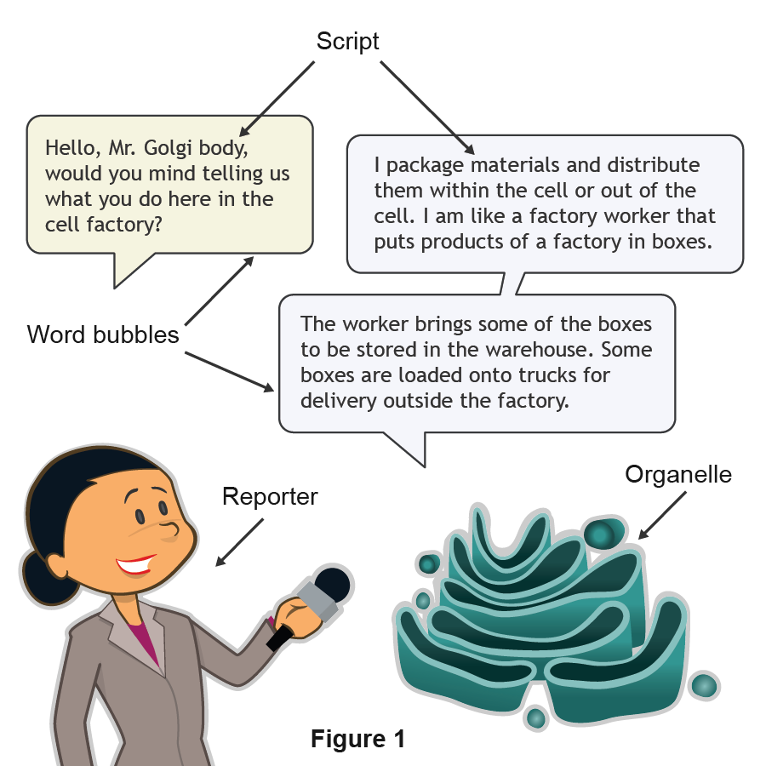

- Introduce the comic strip.
  - Using Figure 1 as a guide, introduce the comic strip by drawing a reporter in front of a cell describing why it is going to the cell factory and what it hopes to accomplish during her visit. Use a word bubble and script in your drawing.
  - Because the Golgi body has been modeled for you, you will not need to include it in your comic strip.
- Model the cell wall.
  - Use Figure 1 as a guide as you complete the steps below.
  - In the word bubbles, write scripts for the reporter and the structure. In the script, the reporter should be asking the structure what its role is in the cell. The cell wall should talk about its role in the cell in relationship to the job of the part of the factory it represents.
- Model the cell membrane.
  - Repeat step 4.c.1-2 for the cell membrane.
  - Make sure your new script shows the reporter talking to the cell membrane and accurately illustrates its role in the cell, comparing it to a part or worker in a factory.
- Model the nucleus.
  - Repeat step 4.c.1-2 for the nucleus.
  - Make sure your new script shows the reporter talking to the nucleus and accurately illustrates its role in the cell, comparing it to a part or worker in a factory.
- Model the ribosome.
  - Repeat step 4.c.1-2 for the ribosome.
  - Make sure your new script shows the reporter talking to the ribosome and accurately illustrates its role in the cell, comparing it to a part or worker in a factory.
- Model the mitochondrion.
  - Repeat step 4.c.1-2 for the mitochondrion.
  - Make sure your new script shows the reporter talking to the mitochondrion and accurately illustrates its role in the cell, comparing it to a part or worker in a factory.
- Model the endoplasmic reticulum.
  - Repeat step 4.c.1-2 for the endoplasmic reticulum.
  - Make sure your new script shows the reporter talking to the endoplasmic reticulum and accurately illustrates its role in the cell, comparing it to a part or worker in a factory.
- Model the chloroplast.
  - Repeat step 4.c.1-2 for the chloroplast.
  - Make sure your new script shows the reporter talking to the chloroplast and accurately illustrates its role in the cell, comparing it to a part or worker in a factory.

Step 5: Evaluate your model using this checklist.
If you can check each criterion below, you are ready to submit your project.
- Does your comic strip show drawings of a reporter interviewing the cell wall, cell membrane, nucleus, ribosome, mitochondrion, endoplasmic reticulum, and chloroplast?
- Are the word bubbles properly drawn near the reporter and the structures or organelles?
- Does each structure/organelle talk about its role in the cell in relationship to the job of the part of the factory or factory worker it represents as part of its script?
- Did you put together the reporter, the structure or organelle, and the word bubbles with the script as shown in Figure 2?
- Did you write neatly and clearly in the word bubbles?
- Did you write your name at the back of the poster board?
Step 6: Revise and submit your project.
- If you were unable to check off all of the requirements on the checklist, go back and make sure that your project is complete.
- When you have completed your project, submit your comic strip to your teacher for grading.
Step 7: Clean up your workspace.
- Return all reusable materials to your teacher.
- Clean up your workspace making sure to throw away any trash. Congratulations! You have completed your project.

