Pre-Lab Information
Purpose Conduct an investigation to explore the behavior of an earthworm that has been exposed to different stimuli.
Time Approximately 45 minutes
Question How is earthworm behavior affected by external stimuli?
Hypothesis #1 If an earthworm is exposed to dry conditions, then it will retreat to a moist place because its skin needs to stay moist for the earthworm to survive.
Hypothesis #2 If an earthworm is exposed to a strong odor, then it will back away from the odor because it will think that the odor is a sign of danger.
Variables for H1 Independent Variable: Exposure to dry conditions
Dependent Variable: Earthworm response
Variables for H2 Independent Variable: Exposure to a strong odor
Dependent Variable: Earthworm response
Summary You will conduct experiments to test earthworms’ responses to different stimuli. First, you will observe four earthworms to orient yourself to their anterior and posterior ends. Second, you will test earthworms’ response to dry conditions by providing both a dry surface and a moist surface for the earthworms to crawl on. Then, you will test earthworms’ response to smell by waving ammonia near them.

Safety
- Always wear a lab coat and safety goggles when performing an experiment.
- Behavior in the lab needs to be purposeful. Do not pull, twist, throw, or otherwise play with the earthworms.
- Use cotton swabs to handle ammonia. Do not taste, smell, or directly touch the ammonia.
- Handle earthworms gently, with care and respect.
- Keep earthworms moist at all times and moisten your hands with water before handling earthworms.
- Wash your hands thoroughly after completing the lab.
- Report all accidents—no matter how big or small—to your teacher.

Lab Procedure
- Gather materials for the lab.
- 4 Earthworms  - Storage container  - Tray | - Paper towels  - Cotton swab  - Ruler | - Spray bottle of water  - Ammonia
- Observe the earthworms.
  - Moisten your hands with water before picking up the earthworms.
  - Place the earthworms on a damp paper towel on the tray.
  - Observe how the earthworms behave before they are exposed to dry conditions or a strong odor.
  - Roll the earthworms over gently and observe what happens. (Note: The side the earthworms prefer up is the dorsal side, and the side they prefer down is the ventral side.)
- Measure the earthworms.
  - Keep the earthworms on the damp paper towel.
  - Place the 0 cm end of a ruler near one end of an earthworm.
  - Gently straighten the earthworm to align it with the ruler. Use caution; do not pull too hard.
  - Record the length of the earthworm in centimeters in Table A.
  - Count the number of segments on the earthworm and record that number in Table A.
  - Locate the thickening of the earthworm’s body. This is known as the clitellum. Note: The leading end of the earthworm is called the anterior end and the trailing end is called the posterior end.
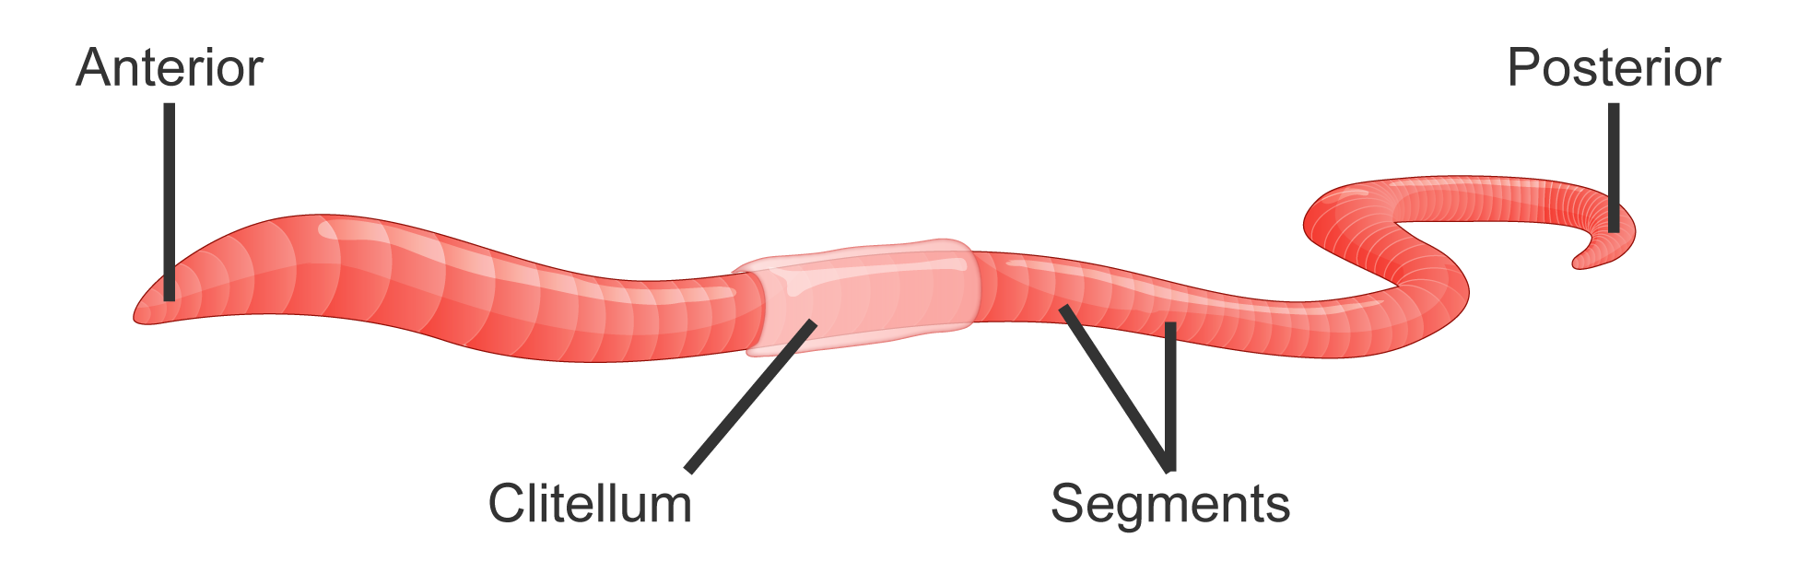
  - Count the number of segments from the anterior end to the clitellum.
  - Record the number of segments from the anterior end to the clitellum in Table A.
  - Repeat Steps 3b–3h for the other three earthworms.
- Determine how the earthworms respond to dry conditions.
  - Place a damp paper towel on half of the tray. Make sure the paper towel is flat and covers the tray from side to side.
  - Place a dry paper towel on the other half of the tray. Make sure the paper towel is flat and covers the tray from side to side.
  - Lay one earthworm on the tray with its anterior end on the moist paper towel and its posterior end on the dry paper towel.
  - Observe the earthworm’s response, and record it in Table B.
  - Repeat Steps 2c and 2d with the other three earthworms.
  - Lay one earthworm on the tray with its posterior end on the moist paper towel so that half of the worm lies on the moist paper towel and half lies on the dry paper towel.
  - Observe the earthworm’s response, and record it in Table B.
  - Repeat Steps 2f and 2g with the other three earthworms.
- Give the earthworms a rest.
  - Remove the dry paper towel from the tray.
  - Cover the entire tray with moist paper towels.
  - Let the earthworms move around on their own for a few minutes.
  - Leave the earthworms on the moist paper towels as you do Step 6.
- Determine how the earthworms respond to odor.
  - Dip one end of a cotton swab in ammonia. Do not touch the worms with the ammonia, as it is toxic to them.
  - Carefully wave the ammonia end of the swab within 2 cm of the posterior end of each earthworm for five seconds.
  - Observe the earthworms’ responses, and record them in Table C.
  - Carefully wave the ammonia end of the swab within 2 cm of the anterior end of each earthworm for five seconds.
  - Observe the earthworms’ responses, and record them in Table C.
- Clean up the lab.
  - Return the earthworms to the class container and dispose of all materials according to your teacher’s directions.

Data
Record your data in the tables below.
Table A
 | Length  (cm) | Number of Segments | Number of Segments from Anterior End  to Clitellum
Earthworm 1
Earthworm 2
Earthworm 3
Earthworm 4

Table B
 | Posterior End Starting on Dry Paper Towel | Anterior End Starting on Dry Paper Towel
Earthworm 1
Earthworm 2
Earthworm 3
Earthworm 4

 | Ammonia Near Posterior End | Ammonia Near Anterior End
Earthworm 1
Earthworm 2
Earthworm 3
Earthworm 4
Table C

Follow-up Questions
Answer the following questions.
- Based on your observations, which end of the earthworm contains an organ that senses smells? Use your data to support your answer.

- How would you expect earthworms to respond to any strong chemical odor?

- If earthworms need to keep their skin moist for the exchange of gases with the environment, why do they come above ground after rain soaks the ground?

