Pre-lab Information
Purpose Use a virtual lab to explore the behavior of an earthworm that has been exposed to different stimuli.
Time Approximately 45 minutes
Question How is earthworm behavior affected by external stimuli?
Hypothesis #1 If an earthworm is exposed to dry conditions, then it will retreat to a moist place because its skin needs to stay moist for the earthworm to survive.
Hypothesis #2 If an earthworm is exposed to a strong odor, then it will back away from the odor because it will think that the odor is a sign of danger.
Variables for H1 Independent Variable: Exposure to dry conditions
Dependent Variable: Earthworm response
Variables for H2 Independent Variable: Exposure to a strong odor
Dependent Variable: Earthworm response
Summary You will conduct virtual experiments to test earthworms’ responses to different stimuli. First, you will observe four earthworms to orient yourself to their anterior and posterior ends. Second, you will test earthworms’ response to dry conditions by providing both a dry surface and a moist surface for the earthworms to crawl on. Then, you will test earthworms’ response to smell by waving ammonia near them.

Lab Procedure
- Observe the earthworms.
  - Start by clicking the spray bottle to moisten your hands and the paper towel with water.
  - Drag the earthworms to the tray to place them on the damp paper towel.
  - Observe how the earthworms behave before they are exposed to dry conditions or a strong odor.
  - Select Roll Over to gently roll the earthworm over, and observe what happens. Repeat this step for the remaining three earthworms. Use the arrow keys to navigate to the next worm. (Note: The side the earthworms prefer up is the dorsal side, and the side they prefer down is the ventral side.)
- Measure the earthworms.
  - Locate the thickening of the earthworm’s body. This is known as the clitellum.

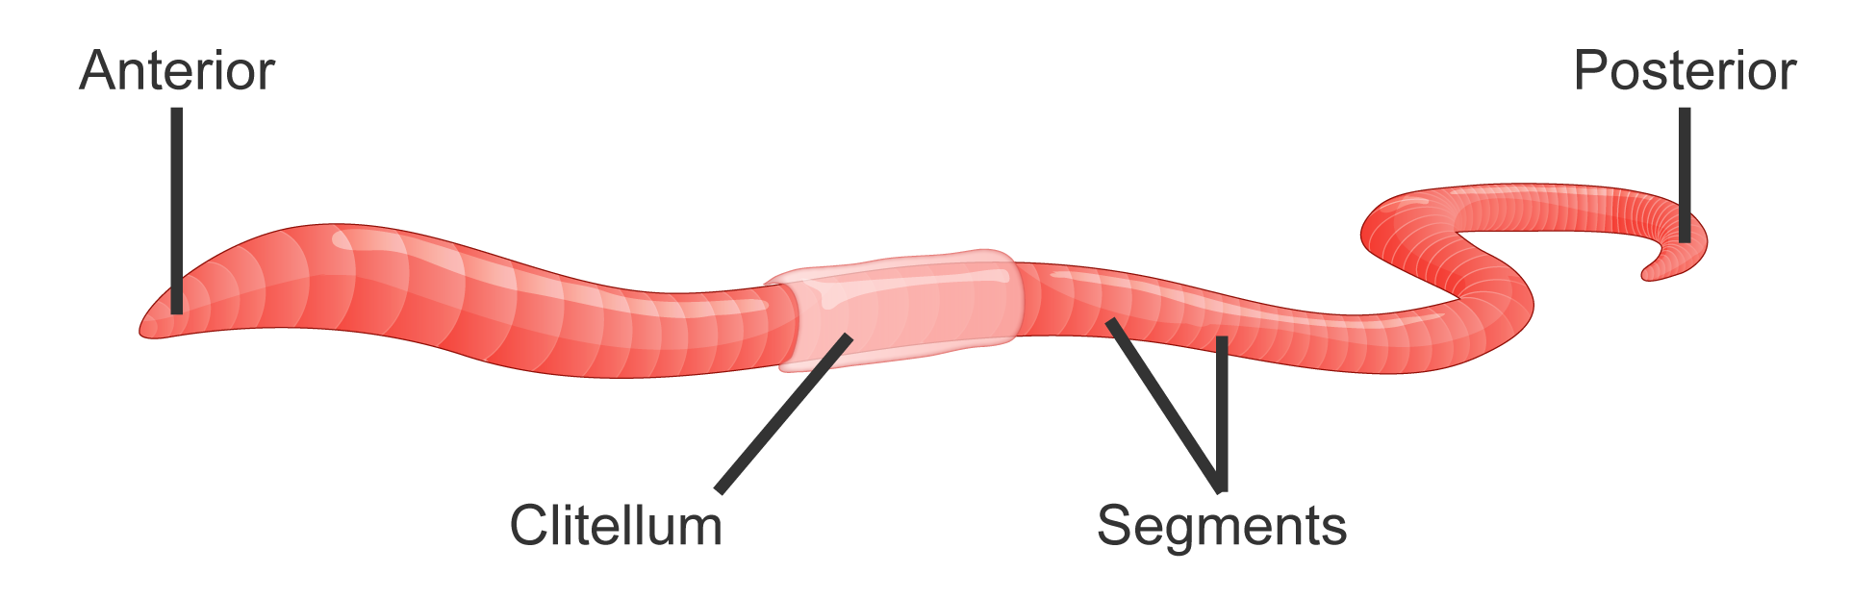
  - Find the leading end. This is the anterior end. The opposite end is the posterior end.
  - Select Measure to measure the earthworm.
  - Record the length of the earthworm in centimeters in Table A of your Student Guide.
  - Record the total number of segments and the number of segments from the anterior to clitellum in Table A of your Student Guide.
  - Repeat these steps for the remaining three earthworms. Use the arrow keys to navigate to the next worm.
- Determine how the earthworms respond to dry conditions.
  - Select Environment to place the earthworm between a dry paper towel and a wet paper towel. A damp paper towel will appear on half of the tray, and a dry paper towel will appear on the other half of the tray. The earthworm will appear on the tray with its anterior end on the moist paper towel so that half of the worm lies on the moist paper towel and half lies on the dry paper towel.
  - Record your observations in Table B of your Student Guide.
  - Now, the earthworm will be placed so that its posterior end is on the moist paper towel. Record your observations in Table B of your Student Guide.
  - Repeat these steps for the remaining three earthworms. Use the arrow keys to navigate to the next worm.
- Give the earthworms a rest.
  - Select the clock to give the earthworms a rest. Note: The clock will move quickly to show a ten-minute rest. Selecting the clock again will replay the ten-minute rest.
- Determine how the earthworms respond to odor.
  - Select Smell to carefully wave the ammonia end of the swab near the posterior and anterior ends of the earthworm.
  - Record your observations in Table C of your Student Guide.
  - Repeat these steps for the remaining three earthworms. Use the arrow keys to navigate to the next worm. Note: One end of a cotton swab has been dipped in ammonia. It is important not to touch the worms with the ammonia, because it is toxic to them.
- Clean up the lab.
  - Finally, drag each earthworm back to the glass container.

Data
Record your data in the tables below.
Table A
 | Length  (cm) | Number of Segments | Number of Segments from Anterior End  to Clitellum
Earthworm 1
Earthworm 2
Earthworm 3
Earthworm 4

Table B
 | Posterior End Starting on Dry Paper Towel | Anterior End Starting on Dry Paper Towel
Earthworm 1
Earthworm 2
Earthworm 3
Earthworm 4

 | Ammonia Near Posterior End | Ammonia Near Anterior End
Earthworm 1
Earthworm 2
Earthworm 3
Earthworm 4
Table C

