Pre-Lab Information
Purpose Explore the relationship between the angle of incidence and the angle of refraction for a medium.
Time Approximately 45 minutes
Question How do the angle of incidence and the angle of refraction for a given medium compare to each other?
Summary In this lab, you will explore how the angle of incidence affects the angle of refraction for a clear liquid. Light changes speed when it enters or exits a medium, causing the light to appear to bend at the boundary between two media. Both the medium and the angle at which light enters the medium, or the angle of incidence, affect the angle at which light exits the medium, or the angle of refraction. The ratio of the sine of these two angles provides the index of refraction for a given medium.

Safety
- Use caution with the laser. Never point the laser at another person’s face.
- Make sure that behavior in the lab is purposeful.
- Report all accidents—no matter how big or small—to your teacher.

Lab Procedure
- Gather materials.
- Transparent, semicircular dish  - Water  - Laser | - Copy of the refraction ray diagram  - Protractor
- Use this diagram as a guide to set up the experiment.
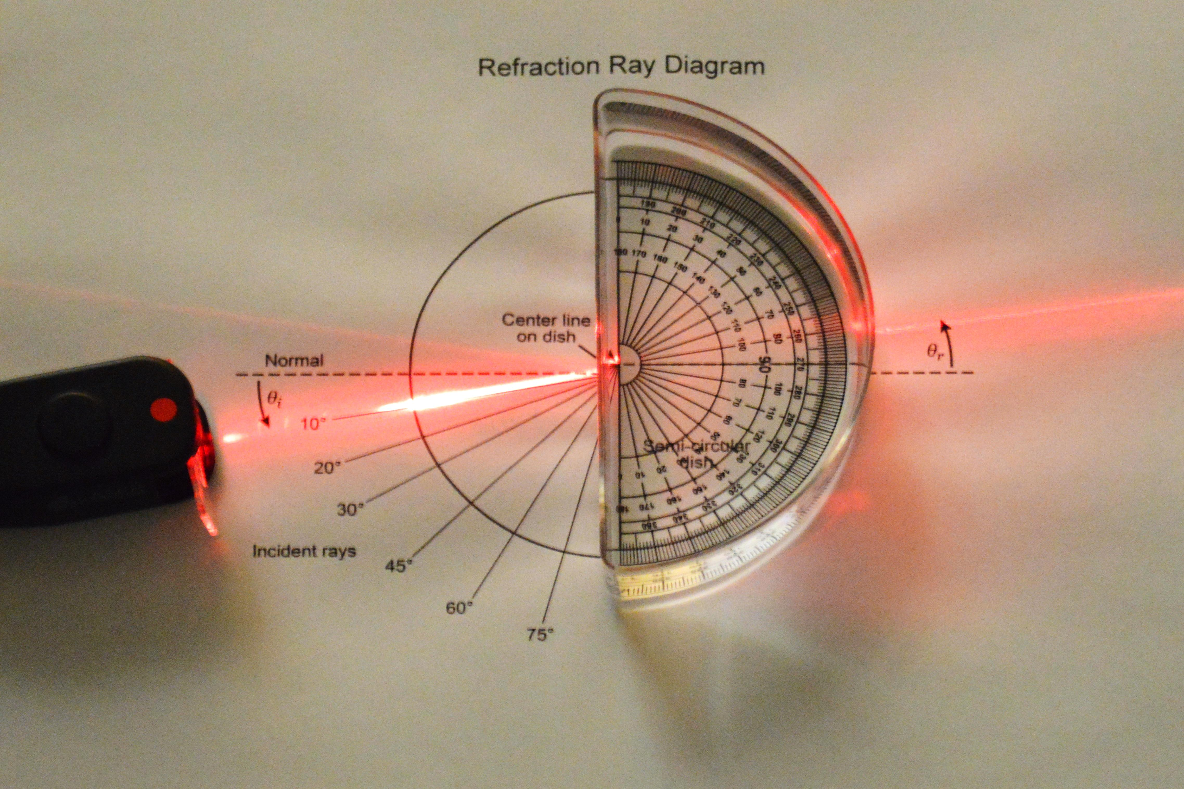
  - Orient the refraction ray diagram printout so that it is easy to see the laser beam and easy to write on.
  - Fill the semicircular dish with water and place it in the area marked “Semicircular dish” on the printout.
- Determine angles of refraction.
  - Orient the laser so that it travels along the line representing a 10° angle of incidence, θ_{i}.
  - Place a mark on the printout where the angle of refraction exits the semicircular dish. Label this mark with a 1.
  - Repeat Steps 3a and 3b for 20°, 30°, 45°, 60°, and 75° angles of incidence. Label these marks with numbers 2–6.
  - Remove the semicircular dish of water.
  - Use a straight edge to draw a line from the “Center line on dish” to the mark labeled with a 1.
  - Use a protractor to measure the angle of refraction, θ_{r}, from the normal. Record this angle in Table A.
  - Repeat Steps 3e and 3f for marks 2–6.
- Graph your results to determine the slope of the line of best fit.
  - Calculate the sine of each angle of incidence and the sine of each angle of refraction. Record these values in Table A.
  - Construct a graph of the sine of the angle of incidence vs. the sine of the angle of refraction using the data in Table A. The sine of the refraction angle, θ_{r}, should be on the x-axis, and the sine of the incident angle, θ_{i}, should be on the y-axis.
  - Draw a single line of best fit through the data points.
  - Calculate the slope, m, of the line of best fit. Record the slope in Table B.
  - Title the graph and label the axes with units.
- Calculate the index of refraction for water.
  - Calculate the index of refraction for water by solving for n_{water} in the formula
m = n_{water} /n_{air}
where n_{air} = 1.00029. Record the index of refraction in Table B.
- Clean up the lab.
  - Dispose of the water and wipe up any spills.
  - Follow your teacher’s directions for putting away the laser and the semicircular dish.
- Answer the follow-up questions.

Data
Record your data either in your lab notebook or in the tables below.
Table A
θ_{i} | θ_{r} | sin θ_{i} | sin θ_{r}
10°
20°
30°
45°
60°
75°

Table B
 | Calculations | Answer
Slope
Index of refraction for water

Follow-Up Questions
Answer the following questions.
- The accepted value for the index of refraction for water is 1.33. How does your value compare to the accepted value?

- Why do you think there is a difference between your value for the index of refraction for water and the accepted value?

