Pre-Lab Information
Purpose Conduct an investigation to explore the relationship between kinetic energy, gravitational potential energy, and heat due to friction to verify the law of conservation of energy.
Time Approximately 45 minutes
Question How does the law of conservation of energy apply to a marble rolling down ramps made of different materials?
Summary This investigation is divided into two parts. The setup for the first part uses a low-friction ramp and a marble. The second part of the lab uses the same marble with a higher-friction ramp. You will apply the relationship between kinetic energy, gravitational potential energy, and heat due to friction to determine the landing position of the marble after it rolls down each ramp and off a table.

Safety
- Always wear safety goggles when performing an investigation, especially with objects in motion.
- Use caution when walking, as marbles will wind up on the floor.
- Be sure that your behavior in the lab is purposeful.
- Report all accidents—no matter how big or small—to your teacher.

Lab Procedure
- Gather materials.
- Metal ramp  - Foam ramp  - Masking tape  - Books | - Stopwatch  - Meter stick  - Target handout  - Carbon paper

Part I: Predicting the Landing Location of the Marble Rolling Off a Metal Ramp
- Use this diagram as a guide to set up the first investigation with the metal ramp.
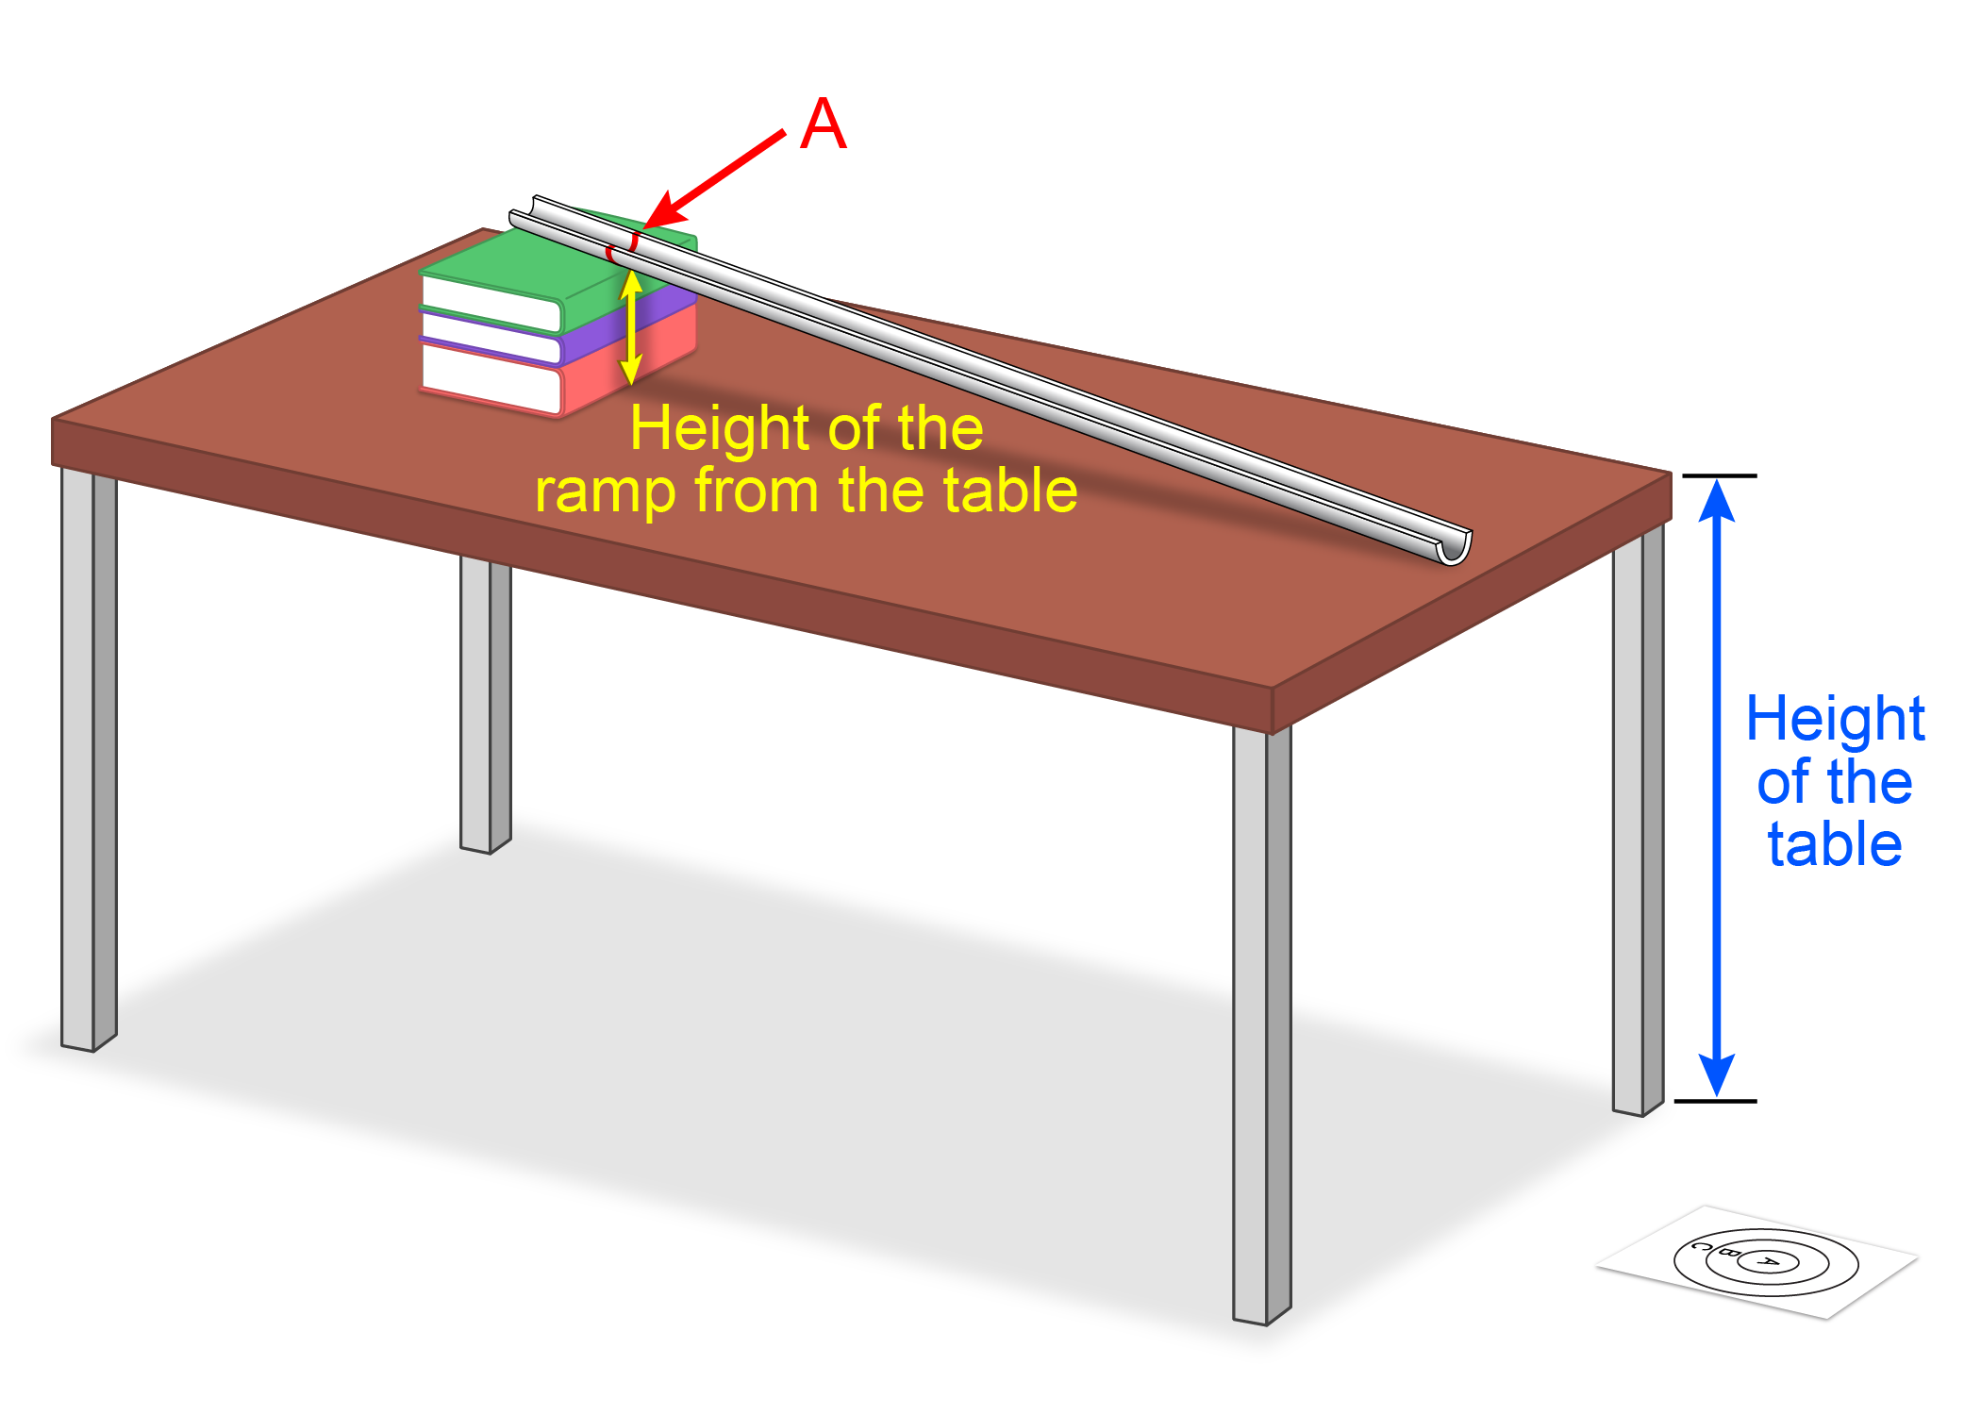
  - Place one end of the ramp on top of three or four textbooks to create an incline.
  - Leave about one inch between the other end of the ramp and the edge of the desk. This ensures that the marble has only a horizontal velocity when it leaves the table.
- Calculate the marble’s velocity at the end of the ramp.
  - Using a pencil or a piece of chalk, place a mark on the ramp to indicate the marble’s release point. This release point is Point A.
  - Measure the height of the ramp from the table to Point A. Record the height in Table A.
  - Set the formulas for potential energy and kinetic energy equal to each other and solve for velocity.
      - Remember that the formula for potential energy (PE) is mass (m) times acceleration due to gravity (g) times height (h):
PE = mgh
      - Remember that the formula for kinetic energy (KE) is one-half the mass (½m) times the velocity squared (v²):
KE = ½mv²
  - Show your calculations and record the velocity in Table B.
- Calculate the time the marble is in the air.
  - Measure the height of the table. Record the height in Table A.
  - Calculate the time it takes the marble to fall from the table to the ground.
      - Recall that for straight line motion with a constant acceleration, the distance (d) is one-half the acceleration (½a) times the time squared (t²) added to the initial velocity (v_{i}) times the time (t):
d = ½at² + v_{i}t
Since the marble is rolling off the table with only a horizontal velocity, it will not have an initial vertical velocity and it will be accelerated only by gravity.
  - Record the time in Table B.
- Calculate the horizontal distance the marble will travel.
  - Using the velocity (v) from Step 3 and the time (t) from Step 4, determine the horizontal distance (d) the marble will travel once it leaves the table by rearranging the following formula:
v = d/t
  - Record the distance in Table B.
- Test your prediction.
  - Tape the target handout on the ground so that the center of Circle A is at your predicted distance.
  - Inform your teacher that you are ready to test your prediction. Your teacher will then give you the marble. Note: Do not conduct the investigation until your teacher is present to observe your results.
  - Place the carbon paper on top of the target handout with the dark side facing down.
  - Release the marble from Point A on the ramp.
  - Remove the carbon paper to see the mark where the marble landed.
  - Keep the marble for Part 2.
Part II: Predicting the Landing Location of the Marble Rolling Off a Foam Ramp
- Set up the second investigation with the foam ramp.
  - Put the metal ramp away according to your teacher’s directions and replace it with the foam ramp.
  - Tape one end of the foam ramp on top of three or four textbooks to create an incline.
  - Pulling the foam tightly to keep it from sagging, tape the other end of the ramp about one inch from the edge of the desk. This ensures that the marble has only a horizontal velocity when it leaves the table.
- Calculate the marble’s velocity at the end of the ramp.
  - Repeat Step 3 for the marble on the foam ramp.
  - Show your calculations and record the velocity in Table C.
- Calculate the horizontal distance the marble will travel.
  - Repeat Step 5 for the marble on the foam ramp.
      - As long as the height of the table has not changed, you do not need to recalculate the time the marble is in the air.
  - Record the distance in Table C.
- Test your prediction.
  - Tape the target handout on the ground so that the center of Circle A is at your predicted distance.
  - Place the carbon paper on top of the target handout with the dark side facing down.
  - Release the marble from Point A on the ramp.
  - Remove the carbon paper to see the mark where the marble landed.
- Determine the horizontal distance the marble travels.
  - Due to the increased friction of the foam ramp, the marble landed short of the target. With the blank side facing up, tape the target handout where the marble landed. Place the carbon paper on top with the dark side against the white paper.
  - Release the marble from Point A five more times.
      - If the marble does not land on the paper or lands too close to an edge, move the paper to where the marble lands. Cross out any stray marks left by the carbon paper.
  - Remove the carbon paper but leave the white paper taped to the ground.
  - Measure the distance from the edge of the table to each mark left by the marble on the white paper. Record these distances in Table D.
      - To ensure that measurements are made exactly from the edge of the table, one person can hold a meter stick perpendicular to the edge of the table. Place a piece of tape on the floor where the bottom of the meter stick meets the floor.
  - Calculate the average distance the marble traveled. Record the average distance in Table D.
- Calculate the horizontal velocity of the marble.
  - Use the time from Table B and the average distance from Table D to calculate the horizontal velocity of the marble. Record the velocity in Table E.
- Calculate the amount of potential energy that was converted to heat due to friction.
  - Use the triple-beam balance to measure the mass of the marble. Record the mass in Table A.
  - Calculate the potential energy the marble had at Point A. Record the potential energy in Table E.
  - Use the horizontal velocity from Step 11 to calculate the kinetic energy the marble had when it left the table. Record this in Table E.
  - Determine the difference between the potential energy and the kinetic energy. This is the amount of potential energy that was converted to heat due to friction. Record this value in Table E.
  - Develop a formula using kinetic energy, potential energy, and heat due to friction to show that energy was conserved. Use the values in your data tables to verify the formula. Record your formula in Table F.
- Clean up the lab.
  - Remove the tape from the foam ramp and from the floor. Dispose of the tape.
  - Follow your teacher’s instructions for putting away the ramps, marbles, and books.
- Answer the follow-up questions.

Data
Record your data and calculations either in your lab notebook or in the tables below.
Table A
Height of metal ramp at Point A
(m)
Height of table
(m)
Height of foam ramp at Point A
(m)
Mass of marble
(kg)

Table B
 | Calculations | Answer
Marble velocity (m/s)
Time in air
(s)
Horizontal distance
(m)

Table C
 | Calculations | Answer
Marble velocity (m/s)
Horizontal distance
(m)

Table D
Distance 1 (m) | Distance 2 (m) | Distance 3 (m) | Distance 4 (m) | Distance 5 (m) | Average distance (m)

Table E
 | Calculations | Answer
Horizontal velocity
(m/s)
Potential energy
(J)
Kinetic energy
(J)
Heat due to friction
(J)

Table F
Conservation of energy formula

Follow-Up Questions
Answer the following questions:
- How do kinetic energy, gravitational potential energy, and heat due to friction change as the marble rolls down the ramp?

- Do your results from Part 1 support the law of conservation of energy? Use your data to justify your answer.

- Do your results from Part 2 support the law of conservation of energy? Use your data to justify your answer.

