Pre-Lab Information
Purpose Conduct an investigation to explore the relationship between the centripetal force, mass, radius, and velocity of an object moving with uniform circular motion.
Time Approximately 90 minutes
Question How do centripetal force, mass, and radius affect the velocity of an object moving with uniform circular motion?
Hypothesis #1 If the centripetal force applied to an orbiting object increases, then the velocity of the orbiting object will increase when the mass of the object and the radius of the orbit are held constant, because centripetal force and velocity have an exponential relationship.
Hypothesis #2 If the mass of an orbiting object increases, then the velocity of the orbiting object will decrease when the centripetal force acting on the object and the radius of the orbit are held constant, because mass and velocity have an inverse relationship.
Hypothesis #3 If the radius of the orbit increases, then the velocity of the orbiting object will increase when the centripetal force acting on the object and the mass of the object are held constant, because radius and velocity have an exponential relationship.
Variables for H1 Independent variable: centripetal force
Dependent variable: velocity
Constants: mass, radius
Variables for H2 Independent variable: mass
Dependent variable: velocity
Constants: centripetal force, radius
Variables for H3 Independent variable: radius
Dependent variable: velocity
Constants: centripetal force, mass
Summary This experiment is divided into three parts. For each part, you will use nylon string with a rubber stopper on one end and metal washers on the other end. You will spin the rubber stopper overhead while two lab partners measure the time it takes the stopper to complete ten revolutions.

For the first part of the experiment, you will change the number of washers hung from the nylon string to examine how a centripetal force applied to the stopper affects the velocity of the stopper.

For the second part of the experiment, you will add mass to the stopper end of the string to examine how the mass of the stopper affects its velocity.

For the third part of the experiment, you will change the length of the nylon string between the tube and the stopper to examine how the radius of the circle affects the velocity of the stopper.

Safety
- Always wear safety goggles when performing an experiment, especially with objects in motion.
- Use caution when twirling masses. Be sure you are a safe distance from people and objects.
- Be sure that your behavior in the lab is purposeful.
- Report all accidents—no matter how big or small—to your teacher.

Lab Procedure
- Gather materials.
- Nylon string with rubber stopper and fishing swivel  - 20 washers  - 1 tube | - 1 stopwatch  - 1 meter stick  - 1 triple-beam balance
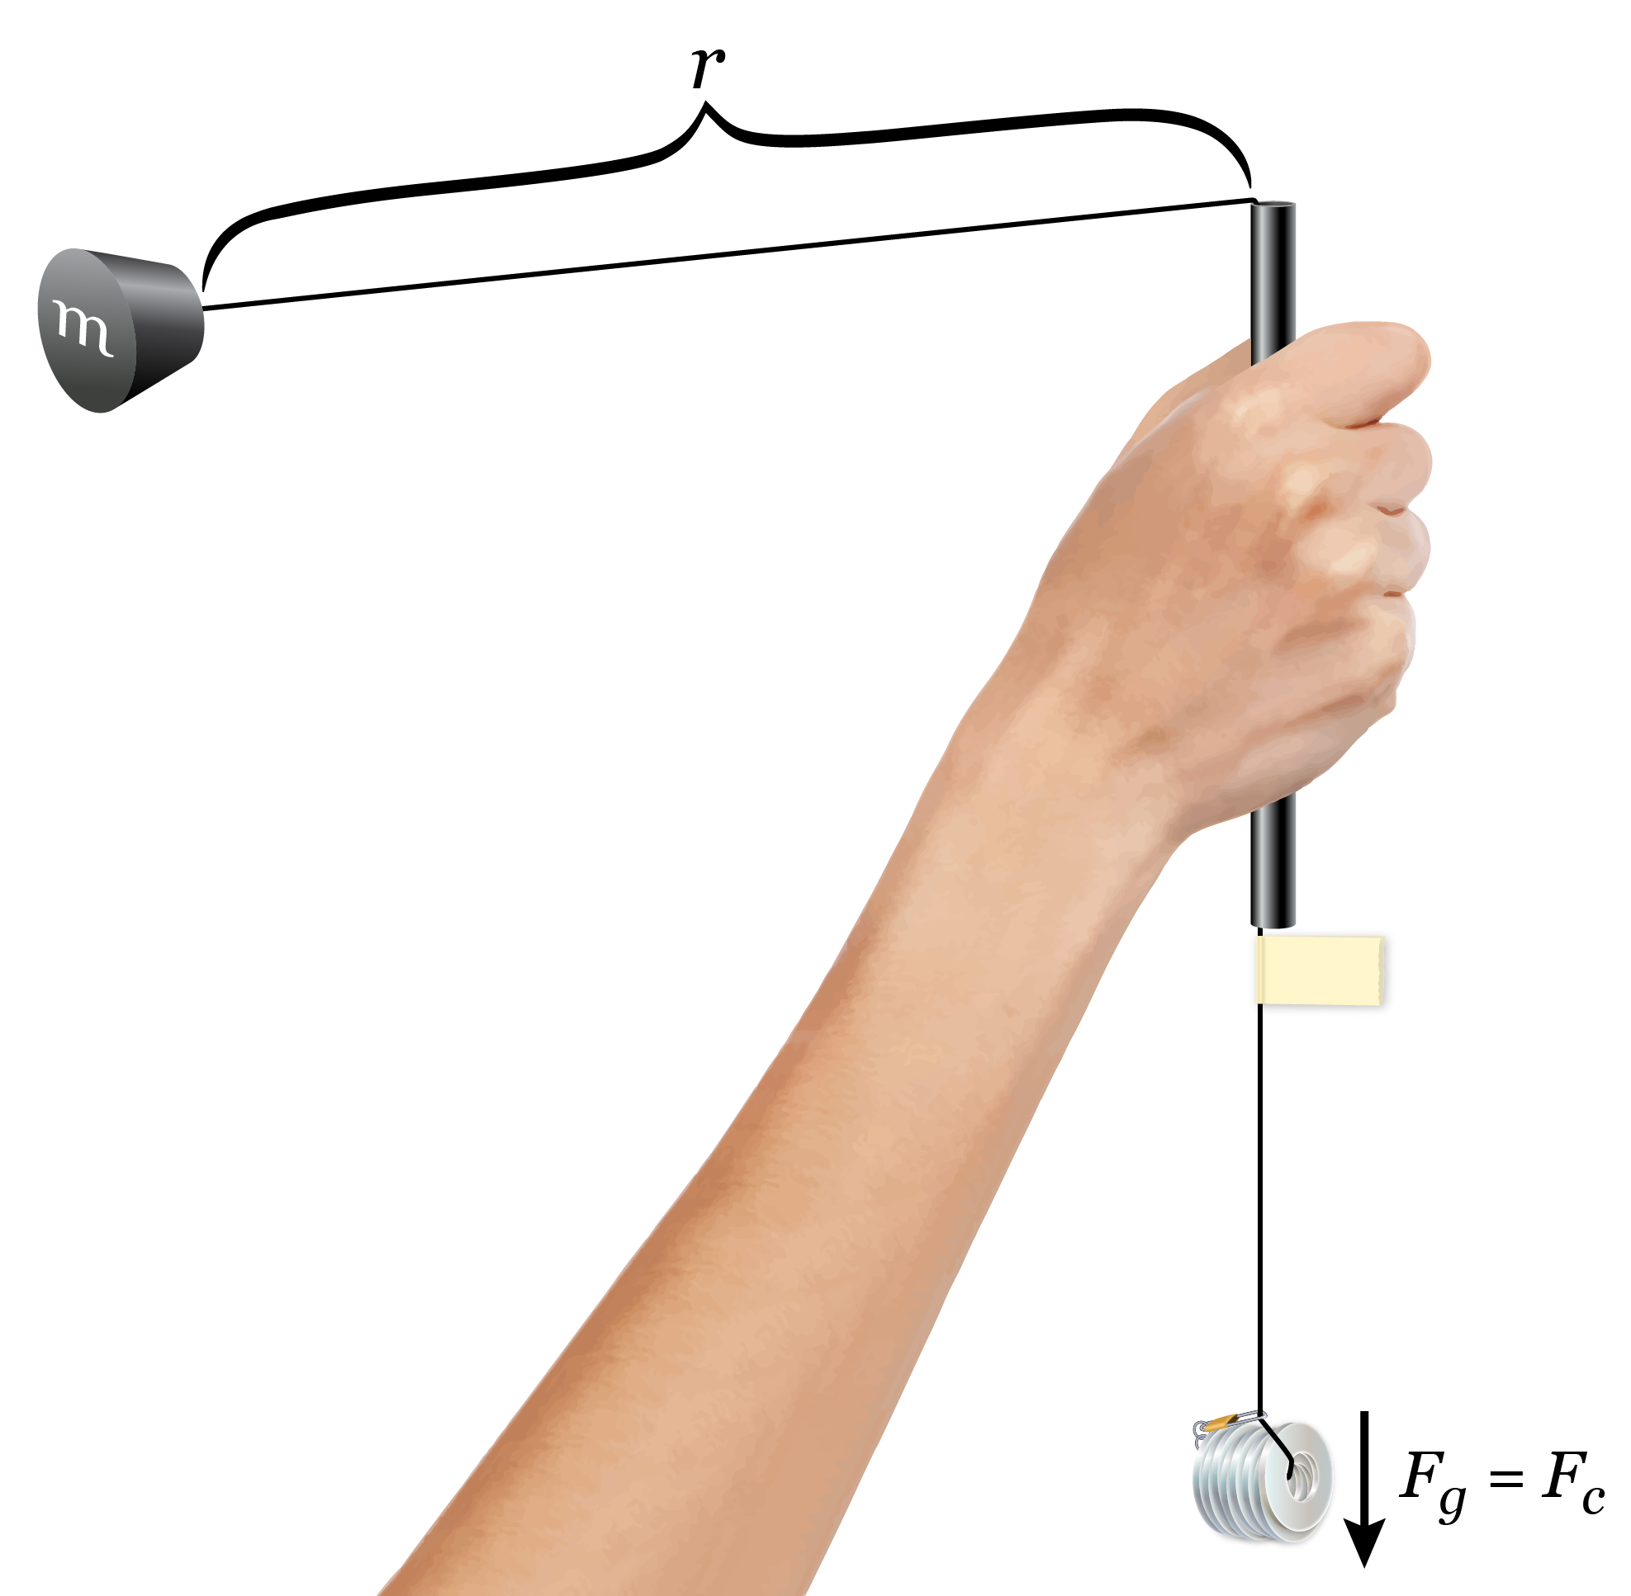
- Use this diagram to set up the experiment.

  - Use the triple-beam balance to find the mass of the stopper. Record the mass in Table A.
  - Use the triple-beam balance to find the mass of one washer. Record the mass in Table A.

Part I: Changing the Centripetal Force
- Run the first trial.
  - Adjust the nylon string so that the distance between the top of the tube and the stopper is 0.7 m.

  - Secure a piece of masking tape to the nylon string. Place it as close as possible to the bottom of the tube without the tape touching the tube. Here is a photo to guide you:
  - Use the fishing swivel to secure eight washers to the bottom of the nylon string.
  - Use the information in Table A to determine the mass of the eight washers in kilograms. Record the mass in Table B.
  - Practice twirling the tube in one hand so that the stopper travels in a horizontal circle.
      - Keep the orbit of the stopper as parallel to the floor as possible.
      - Make sure the tape does not rub against the tube.
      - Keep the tape just below the bottom of the tube, without the tape touching the tube, to maintain a constant radius.
      - When you feel comfortable keeping a constant radius, proceed to collect data.
  - Designate a timer who will use the stopwatch to time ten revolutions of the stopper. Record the time in seconds in Table B.
      - Instead of watching the stopper during a complete revolution, it is easiest to watch a spot on the wall behind the stopper and count how many times the stopper passes that point.
  - Repeat Step 3f two more times for a total of three runs.
- Perform more trials with different centripetal forces.
  - Keep the string length at 0.7 m.
  - Repeat Steps 3c–3g four more times, with ten, twelve, fourteen, and sixteen washers secured to the bottom of the nylon string.
- Calculate the velocity for each trial.
  - First, average the three run times for each trial. Record the averages in Table B.
  - Calculate the period of the stopper for each trial by dividing the average time by ten. Record the periods in Table B.
  - Calculate the velocity of the stopper for each trial. Remember to use the formula for velocity (v), which is the distance (d) divided by the elapsed time (t):
v = d/t
      - In the case of a circular orbit, the distance is equal to the circumference of the circle:
C = 2πr
The circumference, C, of a circle with a radius of 0.7 m is _____ m.
      - The elapsed time is equal to the period, T, of the orbiting object. The velocity can be calculated using this formula:
v = C/T
Record the velocities in m/s in Table C.
- Calculate the centripetal force for each trial.
  - Calculate the centripetal force exerted by the hanging mass.
      - In this situation, the centripetal force (F_{c}) is being supplied by the tension in the string, which is a result of the force due to gravity acting on the hanging washers; therefore, F_{g} = F_{c}. Remember to use the formula for force due to gravity (F_{g}), which is the mass (m) times the acceleration due to gravity, 9.8 m/s²:
F_{c} = F_{g} = m(9.8 m/s²)
Record the centripetal forces in newtons (N) in Table C.
- Graph your results to examine how changing the centripetal force affects the velocity.
  - Construct a graph of velocity vs. centripetal force using the velocity and centripetal force data in Table C. The centripetal force should be on the x-axis, and velocity should be on the y-axis.
  - Determine the shape of the curve on the graph and apply the appropriate formula to linearize the data. Your teacher can provide you with a page titled “Summary of Graph Types” to assist you.
  - Create a new graph using the linearized data.
  - Draw a single line of best fit through the data points.
  - Calculate the slope of the line of best fit and develop the mathematical equation for the line.
      - Remember to use the formula for a straight line. The y-axis variable (y) is equal to the slope (m) times the x-axis variable (x) plus the y-intercept (b):
y = mx + b
Substitute the variables and the values for the slope and the y-intercept from the line of best fit into this formula.
  - Title the graph and label the axes with units. Write the final equation on the graph.

Part II: Changing the Mass
- Run the first trial.
  - Adjust the nylon string so that the distance between the top of the tube and the stopper is 0.7 m.
  - Secure a piece of masking tape on the nylon string as close to the bottom of the tube as possible without the tape touching the tube.
  - Determine the mass of fifteen washers and the centripetal force exerted by them.
      - The mass of fifteen washers is _____ kg, which exerts a force of _____ N.
  - Secure fifteen washers to the bottom of the nylon string with the fishing swivel.
  - Slide four washers over the tube so that they rest against the stopper. Here is a picture to help guide you:
  - Practice twirling the tube in one hand so that the stopper travels in a horizontal circle. When you feel comfortable keeping a constant radius, proceed to collect data.
  - Use the stopwatch to time ten revolutions. Record the time in seconds in Table D.
  - Repeat Step 4g two more times for a total of three runs.
- Perform more trials with different masses.
  - Keep the string length at 0.7 m.
  - Keep fifteen washers attached to the bottom of the nylon string.
  - Repeat Steps 8e–8h four more times, removing one washer from the stopper end of the string each time. Trials should be conducted with three, two, one, and zero washers resting against the stopper.
- Determine the total mass of the stopper with the washers.
  - Use the information in Table A to determine the total mass, in kilograms, of the stopper and the washers resting against it. Record the total masses in Table E.
- Calculate the velocity for each trial.
  - Average the three run times for each trial. Record the averages in Table D.
  - Calculate the period of the orbiting mass for each trial. Record the periods in Table D.
  - Calculate the velocity of the orbiting mass for each trial. Record the velocities in Table E.
- Graph your results to examine how changing the mass affects the velocity.
  - Construct a graph of velocity vs. mass using the velocity and mass data in Table E. The mass of the stopper and washers should be on the x-axis, and velocity should be on the y-axis.
  - Determine the shape of the curve on the graph and apply the appropriate formula to linearize the data.
  - Create a new graph using the linearized data.
  - Draw a single line of best fit through the data points.
  - Calculate the slope of the line of best fit and develop the mathematical equation for the line.
  - Title the graph and label the axes with units. Write the final equation on the graph.

Part III: Changing the Radius
- Run the first trial.
  - Secure fifteen washers to the nylon string with the fishing swivel. Only the stopper should remain at the other end. There should not be any washers against the stopper.
  - Adjust the nylon string so that the distance between the top of the tube and the stopper is 0.5 m.
  - Secure a piece of masking tape on the nylon string as close to the bottom of the tube as possible without the tape touching the tube.
  - Practice twirling the tube in one hand so that the stopper travels in a horizontal circle. When you feel comfortable keeping a constant radius, proceed to collect data.
  - Use the stopwatch to time ten revolutions. Record the time in seconds in Table F.
  - Repeat Step 13e two more times for a total of three runs.
- Perform more trials with different radii.
  - Keep fifteen washers at the bottom end of the string and the stopper at the other end.
  - Repeat Steps 13b–13f with string lengths of 0.7 m and 0.9 m.
- Calculate the velocity for each trial.
  - First, calculate the circumference for each radius. Record the circumferences in Table F.
  - Average the three run times for each trial. Record the averages in Table F.
  - Calculate the period of the stopper for each trial. Record the periods in Table F.
  - Calculate the velocity of the stopper for each trial. Record the velocities in Table G.
- Graph your results to examine how changing the radius affects the velocity.
  - Construct a graph of velocity vs. radius using the velocity and radius data in Table G. The radius should be on the x-axis, and the velocity should be on the y-axis.
  - Determine the shape of the curve on the graph and apply the appropriate formula to linearize the data.
  - Create a new graph using the linearized data.
  - Draw a single line of best fit through the data points.
  - Calculate the slope of the line of best fit and develop the mathematical equation for the line.
  - Title the graph and label the axes with units. Write the final equation on the graph.
- Clean up the lab.
  - Put the apparatus, stopwatches, and other equipment in locations specified by your teacher.
  - Dispose of the masking tape and any unneeded paper trash.

Data
Record your data either in your lab notebook or in the tables below.
Table A
Object | Mass  (kg)
Stopper
Washer

Table B
Number of hanging washers | Hanging mass  (kg) | Run 1 time for ten revolutions  (s) | Run 2 time for ten revolutions  (s) | Run 3 time for ten revolutions  (s) | Average time for ten revolutions (s) | Period  (s)
8
10
12
14
16

Table C
Number of hanging washers | Centripetal force  (N) | Velocity  (m/s)
8
10
12
14
16

Table D
Number of washers added to stopper | Run 1 time for ten revolutions  (s) | Run 2 time for ten revolutions  (s) | Run 3 time for ten revolutions  (s) | Average time for ten revolutions (s) | Period  (s)
4
3
2
1
0

Table E
Number of washers added to stopper | Mass  (kg) | Velocity  (m/s)
4
3
2
1
0

Table F
Radius  (m) | Circumference (m) | Run 1 time for ten revolutions  (s) | Run 2 time for ten revolutions  (s) | Run 3 time for ten revolutions  (s) | Average time for ten revolutions (s) | Period  (s)
0.5
0.7
0.9

Table G
Radius  (m) | Velocity  (m/s)
0.5
0.7
0.9

