Assignment Summary
For this assignment, you will interpret topographic maps and satellite images to identify land and erosional features. You will also predict how these features may be reshaped by weathering. Finally, you will locate significant geologic structures using various mapping representations.

Background Information
Topographic maps are used to show the surface features of an area. They use symbols to portray land from an aerial view. A topographic map uses contour lines to represent elevation, relief, and slope. A contour line joins points that are the same height above sea level. Because it is not possible to label the height of all contour lines on a map, special contour lines called index contours are tagged with the actual height above sea level. The reader has to infer the interval of the lines, based on the heights given by the index contours, and determine the height that each contour line represents.

Materials

- Student Guide
- Pencil

Assignment Instructions
For this project, you are expected to submit this document after answering the questions below in the Student Answer Sheet section.
Step 1: Prepare for the project.
- Read through the guide before you begin so you know the expectations for this project.
- If there is anything that is not clear to you, be sure to ask your teacher.
Step 2: Complete the Student Worksheet.
- Look over each of the topographic maps below, noting the topographic features.
- Answer the questions about Maps, A, B, C, and D
Step 3: Evaluate your project using this checklist.
If you can check each box below, you are ready to submit your project.
- Did you answer all the questions about each map?
- Does your paper have your name on it?
- Did you use different colors to show different elevations and landforms?
Step 4: Revise and submit your project.
- If you were unable to check off all of the requirements on the checklist, go back and make sure that your project is complete.
- Ask your teacher how he/she prefers that you submit your completed worksheet.
- Congratulations! You have completed your project.

Student Worksheet

Map A
- What is the elevation of Cady Hill?

- What is the contour interval of this map?

- What landform is featured at point A on the map?

- Would a flood plain form at point B? Why or why not?

Map B

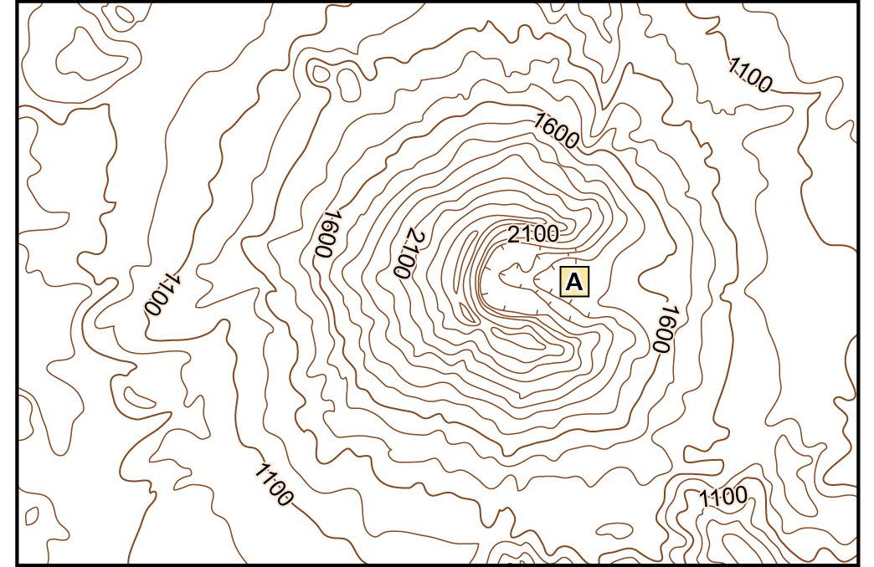
- What is the contour interval on this map?

- What is the approximate highest point on this map?

- What landform is marked with point A?

- Would you expect a lot or just a little runoff from this feature? Explain.

- Which satellite image shows the landform featured in this map?

Map C

- Is the elevation at the red arrow higher or lower than the elevation at the blue arrow?

- What is the relief between the red arrow and blue arrow?

- Which satellite image shows the landform featured in this map?

Map D

- How do you know that the landform indicated by the red arrow has a steep elevation?

- How is the area labeled Ash Creek Butte similar to a plateau?

- The area indicated by the blue arrow is a stream. In which direction does this stream flow? Explain.

Satellite Images
Image 1

Image 2
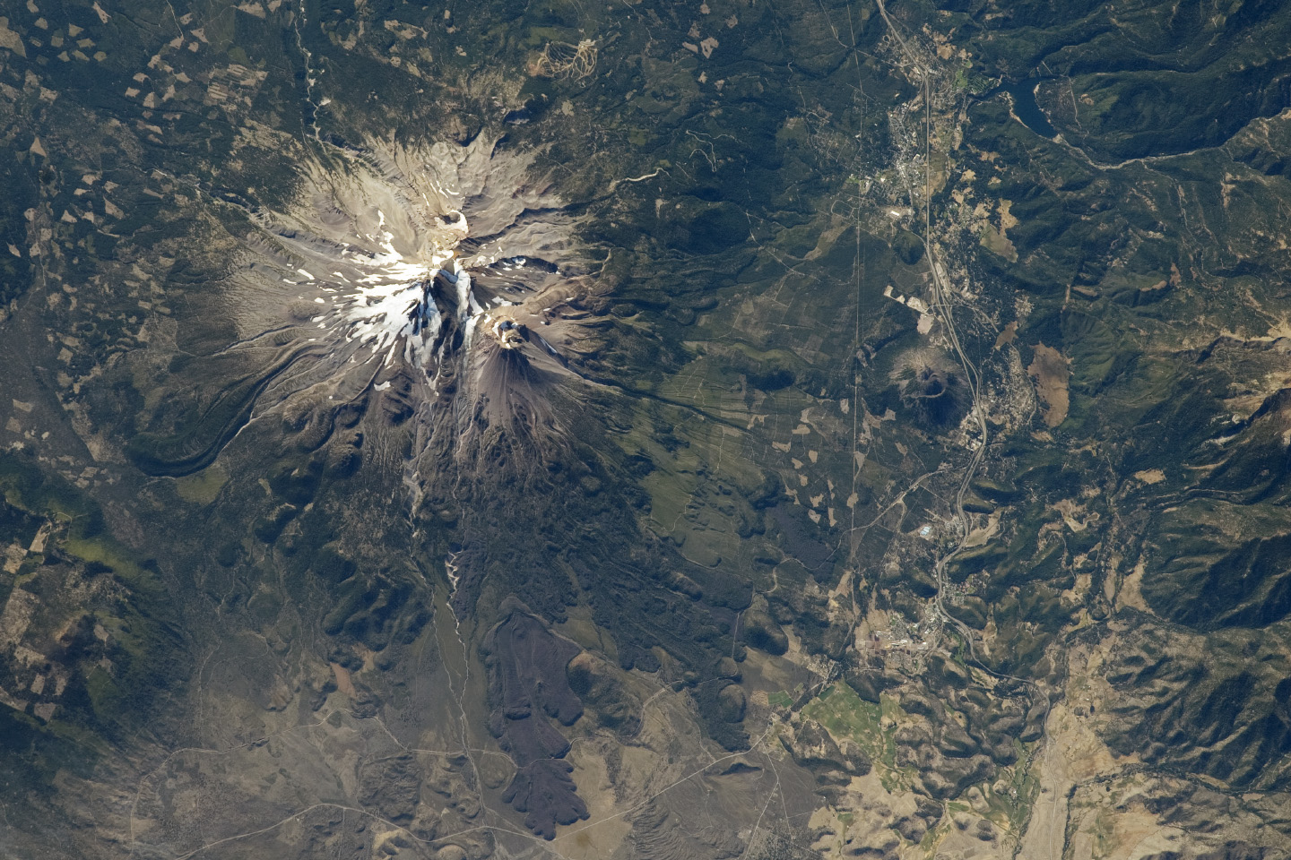

Image 3
