Assignment Summary
For this assignment, you will first construct a model that shows how Earth’s rotation causes day and night. Using this model, you will then engage in a group activity that illustrates how Earth’s tilt toward the Sun causes seasons and regional climates. Once you have completed your model and the group activity, you will write a paper of several paragraphs describing your model and the conclusions drawn from the group activity.

Background Information
The cycle of seasons is caused by Earth's tilt toward the Sun. Earth makes a complete orbit around the Sun every 365.25 days. It spins on an invisible axis that is tilted at an angle of 23.5°. The angle does not change; only the direction of the axis in relation to the Sun changes.
The north end of the axis points away from the Sun for half of year and toward the Sun for the other half. Depending on the time of year, some parts of Earth are tilted more toward the direct rays of the Sun than other parts. Parts of Earth that get more direct rays get warmer, and parts that get fewer direct rays are cooler. The difference in the amount of heat and light available at Earth’s surface determines the seasons.
Seasons vary from one part of the world to another. At different times during the year, the Northern or Southern Hemisphere is closer to the Sun. When it is summer in the Northern Hemisphere, it is winter in the Southern Hemisphere. When it is winter in the Northern Hemisphere, it is summer in the Southern Hemisphere. Both hemispheres get similar amounts of energy from the Sun during fall and spring.

Materials

- Tennis ball  - Metal BBQ skewer  - Marker  - Plastic cup | - Ruler  - Tape  - Flashlight or lamp with single bulb  - Room that can be darkened

Assignment Instructions
Step 1: Prepare for the project.
- Read through this guide before you begin so you know the expectations for this project. Pay particular attention to the instructions for creating a model using the tennis ball, skewer, and plastic cup.
- If anything is not clear to you, be sure to ask your teacher.
Step 2: Gather materials for the model.
Step 3: Create models.
- Create a model of Earth on its axis.
  - Use a tennis ball as Earth and poke a metal skewer into it as the axis around which Earth rotates. Be careful because the skewer is sharp. One end is north, and the other end is south.
  - Draw a circle around the center of the ball with the marker. This is Earth’s equator. See illustration 1 for further guidance.
  - Find the approximate latitude of your current location and draw a dot on the ball. For example, if you live in Chicago, which is at about 40° north of the equator, you would draw your dot slightly less than halfway between the equator and the North Pole.
  - Poke a hole in the plastic cup with the metal skewer. Be sure that the hole is large enough for the skewer to rotate in it. See illustration 2 for further guidance.
  - Cut off a three-inch piece of tape and paste in its center a one-inch piece of tape (sticky sides together). Place the skewer into the hole in the cup and use the tape to hold the skewer against the side of the cup. Your model should have an angle of about 23.5°. See illustration 3 for further guidance.
  - Turn on a lamp or flashlight, which serves as the Sun. Choose a visual reference as the North Star and make sure the axis of Earth model points to the North Star at all times. Darken the room, or move to an area that is already dark.
- Create a model showing how Earth’s rotation on its axis causes day and night (individual activity).
  - Rotate the model counterclockwise one full rotation. You should notice that the dot is in light (day) for about half of the rotation and in shadow (night) for the other half of the rotation.
- Create a model showing how Earth’s tilt causes seasons and regional climates (group activity).
  - Form groups of four.
  - Have each person in the group stand in one of the seasonal positions around the center light in the darkened room: December 21, March 21, June 21, and September 21. See illustration 4 for further guidance.
  - Have the person in each position make a complete rotation of his or her model, making sure the axis points to the North Star at all times during the activity.
  - The person at each position should report the following: what fraction of the day his or her dot is in the light and whether the Sun strikes the dot directly or at an angle.
Step 4: Create a typed paper describing models.
- Type several paragraphs describing how your models showed the effect of the rotation of Earth on day and night and the effect of Earth’s tilt on seasons and regional climates.
  - Discuss all components of your model and the group activity, as outlined in step 3.
  - Describe what you observed about darkness and light with your model.
  - Describe what you discovered about the seasons and regional climates in the group activity.
- Make sure your paragraphs include correct sentence structure, punctuation, grammar, and spelling.
- Ask your teacher where you should save your work. Your teacher also may have specific guidelines about the file name you should use.

Step 5: Evaluate your project using this checklist.
If you can check each of the following boxes, you are ready to submit your project.
- Is your name on your model?
- Did your model show the equator, the latitude of your city, and the 23.5° tilt of Earth’s axis?
- Did your model depict the effects of the Sun on Earth during a complete rotation?
- Did the group activity show how the tilt of Earth on its axis determines the seasons and regional climates as it orbits around the Sun?
- Did you write several paragraphs describing the results of your experiment? Did you discuss all components of your model and the group activity in this paper?
- Did you double-check for correct sentence structure, punctuation, grammar, and spelling in your paper?

Step 6: Revise and submit your project.
- If you were unable to check off all the requirements on the checklist, go back and make sure that your project is complete. Save your project before submitting it.
- Turn in your model to your teacher. Be sure that your name is on it.
- Submit your typed paper through the virtual classroom.
- Congratulations! You have completed your project.

[See next page for art specs]
Illustration 1
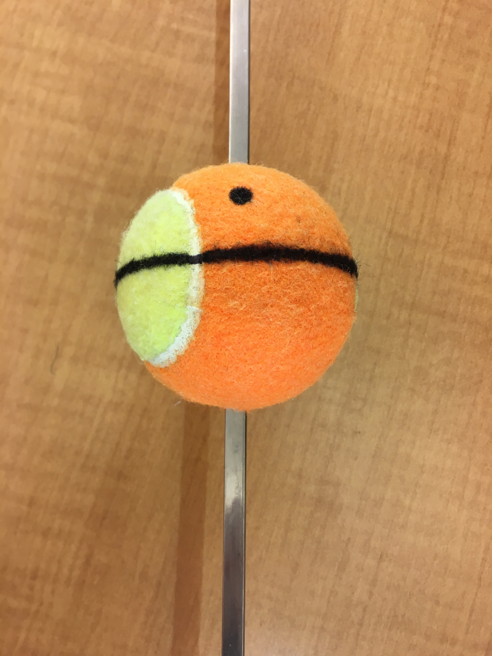
Illustration 2
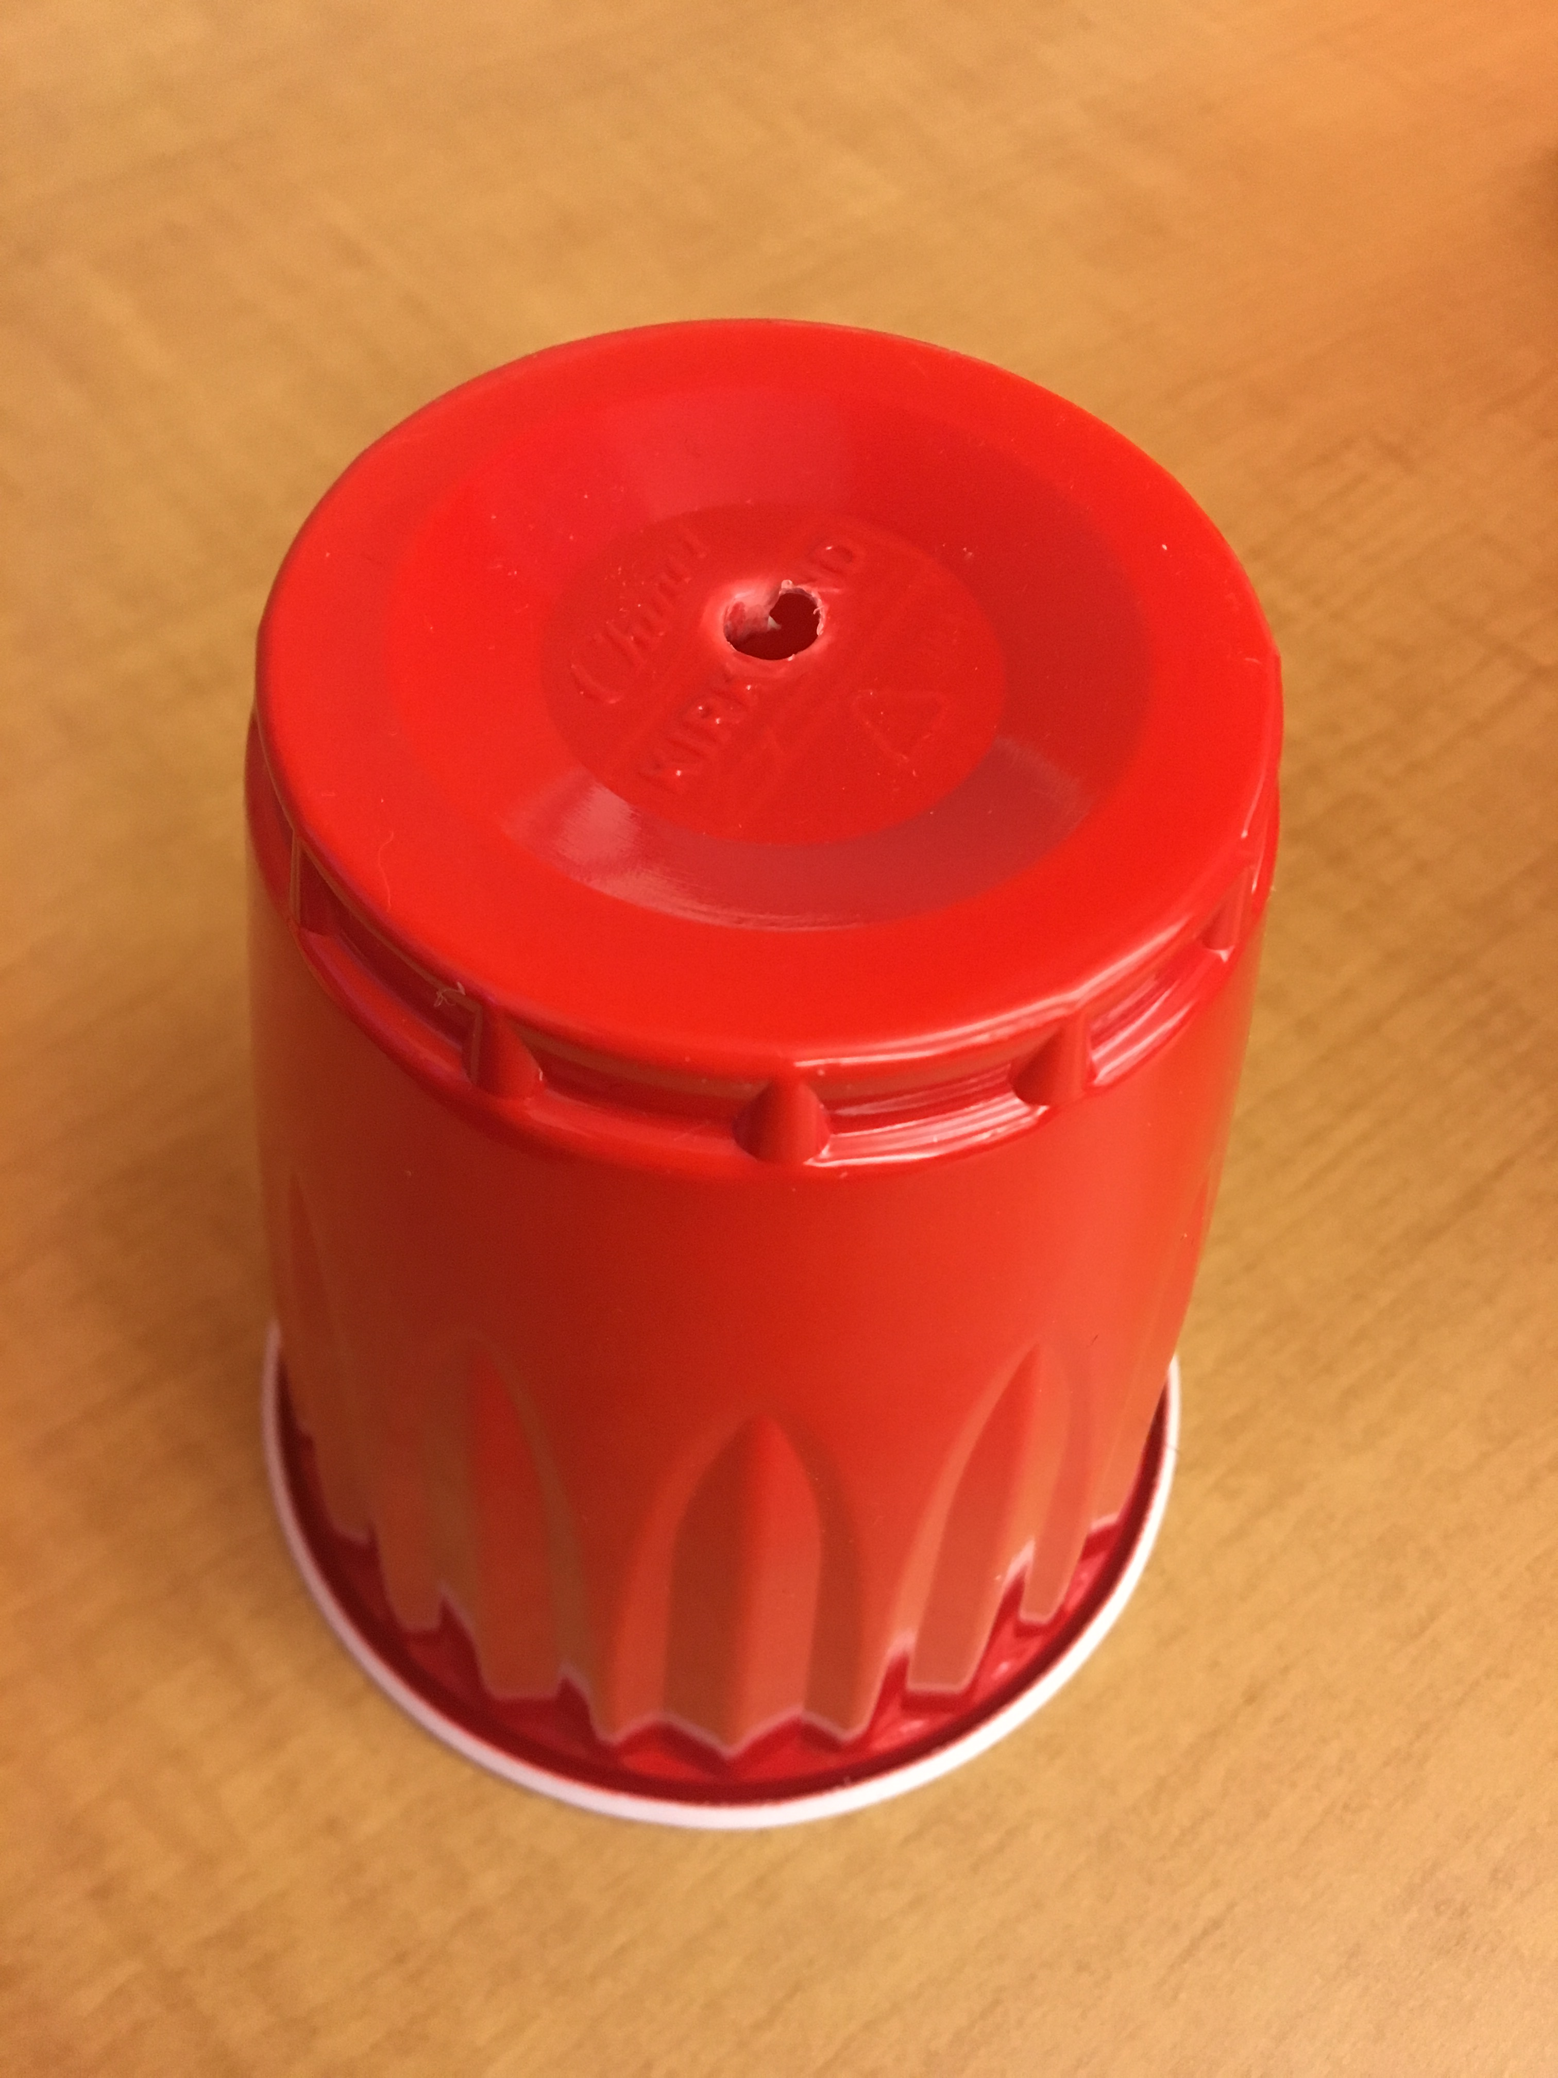

Illustration 3
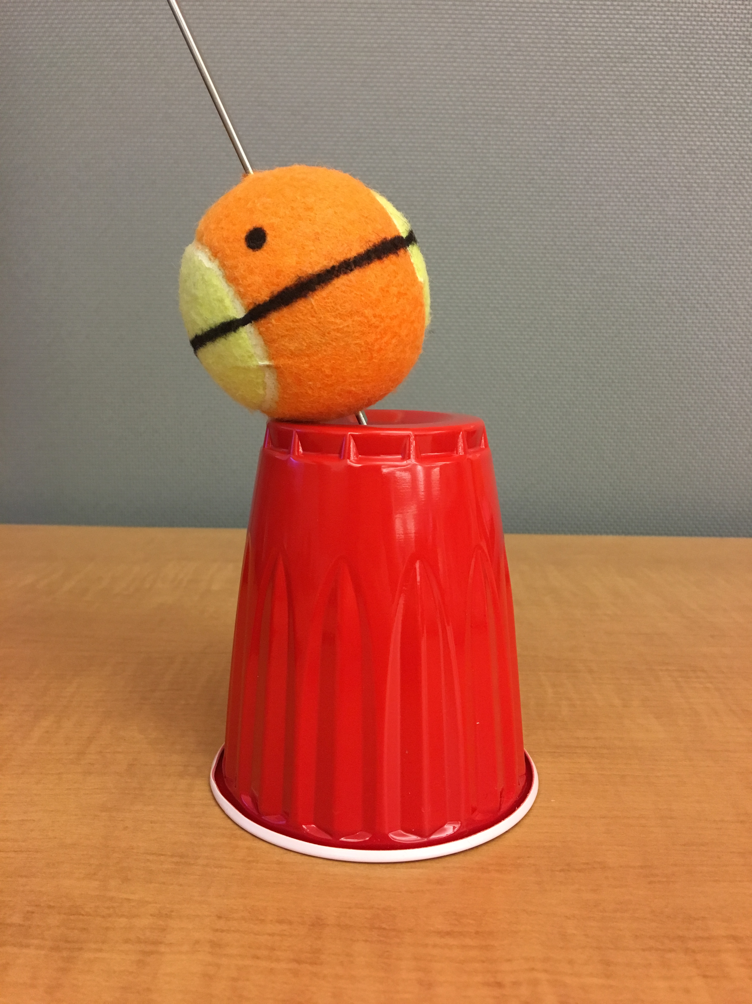

Illustration 4
