Assignment Summary
For this assignment, you will analyze weather maps and interpret weather data sets. You will then use this information to answer a series of questions.

Background Information
Many maps use a feature called isolines, lines that connect points that have equal value. For example, contour maps use isolines to connect areas with the same elevation. In meteorology, the study of weather, isolines are used to represent air pressure and wind speed. This assignment includes isohyets, which are isolines used to connect areas with similar amounts of rainfall.
There are several simple rules for maps with isolines:
- Isolines connect points that have the same value.
- Isolines cannot cross or touch.
- The numerical distance between lines is called the interval, and on each map, the interval is the same between all lines.
- An isoline represents the difference between higher and lower values.
- Isolines show the amount of change over the distance between them. If the isolines are far apart, the change is gradual. If the lines are close together, the change is more prominent.
In addition to isolines, meteorologists collect weather data and observe trends and patterns to predict what will happen in the future. The data meteorologists collect include precipitation, wind speed, and temperature. These data are also useful in determining what to pack for a vacation!

Materials

- Student Guide
- Pencil or pen

Assignment Instructions
For this project, you are expected to submit a student answer sheet.
Step 1: Prepare for the project.
- Read through the guide before you begin so you know the expectations for this project.
- If there is anything that is not clear to you, be sure to ask your teacher.
Step 2: Study the weather map, and answer the questions that follow.
- Look over the weather map located at the end of this document.
- Answer the questions that follow. Your answers do not need to be full sentences.
Step 3: Examine the weather data for Alexandria, Virginia.
- Review Data Set A at the end of this document.
- Answer the questions that follow. Your answers do not need to be full sentences.
Step 4: Examine the weather data for Albany, New York.
- Review Data Set B at the end of this document.
- Answer the questions that follow. Your answers do not need to be full sentences.
Step 5: Evaluate your project using this checklist.
- Did you analyze the maps and graphs carefully to answer the questions?
- Did you answer all the questions?
- Did you review your answers?
- Did you write your name on your worksheet?
Step 6: Revise and submit your project.
- If you were unable to check off all of the requirements on the checklist, go back and make sure that your project is complete. Save your project before submitting it.
- Submit your student answer sheet to your teacher or through the virtual classroom.
- Congratulations! You have completed your project.

Student Answer Sheet

Weather Map
Weather Map: Surface Temperatures of North America
Review the weather map and answer the questions that follow. Your answers do not need to be complete sentences.

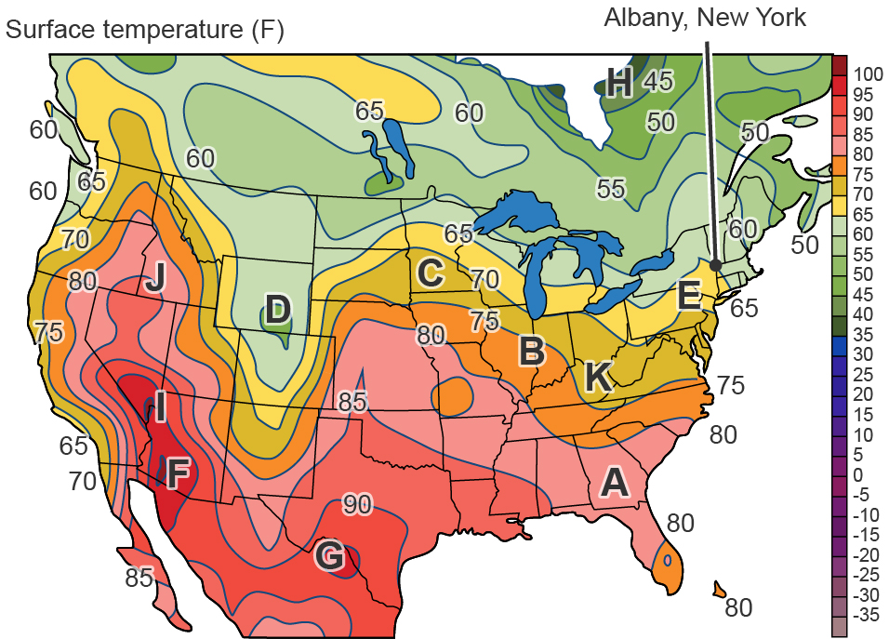
- What is the interval of the isotherms on this map?

- What is the temperature at letter D?

- What is the lowest temperature in degrees Fahrenheit on the map?

- Which letter indicates a temperature of about 67 degrees Fahrenheit?

- What is the hottest temperature in degrees Fahrenheit on the map?

- Which letter has roughly the same temperature as letter C?

- Which letter indicates the most gradual change in temperature?

- Which letter indicates the most sudden change in temperature?

- Why are the average temperatures in the middle of the United States warmer than the coasts?

Data Sets
Data Set A: Average Weather for Alexandria, Virginia
Review the weather data below and answer the questions that follow. Your answers do not need to be complete sentences.

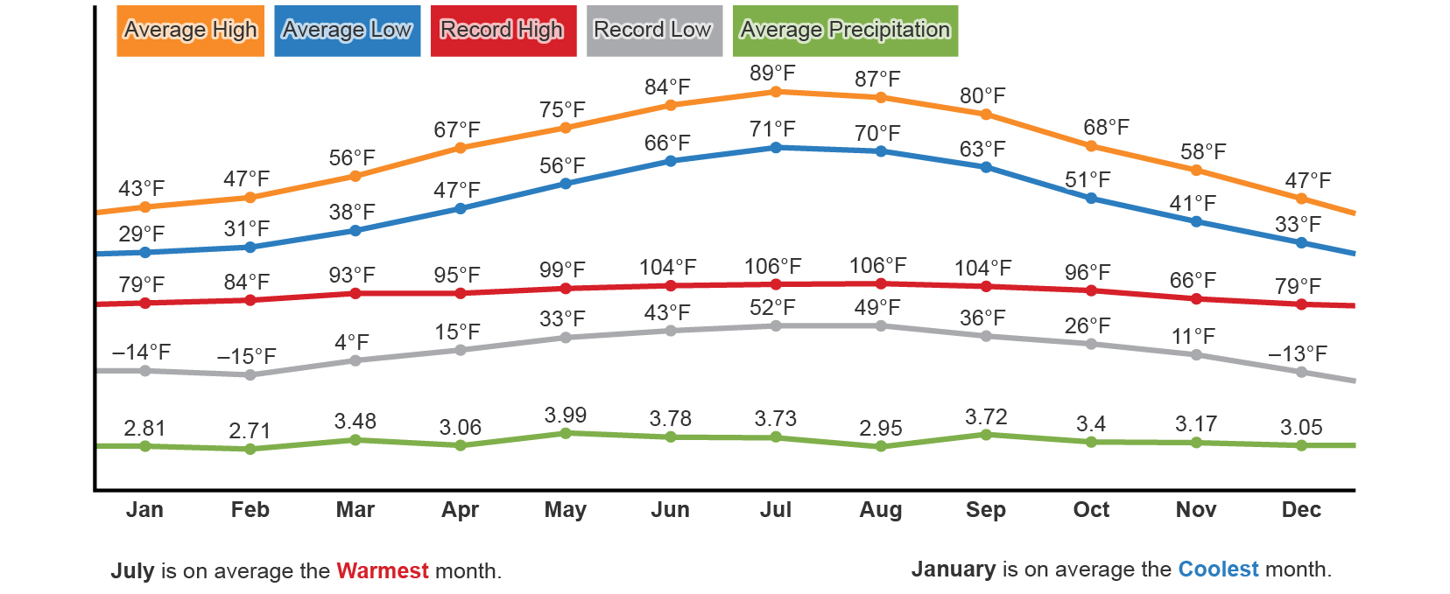

- Which month receives the most precipitation in Alexandria?

- Which month has a record low of 36 degrees Fahrenheit?

- Which months have an average high of 47 degrees Fahrenheit?

- What is the difference in degrees Fahrenheit between the record high and record low for the month of October?

Data Set B: Weather Data for Albany, New York
Review the weather data below and answer the questions that follow. Your answers do not need to be complete sentences.

Monthly Climate in Albany, New York
 | Jan | Feb | Mar | Apr | May | Jun
Average high in ⁰F | 30.6 | 34.5 | 44.4 | 58.3 | 69.4 | 77.9
Average low in ⁰F | 14.5 | 17.2 | 26.0 | 37.2 | 47.1 | 56.5
Average rainfall in inches | 2.6 | 2.2 | 3.23 | 3.19 | 3.62 | 3.78
Average days with precipitation | 8 | 7 | 8 | 8 | 10 | 9
Average snowfall in inches | 18 | 12 | 10 | 2 | 0 | 0
 | Jul | Aug | Sept | Oct | Nov | Dec
Average high in ⁰F | 82.2 | 80.1 | 72.1 | 59.7 | 47.8 | 35.8
Average low in ⁰F | 61.3 | 60.1 | 52.1 | 39.7 | 16.9 | 7.5
Average rainfall in inches | 4.13 | 3.46 | 3.31 | 3.66 | 3.31 | 2.91
Average days with precipitation | 8 | 8 | 7 | 6 | 9 | 9
Average snowfall in inches | 0 | 0 | 0 | 0 | 3 | 14

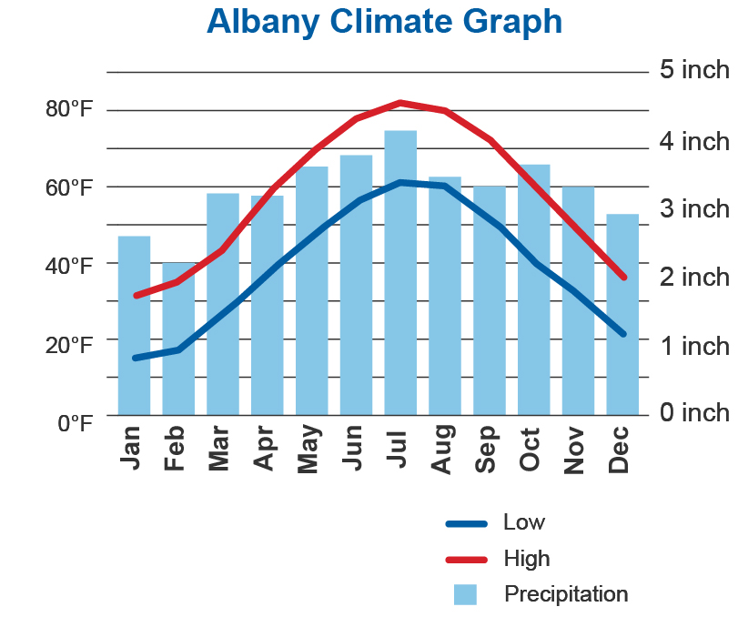
Albany Weather Averages
 | Annual Average
Average high in ⁰F | 57.8
Average low in ⁰F | 38.6
Average temperature in ⁰F | 48.2
Average precipitation in inches | 39.4
Average snowfall in inches | 59

- During which month does Albany get the least amount of rain?

- Which month has an average low of 26 degrees Fahrenheit?
- Which two months get the most snow?

- During which three months is the difference the same between average high temperature and
average low temperature?

- During which month is the average low temperature closest to the annual average temperature?

Comparing and Contrasting Weather Maps and Weather Data
Compare the Weather Map, Data Set A, and Data Set B. Answer the questions below. Your answers do not need to be complete sentences.

- Compare the average precipitation for each month in Data Sets A and B. Which month gets the same amount of rainfall in both places?

- Compare the average highs and average lows in Data Sets A and B. What is the relationship between these two places?

- Look at letter E on the weather map. This is close to the location of Albany, New York. Compare the data from the map with that in Data Set B. What do you notice about the data on the map vs. the data set? Is the map within normal range?

