Prelab Information

Purpose Explore how dichotomous keys are used to identify unknown organisms.

Time Approximately 45 minutes

Question How does a dichotomous key help you identify unknown specimens based on their traits?

Scenario While on vacation, you go fishing on the ocean for the first time. Your goal is to bring in flounder, a species of flat fish that is good to eat. The captain of your boat tells you and your family that, in addition to flounder, there are nine other species of fish and shark commonly caught in these waters at this time of year. However, their harvest is restricted due to conservation efforts. If a restricted species is caught, the captain logs the catch for the local fisheries management agency and releases it back into the water.

Summary Your job is to analyze the characteristics of each of ten fish specimens, using a dichotomous key in your handy field guide to identify the species.

Fish Anatomy Reference

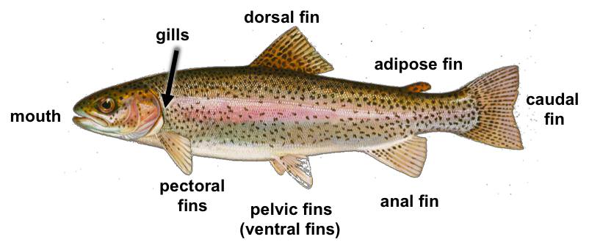

Basic Terms

jaw the framework for the mouth
Fins

dorsal fin fin situated on a fish’s back

gills the respiratory organs of fishes (and some amphibians), over which water flows and oxygen is extracted

tail a flexible appendage at the hind of a fish

Common Fish Body Shapes

fusiform streamlined, tapered both at the head and in rear before the tail

depressed flattened in the up and down direction

laterally compressed flattened from side to side

pectoral fin fin (usually part of a pair) near the front of the body, protruding from the fish’s shoulders

pelvic fin fin (usually part of a pair) on a fish’s abdomen, toward the middle of the body

ventral fin pelvic fin

anal fin fin located on the underside of the body, near the rear, behind the pelvic region

caudal fin fin of the tail

Lab Procedure

For each of the 10 fish specimens:
Specimen | Identity of the  Specimen
1
2
3
4
5
6
7
8
9
10

a) First, carefully examine the picture shown on screen.

b) Start with question 1 of the dichotomous key either on screen or using the excerpt below. Answer the question according to the fish’s characteristics.

c) Based on your answer, progress to the next question. Continue to do so until the answer of the question is the name of a species.

d) Record the species name in the data table.

Dichotomous Key

Question 1: Does the specimen have a jawless, funnel-like mouth?
No: Go to Question 2.

Yes: Lamprey

Question 2: Does the specimen have a laterally compressed body?
Yes: Go to Question 3.

No: Go to Question 4.

Question 3: Does the specimen have a forked tail?
Yes: Halibut

No: Flounder

Question 4: Does the specimen have a depressed body?
Yes: Go to Question 5.

No: Go to Question 7.

Question 5: Does the specimen have a snout with sharp appendages protruding from it?
Yes: Sawfish

No: Go to Question 6.
Question 6: Does the specimen have two hornlike appendages at the front of the body?
Yes: Manta Ray

No: Skate

Question 7: Does the specimen have 6 or more gill slits?
Yes: Cow Shark

No: Go to Question 8.

Question 8: Does the specimen have a forward mouth near the front of the snout (nose)?
Yes: Whale Shark

No: Go to Question 9.

Question 9: Does the specimen have a caudal fin where the top half is approximately the same length as the body?
Yes: Thresher Shark

No: Goblin Shark

